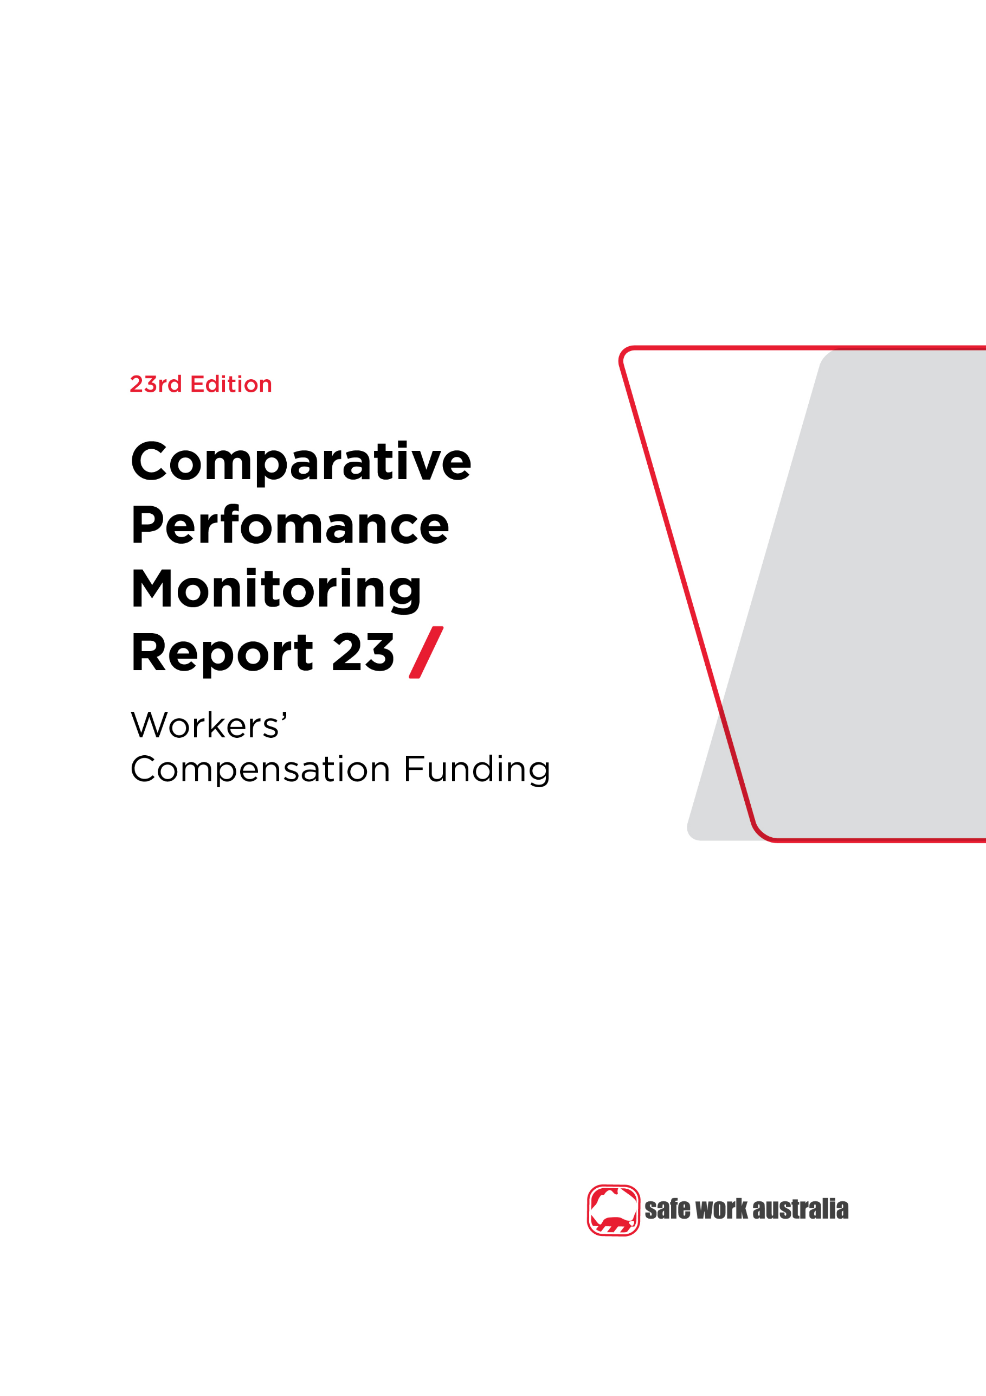

Disclaimer

Safe Work Australia is an Australian Government statutory agency established in 2009. Safe Work Australia includes Members from the Commonwealth, and each state and territory, Members representing the interests of workers and Members representing the interests of employers.

Safe Work Australia works with the Commonwealth, state and territory governments to improve work health and safety and workers’ compensation arrangements. Safe Work Australia is a national policy body, not a regulator of work health and safety. The Commonwealth, states and territories have responsibility for regulating and enforcing work health and safety laws in their jurisdiction.

**ISSN 2209-9158**

Creative Commons

With the exception of the Safe Work Australia logo, this copyright work is licensed under a Creative Commons Attribution 4.0 International licence. To view a copy of this licence, visit creativecommons.org/licenses. In essence, you are free to copy, communicate and adapt the work, even commercially, as long as you attribute the work to Safe Work Australia and abide by the other licence terms.

Contact information

Safe Work Australia | <mailto:info@swa.gov.au> | [www.swa.gov.au](http://www.swa.gov.au)

Contents

**Foreword 5**

**1. Introduction 6**

**1.1 Assets to liabilities ratio 6**

Indicator 17 – Standardised ratio of assets to net outstanding claim liabilities for centrally funded (CF) schemes 7

Indicator 18 – Standardised ratio of assets to net outstanding claim liabilities for privately underwritten (PU) schemes 7

**1.2 Scheme expenditure 8**

Indicator 19 – Scheme expenditure ($m) 10

Indicator 19 – Scheme expenditure (%) 11

Direct compensation payments 12

Indicator 20 – Direct compensation payments by type and jurisdiction, 2019–20 12

Appendix 1 – Assets to liabilities ratio (funding ratio) definitions 13

Prudential margins 13

Appendix 2 – Jurisdictional contact information 15

This image contains the key findings for CPM 23 –Workers’ Compensation Funding
The key findings include that since 2015-16, there has been a 13% decrease in the average funding ratio for centrally funded schemes, and less than one percent decrease in the average funding ratio for privately under-written schemes. Total payments made by Australian workers’ compensation schemes total $9.9 billion, of which 54.4% were provided directly to claimants, 24.1% were provided in services to claimants and 15.2% were provided in insurance operations. 


Foreword

This is the 23rd edition of the Comparative Performance Monitoring (CPM) report which provides trend analyses about work health and safety and workers’ compensation schemes operating in Australia and New Zealand.

This report has been compiled and coordinated by Safe Work Australia with assistance from representatives of all work health and safety and workers’ compensation authorities in Australia and New Zealand. Through a partnership of governments, employers and employees, Safe Work Australia leads the development of national policy to improve WHS and workers’ compensation arrangements across Australia.

The report is presented in the following sections:

* *Work health and safety performance* – provides an overview of work health and safety performance across Australia and New Zealand through analysing trends in serious claim rates and work-related fatalities across jurisdictions.
* *Work health and safety compliance and enforcement activities* – includes a jurisdictional comparison of workplace interventions, inspectorate activity, safety notices, enforceable undertakings, legal proceedings and fines.
* *Workers’ compensation premiums -* includes a national and jurisdictional overview of the standardised average premium rates by industry in the past 5 years.
* *Entitlements under workers’ compensation (scenarios)* – illustrates the differences in entitlement levels across jurisdictions under several scenarios.
* *Workers’ compensation funding – assets, liabilities and expenditure*– includes information about the different funding arrangements of the schemes and compares the differences in scheme funding arrangements and finances (this section).
* *Workers’ compensation disputes* – includes information about disputes against an insurer’s decision or decisions relating to compensation.

Previous editions of the CPM report also included return to work rates as measured in the National Return to Work Survey. At the time of writing, the latest available survey results were from the 2018 Survey. For trend data on the return to work rates (from 2012 to 2018) please refer to the [*22nd edition of the CPM (Part 3)*](https://www.safeworkaustralia.gov.au/resources-and-publications/statistical-reports/comparative-performance-monitoring-report-22nd-edition-part-3). Results from the 2021 National Return to Work Survey will be published on the [Safe Work Australia](https://www.safeworkaustralia.gov.au/collection/national-return-work-survey-2018) website from late 2021.

Readers may find the [*Comparison of Workers’ Compensation Arrangements in Australia and New Zealand*](https://www.safeworkaustralia.gov.au/workers-compensation/comparing-workers-compensation-australia) useful as it discusses the way that each scheme deals with key aspects such as coverage, benefits, self-insurance, common law and disputes.

*About the data*

Data in this publication may differ from jurisdictional annual reports due to the use of different definitions and the application of adjustment factors to aid in the comparability of data.

These statistics should be considered in the broader context of the COVID-19 pandemic when comparing data over previous periods. The potential impact of the COVID-19 pandemic on this data are explored in the[*COVID-19 and Safe Work Australia data*](https://www.safeworkaustralia.gov.au/resources-and-publications/statistical-reports/covid-19-and-safe-work-australia-data) report.

The CPM does not currently include information or data from other industry-specific regulators that have responsibilities with respect to WHS and workers’ compensation. These include national industry-based regulators with compliance and enforcement roles such as the National Heavy Vehicle Regulator, the National Rail Safety Regulator and the National Offshore Petroleum Safety and Environmental Management Authority, and other agencies with responsibility for industry‑specific compensation claims. Further information on these regulators can be found on their respective websites.

In this report ‘Australian Government’ is used for indicators relating to WHS and workers’ compensation matters under the Australian Government jurisdiction, while ‘Comcare’ is used for the indicators relating to premium rates and entitlements.

1. Introduction

There are significant differences in funding arrangements for the various workers’ compensation schemes around Australia.

Schemes that are fully centrally funded (New South Wales, Victoria, Queensland, South Australia, the Australian Government and New Zealand) have both WHS and workers’ compensation functions, and staffing and operational budgets funded by premiums. For those jurisdictions with privately underwritten schemes (Western Australia, Tasmania, the Northern Territory, the Australian Capital Territory and Seacare), funding for non-workers’ compensation functions comes directly from government appropriation.

These differences in funding arrangements should be considered when reviewing this section. More information about the definitions and inclusions for assets to liabilities ratios and scheme expenditure is available in *Appendix 1 – Assets to liabilities ratio (funding ratio) definitions* at the end of the section.

Assets to liabilities ratio

This section reports the standardised ratio of assets to net outstanding claim liabilities (funding ratio) for each jurisdiction over the past five years (2015–16 to 2019–20).

This indicator is a measure of the adequacy of the scheme to meet future claim payments. Ratios above 100% indicate that the scheme has more than sufficient assets to meet its predicted future liabilities. Conversely, low ratios could be an indication of the need for a scheme to increase its premium rates to ensure that assets are available for future claim payments. Funding ratio trends should therefore be considered in conjunction with the premium rates reported in the *Workers’ compensation premiums* section of the Comparison Performance Monitoring report.

Self-insurers are employers who are allowed to manage and pay for their employees’ claims for work-related injuries and disease, rather than paying premiums to insurers to take on these responsibilities. They are required to lodge financial guarantees to provide security for workers’ compensation entitlements. Self‑insurers are excluded from the funding ratio measures as the workers’ compensation assets and liabilities are not quarantined from the rest of the self‑insurer’s business.

Insurers in privately underwritten schemes are governed by the Australian Prudential Regulatory Authority’s prudential regulatory requirements to make sure that enough funds are available to cover all liabilities. The funding ratio measure for privately underwritten schemes does not capture the true extent of the private schemes’ abilities to meet future claim payments and has been shown on a separate graph to those for the centrally funded schemes.

For centrally funded schemes, Indicator 17 shows:

* The average funding ratio for centrally funded schemes was 116% in   
  2019–20, a **12% decrease** from the previous financial year.
  + This decrease in funding ratios was recorded across all centrally funded schemes. The highest decrease was recorded in Victoria (**i decreased 15%** to a ratio of 107% in   
    2019-20), followed by Queensland (**i down 13%** to a ratio of 179%).
* All centrally funded schemes still have funding ratios above 100%, indicating that assets are sufficient to meet future liabilities in these jurisdictions.
* In New Zealand, the funding ratio in 2019–20 (130%) **decreased by 7%** when compared to the previous financial year.

Indicator 17 – Standardised ratio of assets to net outstanding claim liabilities for centrally funded (CF) schemes

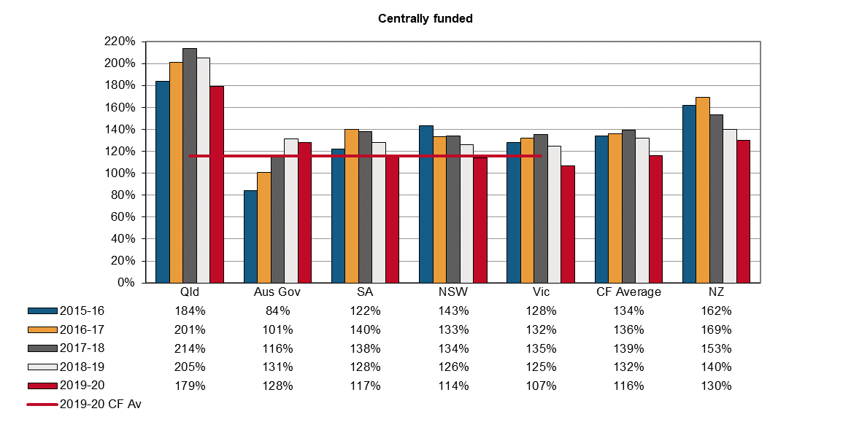

For privately underwritten schemes, Indicator 18 shows:

* In 2019–20 the average funding ratio for privately underwritten schemes was 117%, a **6% increase** from the previous year.
* Tasmania and the Northern Territory both recorded increases in their funding ratios (**h up** **3%** **and 1%** respectively), while Western Australia recorded a **3% decrease**.

Seacare and the Australian Capital Territory schemes are privately underwritten, but no data is currently available for this Indicator.

Indicator 18 – Standardised ratio of assets to net outstanding claim liabilities for privately underwritten (PU) schemes

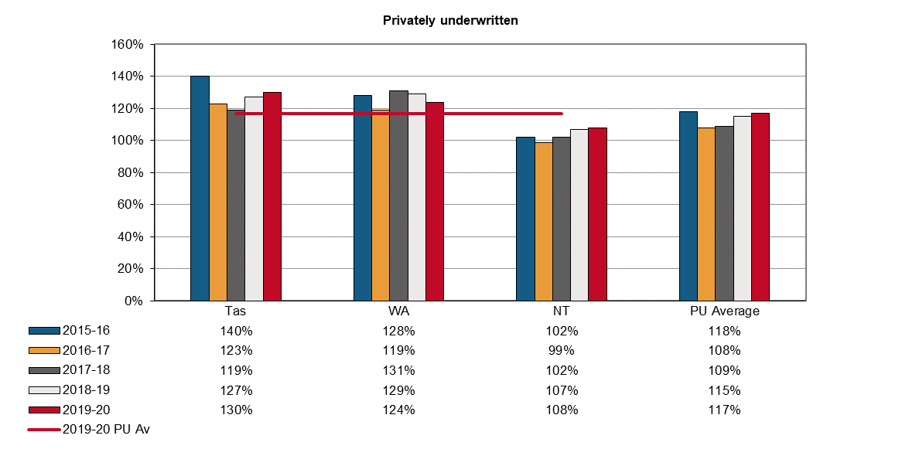

Scheme expenditure

This section shows the amount and proportion of total scheme expenditure paid out to injured workers, plus administrative costs, for the period 2015–16 compared to 2019–20. Since centrally funded and privately underwritten schemes have different financial structures, this indicator separates each jurisdiction into their respective funding arrangement group.

**National**

In 2019–20, total scheme expenditure across Australia was $9.9 billion. This was an **increase of 19%** over the period from 2015–16 and 2019–20. The scheme expenditure consisted of:

* 54.4% provided **directly to claimants** (**h up 21%**). Direct compensation is paid to injured employees either as weekly benefits, redemptions, common law settlements (excluding legal costs), and non-economic loss benefits.
* 24.1% in **services to claimants** (**h up 26%**). Services to claimant encompass costs associated with services to claimants include expenditures for medical and legal services plus expenditures for services like funeral, interpreting and transport services.
* 15.2% in **insurance operations** (**i down 3%**). Insurance operations encompass costs associated with claims management and premium collection functions of the scheme (e.g. premiums/levy management, feed paid to agents, medical reports, registration of employers etc).
* 1.0% in **regulation** (**h up 35%**). Regulation costs include those for license and performance management, compliance activities (e.g. fraud investigations, litigation and prosecution), and services such as advertising, administration, IT costs, research, overseeing employers, etc.
* 1.7% in **dispute resolution** (**h up 21%**). Dispute resolution includes all activities associated with the finalisation of disputes other than the direct costs of a claim. This includes costs associated with departments of justice/courts, conciliation, medical panels and workers’ compensation tribunals/courts.
* 3.7% in **other administration** (**h up 103%**). Other administration costs are generally expenditures for corporate administration purposes.

**Jurisdictions**

Overall an increase in scheme costs was recorded for seven of the nine jurisdictions over the period from 2015–16 to 2019–20.

* While New South Wales recorded the largest percentage increase overall (**h up 36%**), Queensland and Victoria experienced increases in all scheme expenditure categories.

The two jurisdictions that experienced a decrease in scheme costs between 2015–16 to 2019–20 were Comcare (**i down 24%**) and South Australia (**i down** **23%**).

* During these five years, both Comcare and South Australia recorded a decrease in all of the scheme expenditure categories.
* The reductions in South Australia from 2015-16 were in part due to the cessation of the previous scheme, where $169 million was paid in redemptions, which are not a feature of the current scheme.

Examining the individual scheme expenditure categories between 2015–16 to 2019–20, Indicator 19a and 19b show:

* Payments made **directly to workers** increased in six of the nine jurisdictions.
  + The largest increase was recorded by New South Wales (**h up 43%**).
  + The largest decrease was in South Australia (**i down 34%**).
* Expenses paid to workers as **services to claimants** increased in seven jurisdictions.
  + The largest increase was recorded by New South Wales (**h** **up 49%**).
  + The largest decrease was in Comcare (**i down 25%**).
* Costs associated with expenses for **insurance operations** increased in five jurisdictions.
  + The largest increase was recorded by the Northern Territory (**h** **up 34%**).
  + The largest decrease was in New South Wales (**i down 22%**).
* Costs in **regulation** increased in four jurisdictions.
  + The largest increase was recorded by New South Wales (**h up 214%**).
  + The largest decrease was in Comcare (**i down 62%**).
* Costs in **dispute resolution** increased in four jurisdictions.
  + The largest increase was recorded by the Northern Territory (**h up 459%**).
  + The largest decrease was in recorded by Comcare (**i down 95%**).
* Expenditures spent on **‘Other administration’** increased in six jurisdictions.
  + The largest increase was recorded by New South Wales (**h up 932%**).
  + The largest decrease was in Western Australia (**i down 10%**).

Indicator 19a – Scheme expenditure ($m)

|  |  |  |  |  |  |  |  |  |  |  |  |
| --- | --- | --- | --- | --- | --- | --- | --- | --- | --- | --- | --- |
| **Expenditure ($M)** | **Centrally funded** | | | | | **Privately underwritten** | | | | **Total** | |
| **Scheme costs** | **NSW** | **Vic** | **Qld** | **SA** | **Aus Gov** | **WA** | **Tas** | **NT** | **Seacare** | **Australia** | **NZ** |
| **2015–16** |  |  |  |  |  |  |  |  |  |  |  |
| Direct to claimant | 1,057.2 | 1,176.6 | 841.2 | 411.8 | 167.1 | 656.6 | 69.2 | 65.8 | 9.6 | **4,455.0** | 291.8 |
| Services to claimant | 579.9 | 461.9 | 284.9 | 153.6 | 91.6 | 242.8 | 31.3 | 33.3 | 2.4 | **1,881.8** | 207.7 |
| Insurance operations | 510.3 | 462.5 | 112.5 | 114.8 | 26.0 | 255.3 | 38.4 | 23.6 | 1.4 | **1,544.7** | 50.3 |
| Regulation | 10.6 | 37.6 | 11.3 | 6.5 | 2.1 | 4.2 | 1.6 | u/a | 0.0 | **74.0** | 22.4 |
| Dispute resolution | 68.9 | 36.6 | 13.4 | 9.3 | 3.1 | 4.7 | 1.2 | 0.2 | 0.0 | **137.3** | 0.0 |
| Other administration | 15.5 | 48.2 | 43.7 | 35.8 | 23.8 | 9.5 | 0.9 | 1.4 | 1.0 | **180.0** | 36.1 |
| **Total** | **2,242.4** | **2,223.5** | **1,307.1** | **731.8** | **313.7** | **1,173.1** | **142.7** | **124.2** | **14.4** | **8,272.9** | **608.2** |
| **2019–20** |  |  |  |  |  |  |  |  |  |  |  |
| Direct to claimant | 1,507.9 | 1,577.2 | 1,090.9 | 271.0 | 121.9 | 641.6 | 81.5 | 69.5 | 10.6 | **5,372.1** | 428.7 |
| Services to claimant | 862.1 | 577.6 | 397.2 | 146.5 | 68.8 | 252.3 | 34.2 | 36.8 | 2.9 | **2,378.5** | 253.4 |
| Insurance operations | 396.7 | 503.1 | 114.6 | 101.1 | 22.2 | 293.5 | 38.6 | 31.5 | 1.4 | **1,502.8** | 62.8 |
| Regulation | 33.1 | 43.1 | 11.8 | 5.2 | 0.8 | 4.6 | 1.1 | u/a | 0.0 | **99.6** | 19.1 |
| Dispute resolution | 95.9 | 40.3 | 15.7 | 6.7 | 0.1 | 5.2 | 1.1 | 0.9 | 0.0 | **166.0** | 0.0 |
| Other administration | 160.4 | 75.0 | 53.7 | 33.5 | 23.6 | 8.6 | 1.5 | 6.9 | 1.4 | **364.6** | 55.5 |
| **Total** | **3,056.2** | **2,816.3** | **1,683.9** | **564.0** | **237.6** | **1,205.7** | **158.0** | **145.6** | **16.4** | **9,883.6** | **819.5** |

*Note: Figures are rounded to the nearest one decimal place and therefore the rows and columns may not add to the respective totals. u/a – Data is unavailable or not collected.*

Indicator 19b – Scheme expenditure (%)

| **Percentage of total expenditure (%)** | **Centrally funded** | | | | | **Privately underwritten** | | | | **Total** | |
| --- | --- | --- | --- | --- | --- | --- | --- | --- | --- | --- | --- |
| **Scheme costs** | **NSW** | **Vic** | **Qld** | **SA** | **Aus Gov** | **WA** | **Tas** | **NT** | **Seacare** | **Australia** | **NZ** |
| **2015–16** |  |  |  |  |  |  |  |  |  |  |  |
| Direct to claimant | 47.1 | 52.9 | 64.4 | 56.3 | 53.3 | 56.0 | 48.5 | 53.0 | 66.5 | **53.9** | 48.0 |
| Services to claimant | 25.9 | 20.8 | 21.8 | 21.0 | 29.2 | 20.7 | 22.0 | 26.8 | 17.0 | **22.7** | 34.2 |
| Insurance operations | 22.8 | 20.8 | 8.6 | 15.7 | 8.3 | 21.8 | 26.9 | 19.0 | 9.5 | **18.7** | 8.3 |
| Regulation | 0.5 | 1.7 | 0.9 | 0.9 | 0.7 | 0.4 | 1.1 | u/a | 0.1 | **0.9** | 3.7 |
| Dispute resolution | 3.1 | 1.6 | 1.0 | 1.3 | 1.0 | 0.4 | 0.8 | 0.1 | 0.1 | **1.7** | 0.0 |
| Other administration | 0.7 | 2.2 | 3.3 | 4.9 | 7.6 | 0.8 | 0.7 | 1.1 | 6.8 | **2.2** | 5.9 |
| **Total** | **100.0** | **100.0** | **100.0** | **100.0** | **100.0** | **100.0** | **100.0** | **100.0** | **100.0** | **100.0** | **100.0** |
| **2019–20** |  |  |  |  |  |  |  |  |  |  |  |
| Direct to claimant | 49.3 | 56.0 | 64.8 | 48.0 | 51.3 | 53.2 | 51.6 | 47.7 | 64.9 | **54.4** | **52.3** |
| Services to claimant | 28.2 | 20.5 | 23.6 | 26.0 | 29.0 | 20.9 | 21.7 | 25.3 | 17.5 | **24.1** | **30.9** |
| Insurance operations | 13.0 | 17.9 | 6.8 | 17.9 | 9.4 | 24.3 | 24.4 | 21.6 | 8.8 | **15.2** | **7.7** |
| Regulation | 1.1 | 1.5 | 0.7 | 0.9 | 0.3 | 0.4 | 0.7 | u/a | 0.0 | **1.0** | **2.3** |
| Dispute resolution | 3.1 | 1.4 | 0.9 | 1.2 | 0.1 | 0.4 | 0.7 | 0.6 | 0.0 | **1.7** | **0.0** |
| Other administration | 5.2 | 2.7 | 3.2 | 5.9 | 9.9 | 0.7 | 0.9 | 4.7 | 8.7 | **3.7** | **6.8** |
| **Total** | **100.0** | **100.0** | **100.0** | **100.0** | **100.0** | **100.0** | **100.0** | **100.0** | **100.0** | **100.0** | **100.0** |

Direct compensation payments

Indicator 20 shows the distribution of direct payments into weekly benefits and lump sums. The payment of long-term weekly benefits results in higher administration costs. This indicator shows that in 2019–20, all but two Australian schemes (Queensland and Tasmania) paid out more as weekly benefits than lump sum benefits. The New Zealand scheme has little provision for lump sum payments.

Indicator 20 – Direct compensation payments by type and jurisdiction, 2019–20

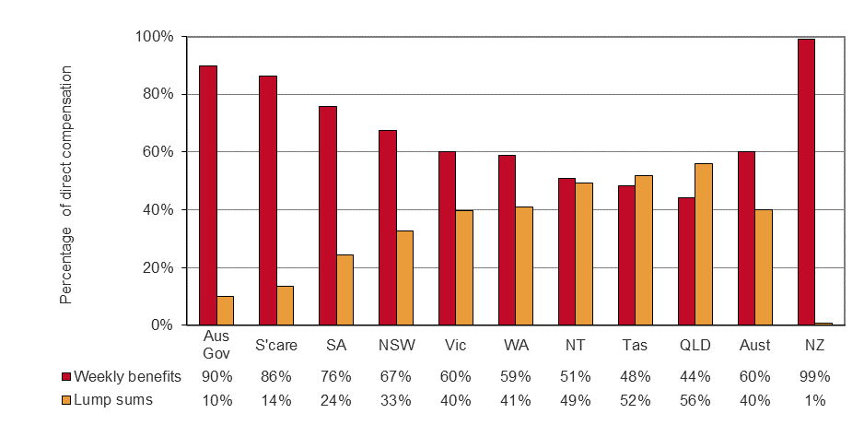

Appendix 1 – Assets to liabilities ratio (funding ratio) definitions

Different measures of assets to liabilities can arise from different economic and actuarial assumptions in valuing liabilities as well as differences in the definitions of:

* assets and net assets, and
* liabilities, such as allowance in some schemes for prudential margins, and allowance for different levels of claim handling expenses.

Different definitions of net assets have been addressed in this publication by applying a consistent definition. For centrally funded schemes, net assets are equal to the total current and non-current assets of the scheme minus the outstanding claim recoveries as at the end of the reference financial year. For privately underwritten schemes, assets are considered to be the insurers’ overall balance sheet claims provisions.

A consistent definition of net outstanding claim liabilities has also been adopted, but there are still some differences between jurisdictions in the measurement of net outstanding claim liabilities. These relate to the different assumptions for claim handling expenses by jurisdictions for which adjustments have not been applied.

Net outstanding claim liabilities for centrally funded schemes are equal to the total current and non-current liabilities of the scheme minus outstanding claim recoveries as at the end of the reference financial year. For privately underwritten schemes, liabilities are taken as the central estimate of outstanding claims for the scheme (excluding the self-insured sector) as at the end of the reference financial year.

For jurisdictions with a separate fund dedicated to workers’ compensation (centrally funded schemes), the assets set aside for future liabilities can be easily identified from their annual reports. Centrally funded schemes operate in Victoria, Queensland, South Australia, the Australian Government and New Zealand.

For jurisdictions where workers’ compensation is underwritten by insurance companies (privately underwritten schemes), assets are set aside to meet all insurance liabilities, but the insurance companies do not identify reserves specifically for workers’ compensation liabilities. For these schemes net assets are considered to be the balance sheet provisions made by the insurers at the end of each financial year. Privately underwritten schemes operate in Western Australia, Tasmania, the Northern Territory, the Australian Capital Territory and Seacare.

The New South Wales scheme is a managed fund, combining some of the features of centrally funded schemes and privately underwritten schemes.

Prudential margins

Many jurisdictions add prudential margins to their estimates of outstanding claims liabilities to increase the probability of maintaining sufficient assets to meet the liabilities estimate. This is done in recognition that there are inherent uncertainties in the actuarial assumptions underlying the value of outstanding liabilities. The addition of a prudential margin will lower the assets to liabilities ratio for that jurisdiction. As some jurisdictions do not have prudential margins, these margins have been removed from the estimates to enhance comparability. For jurisdictions that use prudential margins in determining their liabilities there will be a greater discrepancy between the ratios shown in this report and those shown in their annual reports. The margins that have been removed are:

* New South Wales — a risk margin of 15.6% for 2015–16 and 2016–17, and 15.1% for 2017–18 and 2018–19 at 80% probability of adequacy. For 2019–20 the risk margin was 12.2% with 75% probability of adequacy.
* Victoria — a risk margin of 8.0% for 2015–16, 2016–17, 2017–18 and 2018–19 and 9.5% for 2019–20. The risk margin for the Insurers’ Guarantee Fund and the Uninsured Employers and Indemnity Funds is 40% for the period 2015–16 to 2019–20.
* Queensland — a prudential margin 9.8% from 2015–16 and 2016–17, 9.6% from 2017–18, 9.0% from 2018–19 and 10.0% from 2019–20.
* South Australia — a prudential margin of 6.8% from 2015–16, 12.9% from 2016–17, 13.3% from 2017–18, 12.6% from 2018–19 and 12.7% from 2019–20.
* Northern Territory — a prudential margin of 15% for all years.

Appendix 2 – Jurisdictional contact information

|  |  |  |
| --- | --- | --- |
| Jurisdiction | Organisation | Contact details |
| New South Wales | State Insurance Regulatory Authority  SafeWork NSW  NSW Personal Injury Commission  icare NSW | 13 10 50  [contact@sira.nsw.gov.au](mailto:contact@sira.nsw.gov.au)  [www.sira.nsw.gov.au](http://www.sira.nsw.gov.au/)  contact@safework.nsw.gov.au  [www.safework.nsw.gov.au](http://www.safework.nsw.gov.au/)  1800 742 679  [www.pi.nsw.gov.au](http://pi.nsw.gov.au/)  [www.icare.nsw.gov.au](http://www.icare.nsw.gov.au) |
| Victoria | WorkSafe Victoria | Advisory Service 1800 136 089  [info@worksafe.vic.gov.au](mailto:info@worksafe.vic.gov.au)  [www.worksafe.vic.gov.au](http://www.worksafe.vic.gov.au/) |
| Queensland | Office of Industrial Relations | Infoline 1300 362 128  [www.worksafe.qld.gov.au](https://www.worksafe.qld.gov.au/) |
| Western Australia | WorkCover WA  Department of Mines, Industry Regulation and Safety – WorkSafe | 1300 794 744  [www.workcover.wa.gov.au](http://www.workcover.wa.gov.au/)  1300 307 877  [www.dmirs.wa.gov.au](http://www.dmirs.wa.gov.au/) |
| South Australia | ReturnToWorkSA  SafeWork SA | 13 18 55  [www.rtwsa.com](http://www.rtwsa.com/)  1300 365 255  [www.safework.sa.gov.au](http://www.safework.sa.gov.au/) |
| Tasmania | WorkSafe Tasmania | 1300 366 322 (inside Tas)  (03) 6166 4600 (outside Tas)  [wstinfo@justice.tas.gov.au](mailto:wstinfo@justice.tas.gov.au)  [www.worksafe.tas.gov.au](http://www.worksafe.tas.gov.au/) |
| Northern Territory | NT WorkSafe | 1800 019 115  [ntworksafe@nt.gov.au](mailto:ntworksafe@nt.gov.au)  [www.worksafe.nt.gov.au](http://www.worksafe.nt.gov.au/Pages/default.aspx) |
| Australian Capital Territory | WorkSafe ACT | 13 22 81  [www.worksafe.act.gov.au](https://www.worksafe.act.gov.au/) |
| Seacare | Seacare Authority | (02) 6275 0070  [seacare@comcare.gov.au](mailto:seacare@comcare.gov.au)  [www.seacare.gov.au](http://www.seacare.gov.au/) |
| Australian Government | Comcare | 1300 366 979  [www.comcare.gov.au](http://www.comcare.gov.au/) |
| New Zealand | Accident Compensation Corporation  WorkSafe New Zealand | 64 7 848 7400  [www.acc.co.nz](http://www.acc.co.nz/)  0800 030 040  [www.worksafe.govt.nz](http://www.worksafe.govt.nz) |