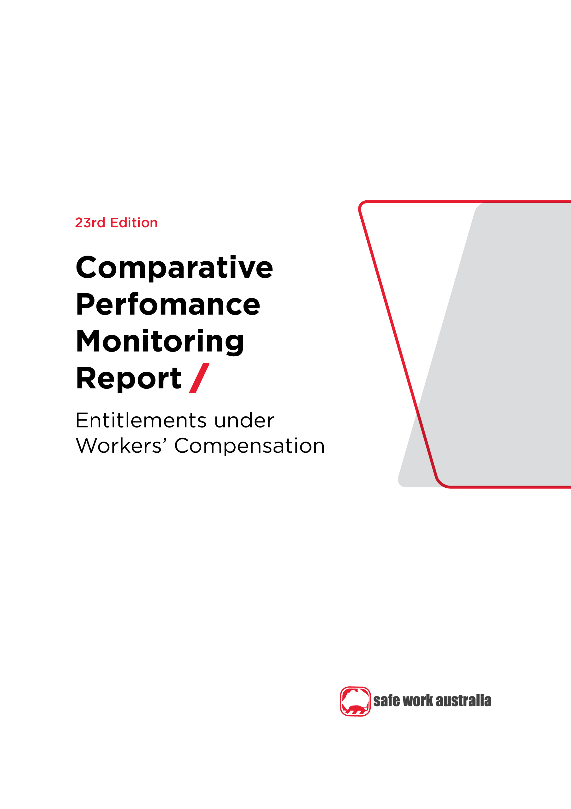

Disclaimer

Safe Work Australia is an Australian Government statutory agency established in 2009. Safe Work Australia includes Members from the Commonwealth, and each state and territory, Members representing the interests of workers and Members representing the interests of employers.

Safe Work Australia works with the Commonwealth, state and territory governments to improve work health and safety and workers’ compensation arrangements. Safe Work Australia is a national policy body, not a regulator of work health and safety. The Commonwealth, states and territories have responsibility for regulating and enforcing work health and safety laws in their jurisdiction.

**ISSN 2209-9158**

Creative Commons

With the exception of the Safe Work Australia logo, this copyright work is licensed under a Creative Commons Attribution 4.0 International licence. To view a copy of this licence, visit creativecommons.org/licenses. In essence, you are free to copy, communicate and adapt the work, even commercially, as long as you attribute the work to Safe Work Australia and abide by the other licence terms.

Contact information

Safe Work Australia | <mailto:info@swa.gov.au> | [www.swa.gov.au](http://www.swa.gov.au)

Contents

Foreword 4

1. Introduction to entitlements 5

1.1 Temporary impairment (scenario) 5

Indicator 15 – Average percentage of pre-injury earnings for selected periods of incapacity, as of 1 January 2020 6

1.2 Permanent impairment (scenario) 6

1.3 Workplace fatality (scenario) 7

Indicator 16 – Entitlements for permanent incapacity or fatality as at 1 January 2020 8

Appendix 1 – Notes for Indicator 15 and 16 9

Appendix 2 – Jurisdictional contact information 11

Foreword

This is the 23rd edition of the Comparative Performance Monitoring (CPM) report which provides trend analyses about work health and safety and workers’ compensation schemes operating in Australia and New Zealand.

This report has been compiled and coordinated by Safe Work Australia with assistance from representatives of all work health and safety and workers’ compensation authorities in Australia and New Zealand. Through a partnership of governments, employers and employees, Safe Work Australia leads the development of national policy to improve WHS and workers’ compensation arrangements across Australia.

The report is presented in the following sections:

* *Work health and safety performance* – provides an overview of work health and safety performance across Australia and New Zealand through analysing trends in serious claim rates and work-related fatalities across jurisdictions.
* *Work health and safety compliance and enforcement activities* – includes a jurisdictional comparison of workplace interventions, inspectorate activity, safety notices, enforceable undertakings, legal proceedings and fines.
* *Workers’ compensation premiums* –includes a national and jurisdictional overview of the standardised average premium rates by industry in the past 5 years.
* *Entitlements under workers’ compensation (scenarios)* – illustrates the differences in entitlement levels across jurisdictions under several scenarios (this section).
* *Workers’ compensation funding – assets, liabilities and expenditure* – includes information about the different funding arrangements of the schemes and compares the differences in scheme funding arrangements and finances.
* *Workers’ compensation disputes* – includes information about disputes against an insurer’s decision or decisions relating to compensation.

Previous editions of the CPM report also included return to work rates as measured in the National Return to Work Survey. At the time of writing, the latest available survey results were from the 2018 Survey. For trend data on the return to work rates (from 2012 to 2018) please refer to the [*22nd edition of the CPM (Part 3)*](https://www.safeworkaustralia.gov.au/resources-and-publications/statistical-reports/comparative-performance-monitoring-report-22nd-edition-part-3). Results from the 2021 National Return to Work Survey will be published on the [Safe Work Australia](https://www.safeworkaustralia.gov.au/data-and-research/measuring-return-work-outcomes) website from late 2021.

Readers may find the [*Comparison of Workers’ Compensation Arrangements in Australia and New Zealand*](https://www.safeworkaustralia.gov.au/workers-compensation/comparing-workers-compensation-australia) useful as it discusses the way that each scheme deals with key aspects such as coverage, benefits, self-insurance, common law and disputes.

*About the data*

Data in this publication may differ from jurisdictional annual reports due to the use of different definitions and the application of adjustment factors to aid in the comparability of data.

These statistics should be considered in the broader context of the COVID-19 pandemic when comparing data over previous periods. The potential impact of the COVID-19 pandemic on this data are explored in the [*COVID-19 and Safe Work Australia data*](https://www.safeworkaustralia.gov.au/resources-and-publications/statistical-reports/covid-19-and-safe-work-australia-data) report.

The CPM does not currently include information or data from other industry-specific regulators that have responsibilities with respect to WHS and workers’ compensation. These include national industry-based regulators with compliance and enforcement roles such as the National Heavy Vehicle Regulator, the National Rail Safety Regulator and the National Offshore Petroleum Safety and Environmental Management Authority, and other agencies with responsibility for industry‑specific compensation claims. Further information on these regulators can be found on their respective websites.

In this report ‘Australian Government’ is used for indicators relating to WHS and workers’ compensation matters under the Australian Government jurisdiction, while ‘Comcare’ is used for the indicators relating to premium rates and entitlements.

1. Introduction to entitlements

Entitlements are payable under workers’ compensation in the event an employee is injured or develops a work-related disease.

To illustrate the differences in entitlement levels across jurisdictions, this section calculates indicative entitlement payments under three different scenarios. These scenarios cover entitlements for a *temporary impairment, permanent impairment* and *fatality.*

This section also demonstrates the differences between *low, middle and high income employees* by using pre-injury earnings of $1,150 gross per week, $1,800 gross per week and $2,400 gross per week1. These profiles have been chosen to highlight the statutory maximum entitlements payable, as well as jurisdictional differences in entitlements to workers employed on different income levels.

A brief summary of how entitlements are calculated is contained in *Appendix 1 – Features of Australian workers’ compensation schemes* at the end of this section. More detailed information about the differences between schemes can also be found in the [*Comparison of Workers’ Compensation Arrangements in Australia and New Zealand*](https://www.safeworkaustralia.gov.au/workers-compensation/comparing-workers-compensation-australia) publication on the [Safe Work Australia](https://www.safeworkaustralia.gov.au/) website.

* 1. Temporary impairment (scenario)

Impairment is assessed as temporary when the injury or illness is not likely to continue indefinitely and the employee remains unable to work for a period of time before returning to previous duties on an ongoing basis.

This example details how jurisdictions compensate low, middle and high income[1] employees during selected periods of temporary impairment.

*Scenario: The employee remains unable to work for a period of time before returning to their previous duties on a full-time basis. The employee has a dependant spouse and two children aged seven and eight. The employee injured their back and has lower back strain as a result.*

Indicator 15 shows that:

* For low income earners, seven Australian jurisdictions provide full income protection for the first 26 weeks. For middle and high income earners, this reduces to five jurisdictions that provide full income protection for this period of incapacity.
* For low income earners with 130 weeks of impairment, Western Australia provides full coverage (100%) of pre‑injury earnings. This was followed by Queensland (97%) and the Northern Territory (92%).
* For middle and high income earners with 130 weeks of impairment, Tasmania and South Australia provides the highest percentage of pre-injury earnings (both 88%), followed by Western Australia (87%) and Comcare (84%).
* The Australian Capital Territory provided the lowest percentage of pre-injury earnings in all three example income earners at 130 weeks of impairment (72%) due in part to the step-down[2] in benefits to 65% of pre-injury earnings after 26 weeks of compensation.

Indicator 15 – Average percentage of pre-injury earnings for selected periods of incapacity, as of 1 January 2020

|  |  |  |  |  |  |  |  |  |  |  |
| --- | --- | --- | --- | --- | --- | --- | --- | --- | --- | --- |
| **Level of pre-injury income** | **NSW** | **Vic** | **Qld** | **WA** | **SA** | **Tas** | **NT** | **ACT** | **Comcare** | **NZ** |
| **13 weeks of incapacity** | | | | | | | | | | |
| Low income | 95 | 95 | 100 | 100 | 100 | 100 | 100 | 100 | 100 | 80 |
| Middle income | 95 | 95 | 85 | 100 | 100 | 100 | 100 | 100 | 100 | 80 |
| High income | 91 | 95 | 85 | 100 | 100 | 100 | 100 | 100 | 100 | 80 |
| **26 weeks of incapacity** | | | | | | | | | | |
| Low income | 88 | 88 | 100 | 100 | 100 | 100 | 100 | 100 | 100 | 80 |
| Middle income | 88 | 88 | 85 | 93 | 100 | 100 | 100 | 100 | 100 | 80 |
| High income | 86 | 88 | 85 | 93 | 100 | 100 | 100 | 100 | 100 | 80 |
| **52 weeks of incapacity** | | | | | | | | | | |
| Low income | 84 | 84 | 98 | 100 | 100 | 95 | 95 | 83 | 97 | 80 |
| Middle income | 84 | 84 | 80 | 89 | 100 | 95 | 88 | 83 | 97 | 80 |
| High income | 83 | 84 | 80 | 89 | 100 | 95 | 88 | 83 | 97 | 80 |
| **130 weeks of incapacity** | | | | | | | | | | |
| Low income | 82 | 82 | 97 | 100 | 88 | 88 | 92 | 72 | 84 | 80 |
| Middle income | 82 | 82 | 77 | 87 | 88 | 88 | 80 | 72 | 84 | 80 |
| High income | 81 | 82 | 77 | 87 | 88 | 88 | 80 | 72 | 84 | 80 |

See *Appendix 1: Notes* *for Indicator 15 and 16* for further information.

* 1. Permanent impairment (scenario)

Impairment is assessed as permanent when it has reached maximal medical improvement. Maximal medical improvement generally refers to where the impairment has become stable and is unlikely to change, with or without medical treatment. Over time, there may be some change; however, further recovery or deterioration is not anticipated.

This scenario shows the entitlements payable for a degree of permanent impairment caused by a workplace injury.

*Appendix 1 – Table 3: Other entitlements under Australian workers’ compensation schemes for award wage earners as at 1 January 2020* lists entitlements under workers’ compensation schemes for each jurisdiction.

*Scenario: As a result of a workplace incident the employee was diagnosed with complete tetraplegia below the 6th cervical neurological segment. This resulted in paralysis of his hands, impaired upper body movement and paralysis of his trunk and lower limbs. He lost all lower body function and was wheelchair-bound. Impairment was total and permanent and there was no real prospect of returning to work.*

*The employee’s pre-injury earnings were $1,800 gross per week. The employee is 35 years of age and has a dependant spouse and two children aged seven and eight. The younger child entered the workforce at 16 and the older child remained in full-time education until age 25. The employee contributed to a superannuation fund. There was no contributory negligence on his part; however, there was negligence on the part of the employer.*

Indicator 16 (in the next section) details the entitlements payable to the injured employee. Entitlements may be paid as two components;

* a statutory component that may include both weekly payments and/or a lump sum

The statutory component includes the weekly benefits payable for the remainder of the employee’s working life.

* a common law component paid as a lump sum.

The common law component is an estimate of the additional payment available under a common law settlement, where applicable. All figures exclude medical and like services such as attendant care. If a common law component is paid, previous statutory components are deducted from the lump sum. In Western Australia, New South Wales, Queensland, Tasmania and the Australian Capital Territory there is no upper limit on damages that could be expected from a common law claim under this scenario.

Indicator 16 shows that:

* Apart from South Australia, the Northern Territory and Comcare, all other jurisdictions provide common law benefits.
  + In this scenario, Western Australia provides a common law maximum of $4,317,725 (excluding medical and carer costs). This is based on the average of the five highest common law payments for claims finalised between 2015–16 and 2019–20
* All jurisdictions provide statutory benefits.
  + In this scenario, New South Wales provides approximately $2.25 million paid in weekly benefits if eligible for 30 years (with the first 13 weeks paid at 95% and the remaining weeks paid at 80%) and a maximum statutory lump sum benefit of $649,950.
* Comparisons between jurisdictions should be made with caution as there are many differences between compensation schemes. See the notes section in Indicator 16 and Appendix 1 for more information.
* The entitlements provided by the New Zealand scheme in this scenario are comparable to those provided by Australian jurisdictions. However, there is no access to common law under the New Zealand scheme.
  1. Workplace fatality (scenario)

This example examines the entitlements payable to dependants of an employee who died as a result of a work‑related injury. Entitlements to dependants are paid by way of a lump sum and/or weekly benefits, depending on the employee’s circumstances and scheme design.

Pecuniary entitlements may be affected by common law payments in jurisdictions where there is access to common law redress. South Australia and the Northern Territory have no access to common law, while the Comcare scheme has limited access to common law. In Victoria there may be access to an additional lump sum under the Wrongs Act 1958 (Wrongs Act)*,* which is the main legislation in Victoria that applies to common law claims for damages for personal injury in cases other than workplace injuries or transport accidents.

*Scenario: The employee and family circumstances in this scenario are the same as the previous example, but in this case the workplace incident resulted in death on 1 January 2020. The spouse did not re-enter the workforce or re-marry for 10 years.*

Indicator 16 shows the total entitlements payable to dependants in the case of a fatality varied across jurisdictions. In particular:

* South Australia provided the highest entitlement payable to dependants in Australia following a workplace incident resulting in a fatality at the amount of $1,048,762. This was followed by New South Wales ($984,103).
* The lowest entitlements for a fatality were provided in Tasmania ($702,796) and Western Australia ($736,853).

Indicator 16 – Entitlements for permanent incapacity or fatality as at 1 January 2020

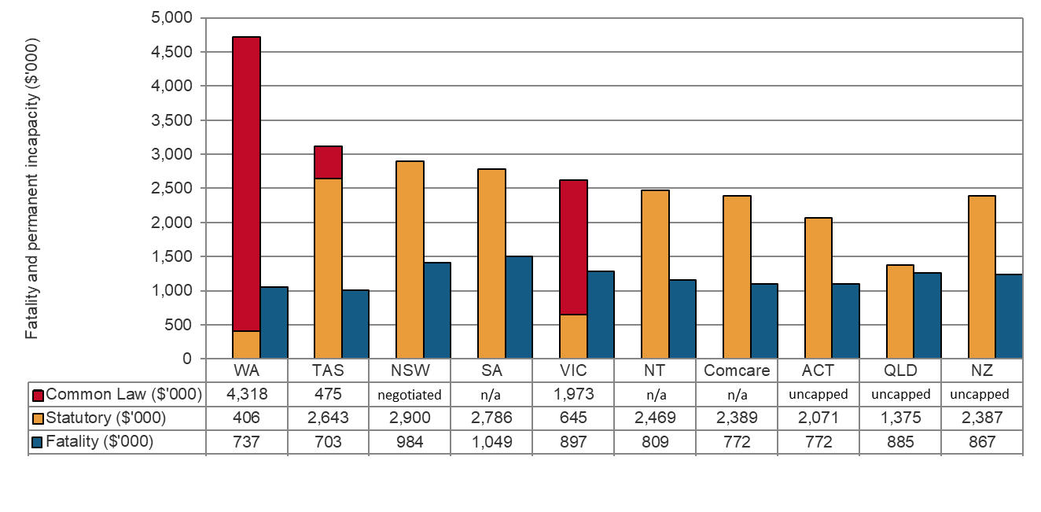

Notes:

n/a – not applicable. See *Appendix 1: Notes* *for Indicator 15 and 16* for further information.

These figures are calculated based on entitlements as at 1 January 2020. Many payments made by the jurisdictions are indexed regularly and these have generally been excluded when estimating payments for the scenarios (as they are not yet known).

Appendix 1 – Notes for Indicator 15 and 16

1. New South Wales:
   1. Indicator 15: In New South Wales maximum weekly payments are capped at $2,195.70.
   2. Indicator 16: For the statutory lump sum it is assumed that the worker would be assessed with a permanent impairment of over 75%. If the whole impairment is to the back, then a 5% increase to the lump sum benefit applies (see s66(2A) of the *Workers Compensation Act 1987* (*NSW*)). This will give the worker an entitlement to the maximum lump sum benefit of $619,000 plus an additional 5% ($30,950), giving a total of $649,950 (as at 1 January 2020).
2. Victoria:
   1. Indicator 15: The Victorian statutory maximum for weekly payments during week 0-52 is $2,380.
   2. Indicator 15: For the periods that the worker worked within the first 13 weeks, they will be entitled to 95% of their pre-injury average weekly earnings, minus 100% of their current weekly earnings. For the periods that the worker worked within weeks 14-130, they will be entitled to 80% of their pre-injury average weekly earnings, minus 80% of their current weekly earnings.
3. Queensland:

3.1 Indicator 15: Workers are paid a proportion of their normal weekly earnings (NWE) or a percentage of the seasonally adjusted amount of Queensland full time adult persons ordinary time earnings (QOTE) (i.e. 0 to 26 weeks 85% NWE or Award; 26 to 52 weeks 75% NWE or 70% QOTE). The amounts provided here are the higher amounts of the two possible payments.

3.2 Indicator 16: Common Law is uncapped in Queensland, so an amount is unable to be determined.

1. Western Australia:
   1. Indicator 15: There are differences in how award and non-award workers receive statutory benefits. Non-award workers are subject to a step-down to 85% pre-injury earnings after 13 weeks. Award workers are not subject to any step-down. In this example, the low income earner is based on an award worker, whereas the middle and high income earners are based on non-award workers. Therefore caution should be used when making comparisons between the pre-injury income examples. If all three scenarios used award workers, percentage of pre-injury earnings payable would be 100% in all examples.
   2. Indicator 15: A cap on weekly earnings set at twice the annual Average Weekly Earnings (WA) as published by the Australian Bureau of Statistics each year is applied to all income levels. This means the middle and high income earner would exhaust the prescribed total amount for weekly benefit before 130 weeks of compensation.
   3. Indicator 16: A cap on common law benefits applies for injuries with more than 15% to less than 25% whole of person impairment (WPI). However, in this example no common law cap has been applied as the impairment would likely exceed the 25% or more WPI threshold.
2. South Australia:
   1. Indicator 15: In South Australia a worker's entitlement reduces to 80% (of their Notional Weekly Earnings) after 52 weeks from the date on which the incapacity for work first occurs. After the end of the period of 104 weeks from the date on which the incapacity for work first occurs a worker's entitlement ceases, unless the worker is taken to be a seriously injured worker (see s21, s41 and s47 of the *Return to Work Act 2014 (SA*)).
   2. Indicator 16: In the fatality example it has been assumed that the spouse was totally dependent on the deceased worker for a period of 5 years.
3. Tasmania:

6.1 Indicator 15 and 16: For the first 26 weeks of incapacity a worker receives payments at 100% of their normal weekly earnings. Where a worker is incapacitated for more than 26 weeks, their weekly payments are paid at either 90% their normal weekly earnings. Where a worker’s incapacity exceeds 78 weeks, their weekly payments are reduced to 80% of their normal weekly earnings.

1. Northern Territory:
   1. Indicator 15: The minimum long term (after first 26 weeks) benefits provide for entitlement of greater than 75% but not more than 90%, of loss of earning capacity, for low to middle income earners. Those with dependants are more likely to qualify (s65(7) to (12) of *Return to Work Act 1986* (NT)).
2. Australian Capital Territory:
   1. Indicator 15: The worker's entitlement reduces to the greater of the Statutory Floor or 65% of pre-incapacity weekly earnings applies after 26 weeks of total incapacity (see s41 of the ACT Workers Compensation Act 1951). There are no entitlements for dependants in this scenario. The Statutory Floor means the national minimum wage set by a national minimum wage order in an annual wage review by Fair Work Australia under the Fair Work Act 2009 (Cwlth). According to the National Minimum Wage Order 2019, the national minimum wage as of 1 January 2020 was $740.80 per week, calculated on the basis of a week of 38 ordinary hours, or $19.49 per hour.
   2. Indicator 16: Common Law is uncapped in the ACT, so an amount is unable to be determined.
   3. Indicator 16: A single lump sum payment is divided between the dependants as compensation for the death of a worker and the division may be determined by the Magistrates Court as they see appropriate. There are no weekly benefits payable to a spouse. Dependants would also be entitled to an additional amount to cover funeral expenses.
   4. Indicator 16: A child that remains in full time education would stop being entitled to receiving weekly compensation benefits if they entered into a domestic partnership.
3. Comcare:
   1. Indicator 16: The 'cut-off' for weekly benefits has been changed under the SRC Act and is now 'pension age' as defined by the DSS Act, rather than age 65. Therefore, the weekly incapacity benefits can potentially be paid to age 67 (the DSS pension age) and this has not been applied to the above figure.
   2. Indicator 16: If common law action is taken by the injured worker, a maximum of $110,000 is payable for non-economic loss (only). However, if the worker opts for common law, they lose their entitlement to a 'Statutory Lump Sum' for permanent impairment under the Comcare scheme.
   3. Indicator 16: In the example for permanent impairment, the full statutory lump sums for permanent impairment and non-economic loss have been used.
   4. Indicator 16: The legislation does not prescribe a set amount or percentage to either spouse or children but states the total of the current statutory amount is "payable to, or in accordance with the direction of, Comcare for the benefit of all dependents". For the fatality example, 5% has been paid to each dependent child with the remaining 90% paid to the spouse.
4. New Zealand:

10.1 Indicator 16: Weekly Compensation is 80% of the gross weekly earnings. Clause 52 of the First Schedule of the *Accident Compensation Act* *2001 (NZ)* states that weekly compensation ceases at the age at which the client is eligible for New Zealand Superannuation. In this example, that is age 65.

10.2 Indicator 16: Lump Sums for Whole Person Impairment are set out in the Accident Compensation Act 2001 (NZ). For the purposes of the example, it was presumed that the client was entitled to the maximum one off payment amount.

10.3 Indicator 16: Common Law is uncapped in New Zealand, so an amount is unable to be determined.

Appendix 2 – Jurisdictional contact information

| Jurisdiction | Organisation | Contact details |
| --- | --- | --- |
| New South Wales | State Insurance Regulatory Authority  SafeWork NSW  NSW Personal Injury Commission  icare NSW | 13 10 50  [contact@sira.nsw.gov.au](mailto:contact@sira.nsw.gov.au)  [www.sira.nsw.gov.au](http://www.sira.nsw.gov.au/)  contact@safework.nsw.gov.au  [www.safework.nsw.gov.au](http://www.safework.nsw.gov.au/)  1800 742 679  [www.pi.nsw.gov.au](http://pi.nsw.gov.au/)  [www.icare.nsw.gov.au](http://www.icare.nsw.gov.au) |
| Victoria | WorkSafe Victoria | Advisory Service 1800 136 089  [info@worksafe.vic.gov.au](mailto:info@worksafe.vic.gov.au)  [www.worksafe.vic.gov.au](http://www.worksafe.vic.gov.au/) |
| Queensland | Office of Industrial Relations | Infoline 1300 362 128  [www.worksafe.qld.gov.au](https://www.worksafe.qld.gov.au/) |
| Western Australia | WorkCover WA  Department of Mines, Industry Regulation and Safety – WorkSafe | 1300 794 744  [www.workcover.wa.gov.au](http://www.workcover.wa.gov.au/)  1300 307 877  [www.dmirs.wa.gov.au](http://www.dmirs.wa.gov.au/) |
| South Australia | ReturnToWorkSA  SafeWork SA | 13 18 55  [www.rtwsa.com](http://www.rtwsa.com/)  1300 365 255  [www.safework.sa.gov.au](http://www.safework.sa.gov.au/) |
| Tasmania | WorkSafe Tasmania | 1300 366 322 (inside Tas)  (03) 6166 4600 (outside Tas)  [wstinfo@justice.tas.gov.au](mailto:wstinfo@justice.tas.gov.au)  [www.worksafe.tas.gov.au](http://www.worksafe.tas.gov.au/) |
| Northern Territory | NT WorkSafe | 1800 019 115  [ntworksafe@nt.gov.au](mailto:ntworksafe@nt.gov.au)  [www.worksafe.nt.gov.au](http://www.worksafe.nt.gov.au/Pages/default.aspx) |
| Australian Capital Territory | WorkSafe ACT | 13 22 81  [www.worksafe.act.gov.au](https://www.worksafe.act.gov.au/) |
| Seacare | Seacare Authority | (02) 6275 0070  [seacare@comcare.gov.au](mailto:seacare@comcare.gov.au)  [www.seacare.gov.au](http://www.seacare.gov.au/) |
| Australian Government | Comcare | 1300 366 979  [www.comcare.gov.au](http://www.comcare.gov.au/) |
| New Zealand | Accident Compensation Corporation  WorkSafe New Zealand | 64 7 848 7400  [www.acc.co.nz](http://www.acc.co.nz/)  0800 030 040  [www.worksafe.govt.nz](http://www.worksafe.govt.nz) |

1. Low ($1,150 pw), medium ($1,800 pw) and high ($2,400 pw) incomes are indicative amounts selected to show differences in entitlements for injured employees between jurisdictions based on income during selected periods of temporary impairment.
2. Step-down denotes the proportionate reduction in the entitlements paid to an injured worker to the increase in time lost (in weeks) from work.