CRANE-LIFTED WORK BOXES  
INFORMATION SHEET

## Overview

This information sheet provides advice on managing the risk of lifting people in crane-lifted work boxes.

For further information see the [*General guide for* *cranes*](http://www.safeworkaustralia.gov.au/resources-and-publications/guidance-materials/general-guide-cranes)*.*

## What is a work box?

A **work box** means a personnel carrying device designed to be suspended from a crane to provide a working area for a person elevated by and working from the device (see Figure 1).

A crane-lifted work box includes a first aid box (see Figure 2). First aid boxes should be clearly identified and marked as first aid boxes and only be used to retrieve injured people.

**Figure 1** Crane-lifted work box with data plate

[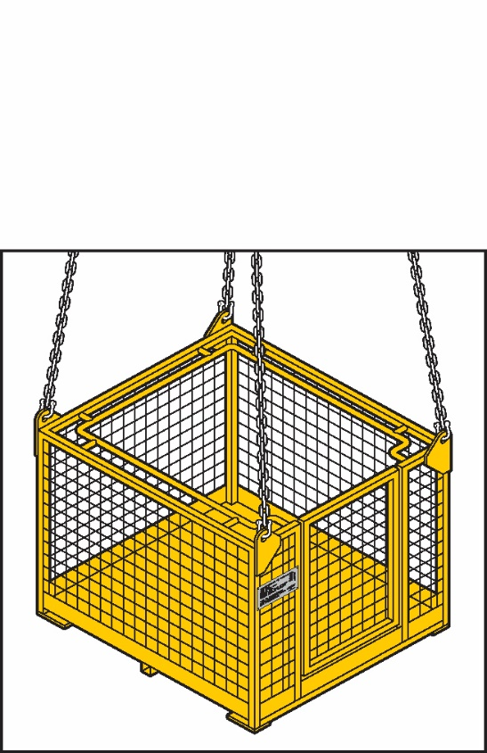](http://www.nobles.com.au/getattachment/Products/Height-Safety/Forklift-Cages-and-Workboxes/Crane-Workboxes/crane-workbox-open.jpg?maxsidesize=700)

**Figure 2** A crane-lifted first aid box**[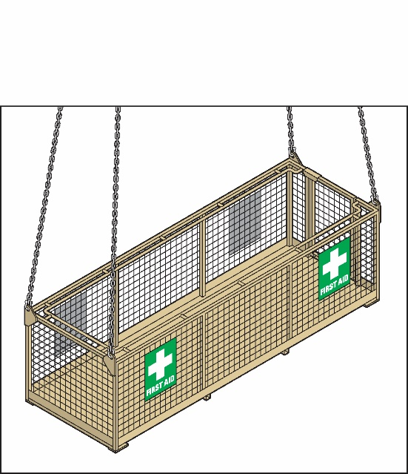](http://www.alllifting.com.au/wp-content/uploads/2014/02/First-aid-box.jpg)**

## Lifting people with plant

Plant specifically designed to lift and support people while they work should be used if they need to access an elevated work area. This can include scaffolding and elevating work platforms.

If it is not possible to use plant specifically designed to lift people, a crane-lifted work box may be used to help workers perform minor work for a short amount of time.

## Work box requirements

Work boxes must be design registered with   
the regulator. Crane-lifted work boxes should:

* have the working load limit, tare mass and design registration number clearly marked e.g. on a data plate
* have sides not less than 1 metre high
* have fall-arrest anchorage points
* be correctly tagged
* have lifting slings supplied to be attached to the lifting points by hammerlocks or moused shackles
* have a safety factor for each suspension sling of at least eight for chains and 10 for wire rope
* where provided, a door is to be inward opening only and self-closing with a latch to prevent unintentional opening, and
* first aid boxes may be provided with outward opening doors for ease of access, but doors are to be self-closing with automatic latches.

## Crane requirements

If a crane is to lift a work box the crane should:

* where practicable, be equipped with a secondary back-up system that will prevent the load from falling if the primary lifting device fails
* have a minimum rated capacity of at least twice the total load of the workbox and its contents at the maximum radius for the task to be performed and not less than 1000 kg
* be fitted with an upper hoist limit—anti-two block—that stops operation of the hoist, luff and telescope functions of the crane or be designed so two-blocking cannot damage part of the crane or lifting gear, and
* have levers and foot pedals fitted with a constant pressure system so crane motion stops immediately after the operator removes pressure from the controls.

If the crane is fitted with a free fall facility, this function should be positively locked out to prevent inadvertent activation when lifting   
a work box.

Where a crane has a brake acting directly on the drum, the braking efficiency of the hoisting drive train should be tested by hoisting and holding a load:

* equivalent to the line pull of the hoist winch, or
* not less than twice the maximum hoisted load.

If the crane will be used to lift other loads the test should be repeated before re-lifting the work box.

During operation of the crane with a work box the line pull of the hoist winch should not exceed that used in the test.

## Using crane-lifted work boxes

Crane-lifted work boxes do not provide a level of safety equivalent to properly erected scaffolding, elevating work platforms and other specifically designed access systems.

However, using a crane-lifted work box does provide a higher level of safety than using fall‑arrest systems as the primary control measure.

To help make sure people in a crane-lifted work box are safe:

* the work box must be securely attached to the crane
* full body fall-arrest harnesses should be worn at all times
* harnesses should be attached to fall-arrest anchorage points in the work box or to the main sling ring above the heads of the workers
* directions to the crane operator should only be provided from the workbox by a person holding a dogging or rigging licence
* the crane must not travel while suspending a work box
* workers remain substantially inside the work box while it is lifted or suspended, and
* emergency retrieval arrangements are put in place before the lift so workers can safely exit the work box in the event of crane failure.

## Further information

The following technical standards provide further information on work boxes and cranes:

* AS 1418.17-1996: *Cranes (including hoists and winches) Part 17: Design and construction of workboxes*, and
* AS 2550.1-2011: *Cranes, hoists and winches—Safe use Part 1: General requirements.*

For further information see the Safe Work Australia website [www.swa.gov.au](http://www.swa.gov.au).