Workplace traffic management

Guidance material

April 2021

**Disclaimer**

Safe Work Australia is an Australian Government statutory agency established in 2009. Safe Work Australia includes Members from the Commonwealth, and each state and territory, Members representing the interests of workers and Members representing the interests of employers.

Safe Work Australia works with the Commonwealth, state and territory governments to improve work health and safety and workers’ compensation arrangements. Safe Work Australia is a national policy body, not a regulator of work health and safety. The Commonwealth, states and territories have responsibility for regulating and enforcing work health and safety laws in their jurisdiction.

ISBN 978-1-74361-691-8 (Online PDF)

ISBN 978-1-74361-691-8 (Online DOCX)

**Creative Commons**

With the exception of the Safe Work Australia logo, this copyright work is licensed under a Creative Commons Attribution Non-Commercial 4.0 International licence. To view a copy of this licence, visit creativecommons.org/licenses In essence, you are free to copy, communicate and adapt the work for non-commercial purposes, as long as you attribute the work to Safe Work Australia and abide by the other licence terms.

**Contact information**

Safe Work Australia | <mailto:info@swa.gov.au> | [www.swa.gov.au](http://swa.hosts.application.enet/business-support/Communication/Documents/www.swa.gov.au)

# Contents

Contents 3

1. Introduction 4

1.1. Who should use this guide? 4

1.2. How to use this Guide 4

1.3. Who has duties under the law? 6

2. How to manage traffic risks 8

2.1. Consultation 8

2.2. The risk management process 8

2.3. Identify hazards 9

2.4. Assess the risk 10

2.5. Implement control measures 10

2.5.1. Elimination control measures 11

2.5.2. Substitution control measures 11

2.5.3. Isolation control measures 11

2.5.4. Engineering control measures 15

2.5.5. Administrative control measures 16

2.5.6. Personal protective equipment 22

2.6. Example - managing the risks of loading and unloading vehicles 22

2.7. Review your control measures 24

3. Appendix A - Traffic Hazard Checklist 25

4. Appendix B – Traffic Control Measures 28

# Introduction

This Guide provides information on how to manage traffic risks in the workplace, including where work is being conducted on or near a public road. It is supported by specific guidance material on traffic management for [shopping centres](https://www.safeworkaustralia.gov.au/doc/traffic-management-guide-shopping-centres), [construction workplaces](https://www.safeworkaustralia.gov.au/doc/traffic-management-guide-construction-work), [warehouses](https://www.safeworkaustralia.gov.au/doc/traffic-management-guide-warehousing) and [events](https://www.safeworkaustralia.gov.au/doc/traffic-management-guide-events), as well as an [Information Sheet](https://www.safeworkaustralia.gov.au/doc/information-sheet-traffic-management) for small businesses and workers.

Traffic management is the planning and control of traffic from one location to another. It is the organisation, arrangement, guidance and control of both stationary and moving traffic, including pedestrians, cyclists and all types of vehicles. Traffic management focuses on creating and managing an orderly and efficient movement of persons and goods, creating a safe environment for all users.

Traffic at a workplace includes:

* vehicles such as cars, trucks, vans and buses
* powered mobile plant such as forklifts,
* cyclists and pedestrians, and
* cattle, horses and other animals.

Traffic in and around the workplace can pose significant health and safety risks. If traffic is uncontrolled or not appropriately planned, it may collide with a person, structure, object or other vehicle or machine. Traffic collisions can lead to significant injuries and fatalities for both the driver or operator and any other person in the vicinity.

## Who should use this guide?

This Guide has been developed to assist duty holders, primarily persons conducting a business or undertaking (PCBUs), meet their duties and obligations under work health and safety (WHS) laws. You should use this Guide if work carried out as part of your business or undertaking involves a risk of traffic colliding with people, plant, objects, vehicles or structures. Such risks may arise because vehicles operate at your premises, or because work is being carried out on or near a public road, including work repairing a road or on a footpath adjacent to a road.

If work is planned to take place on or near a public road you should also contact the relevant road authority about their traffic management requirements and guidelines. You may wish to refer to Austroads’ *Guide to temporary traffic management*.

For information about traffic management at mining workplaces, you should also contact your local mining regulator.

## How to use this Guide

This Guide is intended to supplement other information available from Safe Work Australia to assist you to meet your duties and obligations under WHS laws. It should be read in conjunction with the following:

* [Model Code of Practice: *How to manage work health and safety risks*](https://www.safeworkaustralia.gov.au/doc/model-code-practice-how-manage-work-health-and-safety-risks)
* [Model Code of Practice: *Managing the risks of plant in the workplace*](https://www.safeworkaustralia.gov.au/doc/model-code-practice-managing-risks-plant-workplace)
* [Model Code of Practice: *Construction work*](https://www.safeworkaustralia.gov.au/doc/model-code-practice-construction-work)*,* and
* [Model Code of Practice: *Work health and safety consultation, cooperation and coordination*](https://www.safeworkaustralia.gov.au/doc/model-code-practice-work-health-and-safety-consultation-cooperation-and-coordination)*.*

This Guide includes references to the legal requirements under the WHS Act and WHS Regulations. These are included for convenience only and should not be relied on in place of the full text of the WHS Act or WHS Regulations.

In this Guide, the word ‘must’ indicates a legal requirement that must be complied with. The word ‘should’ indicates a recommended course of action.

## Who has duties under the law?

Everyone in the workplace has a work health and safety duty. The main duties relevant to managing risks of traffic colliding with people, plant, objects, vehicles or structures are set out below. Please be aware that a person can have more than one duty and more than one person can have the same duty at the same time.

### A person conducting a business or undertaking

A PCBU must ensure, so far as is reasonably practicable, that workers and other people are not exposed to health and safety risks arising from work carried out as part of the conduct of the business or undertaking.

This duty relevantly requires the PCBU to eliminate health and safety risks arising from traffic at a workplace, so far as is reasonably practicable, and if it is not reasonably practicable to eliminate those risks, to minimise them so far as is reasonably practicable. A workplace is any place where work is carried out for a business or undertaking and includes any place where a worker goes, or is likely to be, while at work.

A PCBU with management or control of powered mobile plant at a workplace must ensure it does not collide with any person or thing. If there is a risk of collision, the plant must have a warning device alerting persons who may be at risk from its movement.

### Designers, manufacturers, suppliers and importers

Designers, manufacturers, suppliers and importers of plant or structures must ensure, so far as is reasonably practicable, the plant or structure is without risks to health and safety. This duty includes carrying out testing and analysis as well as providing specific information about the plant or structure.

For example, structures such as buildings and roads can be designed with vehicle and pedestrian routes that are separated so workers can carry out maintenance and construction safely. Mobile plant can be designed so the operator has good vision and the plant has speed limiters and warning devices.

### Officers

Officers**,** such as company directors, have a duty to exercise due diligence to ensure the business or undertaking complies with the WHS Act and Regulations. This includes taking reasonable steps to ensure the business or undertaking has and uses appropriate resources and processes to eliminate or minimise risks from traffic at the workplace. Further information on who is an officer and their duties is available in Safe Work Australia’s guide[*: The health and safety duty of an officer*](https://www.safeworkaustralia.gov.au/doc/interpretive-guideline-model-work-health-and-safety-act-health-and-safety-duty-officer-under).

### Workers

While at work, workers have a duty to take reasonable care for their own health and safety and to not adversely affect the health and safety of other persons. Workers must comply with reasonable instructions, as far as they are reasonably able, and co-operate with reasonable health and safety policies or procedures that have been notified to workers. If personal protective equipment (PPE) is provided by the business or undertaking, the worker must so far as they are reasonably able, use or wear it in accordance with the information and instruction and training provided.

### Others

Other people at the workplace, like visitors, must take reasonable care for their own health and safety and must take reasonable care not to adversely affect other people’s health and safety. They must comply, so far as they are reasonably able, with reasonable instructions given by the PCBU to allow that person to comply with the model WHS Act.

# How to manage traffic risks

## Consultation

As a PCBU, you must consult your workers and their health and safety representatives (if any) when deciding how to manage the risks of traffic in the workplace, including when reviewing and making changes to existing processes. You should ensure there are procedures in place and encourage the reporting of safety problems, incidents and near misses.

You should ensure that relevant stakeholders are involved in the risk management process. Depending on the traffic risks identified in your workplace, this may include health and safety representatives (HSRs),representatives or operators of powered mobile plant, supervisors and any other group sharing the traffic routes and working areas of the vehicles.

Responsibilities for health and safety management must be clearly allocated. It is important each worker, contractor, subcontractor, visiting driver and other relevant people clearly understand their role in following safe work practices and taking reasonable care of themselves and others. This may involve discussing work design, processes and site-specific requirements, including entering and exiting the site, vehicle parking, delivery areas and scheduling suitable times for loading and unloading.

If there are other businesses or undertakings involved at your workplace, you must consult with them to agree on and define your roles and work together so risks are eliminated or minimised so far as is reasonably practicable.

If you have a large workplace with a high volume of traffic, or are carrying out work on or near public roads, a traffic management plan can help you plan and communicate how you are managing traffic risks. Consulting with workers on traffic management plans is ideal, however it is not always practicable as the plans are usually prepared during the project design phase and submitted for approval to the relevant road authority before the majority of workers are engaged on site.

In these situations, consultation with workers may involve providing information about the traffic management plan as well as the procedures that will be implemented for monitoring and reviewing it over the course of the project. Workers should be encouraged to provide feedback on health and safety issues relating to the implementation or update of the plan so their feedback can be considered when updating or making changes to the plan. It is important that workers report traffic hazards immediately so that risks can be managed before an injury occurs.

Further information on consultation requirements is in the [Code of Practice*: Work health and safety consultation, co-operation and co-ordination*](https://www.safeworkaustralia.gov.au/doc/model-code-practice-work-health-and-safety-consultation-cooperation-and-coordination).

## The risk management process

Risk management requires you to think about what could go wrong at your workplace and what the consequences could be. Then you must do whatever is reasonably practicable to eliminate or minimise those risks.  
  
Risk management involves four steps:

* Identify hazards—find out what could cause harm.
* Assess risks, if necessary—understand the nature of the harm that could be caused by the hazard, how serious the harm could be and the likelihood of it happening. This step may not be necessary if you are dealing with a known risk with known control measures.
* Control risks – implement the most effective control measure that is reasonably practicable in the circumstances and ensure it remains effective over time.
* Review hazards and control measures to ensure they are working as planned.

Determining what control measure/s are reasonably practicable includes consideration of the availability and suitability of control measures. Cost may also be relevant, but you must only consider this after you have assessed the extent of the risk and the available ways to eliminate or minimise the risk.

Further information on the risk management process is in the [Code of Practice*: How to manage work health and safety risks*](https://www.safeworkaustralia.gov.au/doc/model-code-practice-how-manage-work-health-and-safety-risks)*.*

## Identify hazards

Identifying hazards involves finding things and situations that could potentially cause harm to people.

The following can help you identify traffic hazards:

* Observe the workplace to identify areas where people and vehicles interact. Think about the floor plan and placement of overhead structures in your workplace, whether work is done close to public areas, when traffic volumes are higher, where potential blind spots are and if there are areas of poor visibility. Security footage may be useful if available.
* Review work tasks, design and management. Monitor types and heights of vehicles, where loading and unloading occurs and the general needs of traffic, including parking, road surface and entering and exiting the workplace.
* Ask your workers, pedestrians and visiting drivers about traffic management problems they encounter at your workplace.
* Review your incident and injury records, including near misses.

On a public road, the following may contribute to traffic hazards and should be considered:

* the proximity of the workplace, workers and any plant or machinery, to passing traffic (for example, the clearance between non-road construction sites and roads)
* site access and egress
* speed of the traffic stream passing adjacent to or through a worksite
* traffic volume and composition, including varying traffic flows, such as school drop off and pick up times and the possible sizes of vehicles expected to pass through or past the worksite
* the operating hours of the road work site and the associated temporary traffic control measures,
* geometry of the road approaching and past the work site (for example, sight distance, curve radii etc.), and
* local weather conditions (fog, heavy rain, snow etc.)

### Working at night

Work may be carried out at night due to operational requirements or because of decreased traffic volume, particularly when working on a public road. However, working at night can also introduce new hazards, including reduced visibility of the workers and worksite. When carrying out work at night, you should consider the following:

* all signs, devices, and clothing should be appropriately reflective
* traffic controllers, the worksite and the workers should be well illuminated at all times by portable floodlights, lamps, street lighting, etc.
* the light source should be angled or shielded to minimise glare to approaching traffic, and
* traffic controllers should use a luminous wand when controlling traffic.

Refer to Appendix A - *Traffic Hazard Checklist* to help you identify traffic hazards.

## Assess the risk

A risk assessment can help you determine what action to take to control the risk and how urgently the action needs to be taken.

In many cases the risks and related control measures will be well known. In other cases, you may need to carry out a risk assessment to identify the likelihood of somebody being harmed by the hazard and how serious the harm could be.

Most vehicle incidents at the workplace are from collisions between pedestrians and vehicles reversing, loading and unloading. People who work with or near vehicles are most at risk. Customers and visitors may also be at risk.

For work that is taking place on a public road, you should consider the likelihood of members of the public approaching the worksite, the number of workers on site and the proximity of people to unsafe areas, including oncoming traffic at all times of the day, including after hours.

On a public road there are significant risks of vehicles colliding with workers, including traffic controllers. This can arise through the public being unaware of the road works, or not correctly following relevant signs or directions.

Consideration should also be given to the adequacy of emergency procedures, weather conditions and the knowledge and training of the people who carry out the traffic management work.

## Implement control measures

You must consider available control measures and implement the control measure/s that most effectively eliminate or minimise the risk so far as is reasonably practicable. This may involve a single control measure or a combination of different control measures that together provide the highest level of protection that is reasonably practicable.

Detailed examples of possible control measures for risks of traffic in the workplace are set out below and at Appendix B - *Traffic control measures*.

### Consent to manage traffic

Authorisation for temporary management of traffic on public roads and the erection of certain traffic control devices is required from the relevant road authority prior to traffic control plans being implemented. This authorisation is separate to permission to access and carry out work on the public road, which will also be required from the relevant road authority.

Each road authority will have its own methods, standards and authorisation documents which should be obtained prior to work taking place.

When considering control measures such as road or footpath closures, advice and approvals should be obtained from relevant authorities, including the local council or the local police service.

## Elimination control measures

The first thing you must consider is whether a traffic risk can be eliminated, for example through the removal of powered mobile plant and other vehicles from the workplace.

Eliminating risks is often cheaper and more practical to achieve at the design or planning stage, for example designing public roads so there is no need to maintain a median strip. The best way to eliminate risk is by not introducing a hazard into the workplace. You can also eliminate risks by removing an existing hazard.

For work carried out on or near a road, you may consider whether it is practicable to eliminate traffic risks by closing the road and not allowing traffic through the worksite.

In loading and unloading zones you can eliminate the risk posed by reversing vehicles by using drive-through loading and unloading systems, multi-directional mobile plant or rotating cabins.

If elimination is not reasonably practicable, you should work through the hierarchy of control measures. The ways of controlling risks are ranked from the highest level of protection and reliability to the lowest. The hierarchy of control measures requires the highest level of control measures to be implemented first, so far as is reasonably practicable:

* substitute the hazard giving rise to the risk for something safer, for example replace forklifts with other load shifting equipment like a walker stacker
* isolate the hazard from people, for example use barriers to physically separate traffic controllers from vehicles
* use engineering control measures, such as speed limiters on mobile plant.

## Substitution control measures

Where possible, you should substitute the hazard for something safer.

For example:

* You may be able to use safer mobile plant instead of vehicles (for example, you can substitute trucks and forklifts with other load shifting equipment such as a walker stacker).
* To direct traffic in and around the workplace, you may be able to use electronic traffic control devices or traffic lights instead of traffic controllers.
* Use electronic signs rather than static signs to reduce the frequency of workers changing or covering signs.
* Use mechanical means of work where possible; such as tractors, weed sprayers and automatic cone placing trucks, instead of workers on foot.

## Isolation control measures

Isolation involves physically separating the source of harm from people by distance or using barriers. A good way to minimise risk to pedestrians is to make sure people and vehicles cannot interact.

Where powered mobile plant is used at a workplace, you must ensure it does not collide with pedestrians or other powered mobile plant.

Below are examples of isolation control measures for managing traffic risks at a workplace.

### Keeping people and vehicles apart

You can isolate pedestrians from vehicles by:

* using overhead walkways (see Figure 1)
* providing barriers or guardrails at building entrances and exits to stop pedestrians walking in front of vehicles (see Figure 2)
* providing high impact traffic control barriers (see Figure 3)
* providing temporary physical barriers (see Figure 4)
* where possible, have traffic go around the workplace, rather than through it For example, setting up a detour route or contraflow
* provide separate entries and exits for pedestrians and vehicles
* create exclusion zones e.g. forklift-only areas in loading bays or pedestrian-only areas around tearooms, amenities and entrances
* provide separate entry and exit points for large vehicles, and
* install delineation devices, for example:
  + traffic cones, temporary bollards and barrier boards (used to define the traffic path through, past or around the workplace)
  + containment fences such as tapes or mesh fencing (used to control pedestrians or to maintain clearance between the workplace and moving traffic).

### Parking

Parking may be needed for workers, visitors, trucks and other vehicles used in the workplace. Consider setting out the workplace so parking areas:

* are located away from busy work areas and traffic routes
* have walkways leading to and from parking areas which are separated from vehicles or vehicle routes, for example by using physical control measures like barriers or bollards to prevent vehicles from crossing into walking areas (see Figure 5)
* are on level ground, where possible to prevent parked vehicles from rolling by, preferably in a designated parking area with the brake firmly applied. Where this is not possible, consider installing wheel humps in parking areas to prevent vehicles from rolling
* allow drivers who are not needed during loading and unloading, safe access to amenities away from loading areas or other vehicular traffic. This will minimise their exposure to traffic and other risks, including inadvertent drive-offs, and
* have barriers, traffic lights or other stop signals where necessary so drivers are aware of when it is safe to leave. ,.
* have site access and egress designed to eliminate the interaction of plant, vehicles and people. Consider the potential risks to people and other vehicles associated with how vehicles or plant enter the parking area from a public road, particularly if entering vehicles and plant are required to slow significantly in order to safely park.

**Figure 1** Overhead walkways

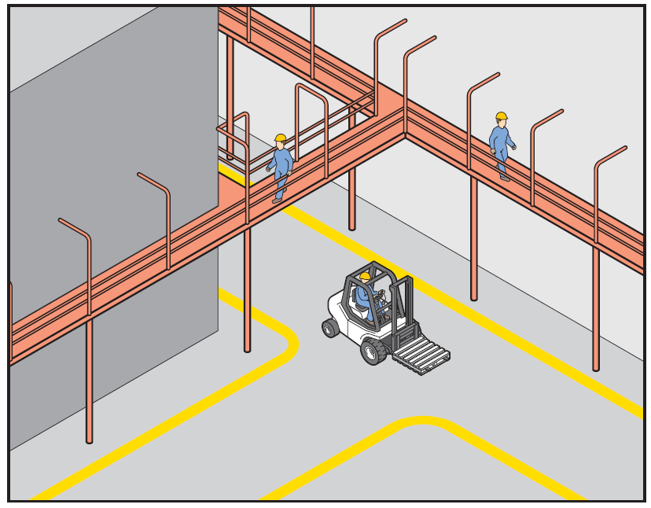

**Figure 2** Guardrail

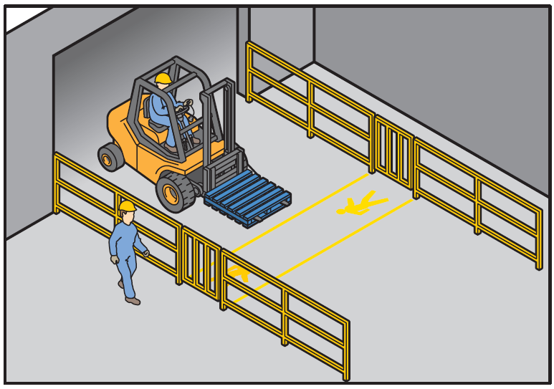

**Figure 3** High impact barrier

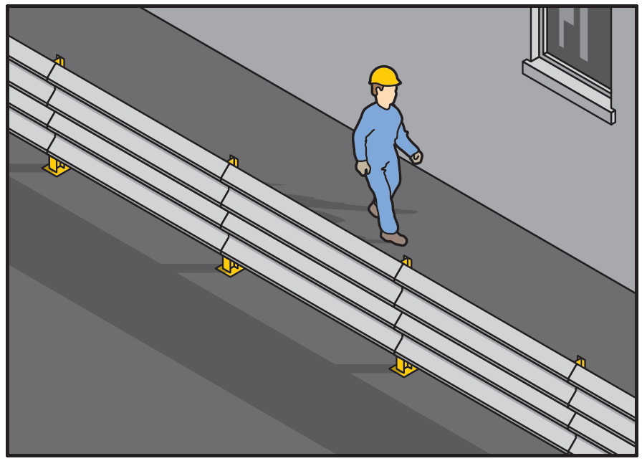

**Figure 4** Temporary physical barriers separating pedestrians from powered mobile plant

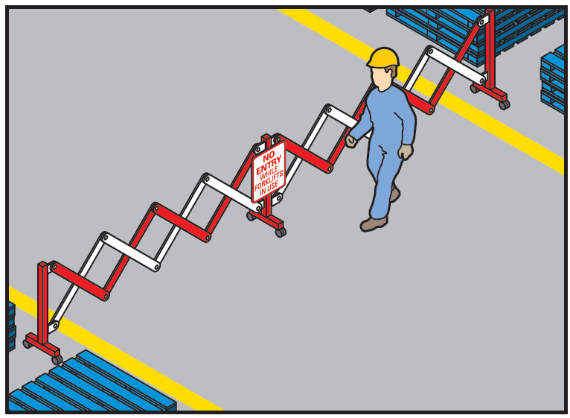

**Figure 5** Pedestrian walkway in car park

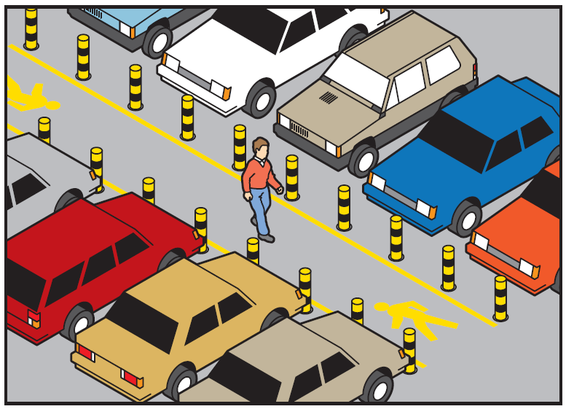

## Engineering control measures

An engineering control is a control measure that is physical in nature, including a mechanical device or process. Engineering control measures include:

* fitting vehicles with devices such as reversing sensors, reversing cameras, mirrors, speed limiting devices
* using warning devices such as signage, lights, alarms and horns on powered mobile plant
* using boom gates and proximity devices that trigger boom gates
* using gates with warning devices or traffic lights systems to guide the movement of traffic and pedestrians
* using devices like speed humps to slow vehicles down
* fitting refractive lenses on rear windows to help drivers see ‘blind spots’. Antiglare screens can also be used to reduce the light glare from work machinery and other vehicles, and
* ensuring vehicles are fitted with seatbelts and parking brakes.

### Loading and unloading

Ways to stop vehicles from moving during loading and unloading activities include using:

* vehicle or trailer restraints
* using speed-limiting devices
* braking alarms or automatic braking systems fitted to heavy vehicles to alert the driver if the brake is not applied when exiting the vehicle
* dock locks
* air brake isolation interlock devices
* systems for controlling access to vehicle keys or the cabin, and
* a combination of audio and visual warning devices like alarms, horns and flashing lights and ensuring these are working when the plant is operating.

If drivers are not needed during loading and unloading, they should be provided with safe access to amenities away from loading areas or other vehicular traffic. This will minimise their exposure to traffic and other risks, including inadvertent drive-offs.

### Public roads

On a public road, installation of detour routes can help guide the traffic around or though the workplace. Barriers and warning devices, such as lights on powered mobile plant, can be used to ensure workers and vehicles stay separated. For example, consider:

* crash barriers that physically separate the workplace from the moving traffic and provide protection for workers, for example fixed and vehicle mounted crash attenuators
* warning devices—including flashing arrows and electronic variable message signs, and
* antiglare screens to reduce the light glare from work machinery and other vehicles.

Contact your relevant road authority for advice on the installation and use of traffic control devices on a public road.

More examples of how pedestrians and vehicles can be kept apart are in Appendix B: *Traffic Control Measures**.*

## Administrative control measures

If risks remain, they should be minimised by implementing administrative control measures, so far as is reasonably practicable. Administrative control measures include work methods or procedures that are designed to minimise exposure to a hazard as well as the information, training and instruction needed to ensure workers can work safely. Administrative control measures could also include implementing speed limits, and ensuring enough time is allowed for workers to carry out their work safely.

Some administrative measures will be necessary to ensure substitution, isolation and engineering control measures are implemented effectively, for example, following safe work procedures when using equipment.

### Traffic management plan

If you have a large workplace with a high volume of traffic or are carrying out work on or near public roads, a traffic management plan can help you plan and communicate how you are managing traffic risks.

Traffic management plans should be developed by a competent person and should be tested on-site by both those who have prepared them and those who will implement them. You should ensure that the traffic management plan is available to workers onsite. A competent person means a person who has acquired through training, qualification or experience the knowledge and skills required for them carry out the work safely.

A traffic management plan should include details of:

* the duties and responsibilities of the people involved
* risks and relevant controls that are to be implemented
* the desired flow of pedestrian and vehicle movements, including the space needed for plant operators to safely get in and out of their machines
* the expected frequency of interaction of vehicles and pedestrians
* illustrations of the layout of barriers, walkways, signs and general arrangements to warn and guide traffic around, past, or through a work site or temporary hazard, and
* how short term, mobile work and complex traffic situations will be managed.

Commonly used terms for defining areas in a traffic management plan include:

* *Advance warning area –* where the advance warning signs are erected to warn and inform of changes to traffic conditions ahead on a public road to give motorists time to adjust their driving patterns.
* *Taper area* – where traffic is guided past the work area, usually by means of cones or bollards set out in a taper (for instance, tapering the left-hand lane so traffic moves into the right).
* *Safety buffer area* – the unoccupied space between the taper and work areas. Safety buffer areas are designed to compensate for driver error and protect workers by allowing errant vehicles to slow down and stop prior to the work area. This also protects road users from hazards in the work area, such as work vehicles and equipment. The length of the safety buffer area should be based on the speed limit of the road.
* *Workplace* – where the work is being undertaken and is occupied by workers, plant and material.
* *Termination area* – where traffic has cleared the work area after which normal traffic conditions resume on public road.

A traffic management plan could also set out:

* responsibilities of people managing traffic in the workplace
* responsibilities of people expected to interact with traffic in the workplace, and
* instructions or procedures for controlling traffic including in an emergency.

Traffic management plans can also outline other specific details relevant to the work being undertaken. For instance, for work on a public road, approvals may stipulate the start and finish times or day of the week the work is to be carried out. In the case of working in front of a school, the approval will usually stipulate no work before 9:30 am and all work to be finished and signage packed up by 2:30 pm.

Like all control measures, a traffic management plan should be monitored and reviewed regularly, especially following an incident, to ensure it reflects any changes to the workplace or work processes. The review should ensure that all aspects of the site operation and management of traffic, to, from, through and past the site have been considered and are appropriately addressed, and ensure the plan continues to align with the realities of the workplace.

### Safe work method statements

Traffic management plans can also be used to prepare safe work method statements (SWMS) for high risk construction work, where required.

Construction work carried out on, in or adjacent to a road or other traffic corridor and work carried out in an area where there is movement of powered mobile plant are classified as ‘high risk construction work’ under the WHS Regulations. A SWMS must be prepared before any high risk construction work commences.

The SWMS must identify the high risk construction work, specify associated hazards, describe measures to control risks, and how these will be implemented, monitored and reviewed.For example, the SWMS should set out the correct installation and use of safety barriers based on the manufacturer’s instructions, the installation and removal of signage and the carrying out of periodic inspections.

### WHS management plans

Traffic management plans and SWMS should also be incorporated in a WHS management plan for a construction project, where required.

A WHS management plan sets out the arrangements to manage the risks associated with more complex construction projects, particularly relating to the interaction and co-ordination of a number of contractors and subcontractors. The WHS management plan must include the names, positions and responsibilities of all people with a specific health and safety responsibility, and the arrangements in place for managing any health and safety incidents that occur.

Under WHS laws, a WHS management plan is required for a ‘construction project’ involving construction work that costs $250 000 or more. Each construction project will have a ‘principal contractor’ who is responsible for preparing a WHS management plan before work on the project commences. A principal contractor may be appointed by the person commissioning the construction project or will be the person commissioning the project.

Further information on the preparation of SWMS and WHS management plans is available in the [*Code of Practice: Construction Work*](https://www.safeworkaustralia.gov.au/doc/model-code-practice-construction-work)*.*

### Information, training, instruction and supervision

*Workers*

You must provide any information, training, instruction and supervision that is necessary to protect workers from risks to their health and safety, so far as is reasonably practicable. The information, training and instruction must take into account the nature of the work carried out by the worker, associated risks and measures implemented to control the risks. This includes providing relevant site specific or plant specific training before work starts. Workers who are required to perform duties associated with traffic management at the workplace must be trained to perform those duties safely.

Training must be easily understood by the worker. This may require providing information and training material in different languages.

Workers should be trained in the content of any traffic management plan, SWMS or WHS management plan, as appropriate.

WHS laws require workers to hold a licence to perform certain types of high risk work. You must not direct or allow an unlicensed worker to carry out work for which a licence is required.

*Visitors*

You must ensure so far as is reasonably practicable that everyone who has access to your workplace, including visitors, are provided with information necessary to protect them from risks to their health and safety. This may include instructions on designated safe routes, parking areas, pedestrian exclusion zones and speed limits. This could be addressed through an induction process at your workplace.

Visitors should report to the reception area or site office and be given information on the safety procedures for the workplace before they are allowed into areas where vehicles or powered mobile plant are used. Escort or supervise visitors where needed, as they may be unfamiliar with the layout of the workplace and any potential hazards.

*Traffic controllers*

Traffic controllers have a responsibility to carry out traffic control in accordance with the requirements of the relevant road authority. The requirements for training and accreditation of traffic controllers should be confirmed with the relevant authority as these may differ between jurisdictions.

### Vehicle and pedestrian routes

Examples of administrative control measures for vehicle and pedestrian routes include:

* providing separate, clearly marked footpaths or walkways. For example, using lines painted on the ground or different coloured surfacing (see Figure 6), and
* not allowing vehicles in pedestrian spaces or not allowing pedestrians in areas where vehicles operate.

Pedestrian routes and intersections should be clearly marked, unobstructed, well maintained and well lit.

Vehicle routes at the workplace should have a firm and even surface, be wide and high enough for the largest vehicle using them and be well maintained and free from obstructions. They should be clearly sign-posted to indicate speed limits, traffic calming measures like speed humps and parking areas.

**Figure 6**Walkway marked with lines and bollards

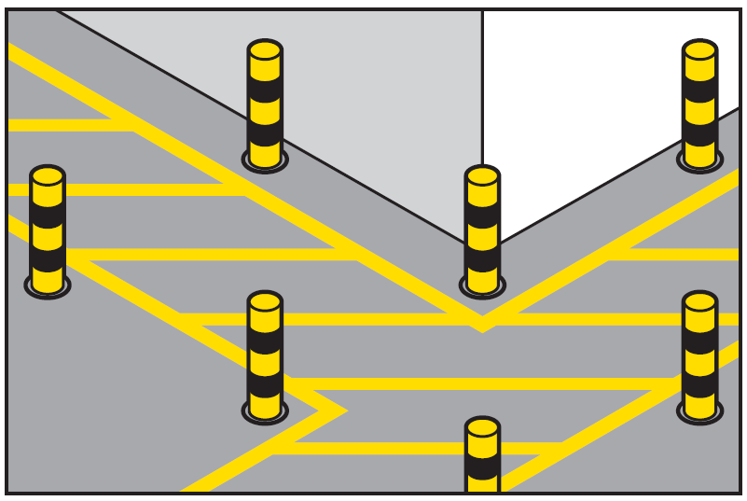

More examples of how vehicle routes can be managed safely are in the *Traffic control measures* checklist at Appendix B.

### Road detour signage

On a public road, installation of detour routes should typically be undertaken in the following order:

* first install the last sign that vehicles will see (that is the sign at the end of the detour), and
* install the remaining signs working back toward the beginning of the detour.

This procedure allows vehicles to detour only after all the signs are in place. Alternatively, the signs can be placed one by one and covered until ready for use, where they are uncovered in the above sequence.

The detour route should be driven to ensure it is suitable for the expected traffic volume and type of vehicles to be detoured.

Removal should be undertaken in the following steps:

* first remove the sign at the beginning of the detour route, and
* remove all other signs in the direction of the flow of traffic.

### Reversing vehicles

Administrative control measures for managing the risks of reversing vehicles include:

* using a competent person to direct the reversing vehicle if they cannot see clearly behind—this person should be in visible contact with the driver at all times and wear high-visibility clothing, and
* providing designated clearly marked, signposted and well-lit reversing areas.

### Speed management

Temporary speed zones may be implemented where the consequence of speed through a work zone is not apparent to drivers and operators of plant and, therefore, they are unlikely to reduce speed to a safer level.

Like other administrative control measures, reducing speed should only be used as a way to supplement higher level control measures, as a short term interim measure until a more effective way of controlling the risk can be used, or as a last resort where no other practical control measures are available. Variations to speed limits should be clearly signposted.

On a public road, reductions in the speed limit should be made in steps depending on the difference between the existing approach road speed limit and the required work zone speed limit. Ensure you check with your relevant road authority for how to implement speed limit changes.

The speed limit selected for the work zone depends on the several factors. These include the degree of vehicular and pedestrian conflict, the type and extent of the work in progress, the characteristics of the road, and the lateral separation between workers and the passing trafficable lanes.

To be effective, work zone speed limits should:

* not be used in place of more effective means of traffic control, rather they should be used in combination with such control measures
* be used in conjunction with other signs or devices required by the specific site conditions (such as temporary speed humps or rumble strips), and
* only be used while work is being undertaken or temporary road conditions exist that are prejudicial to safety.

Approval from the relevant road authority is required when changing speed limits on a public road.

### Signs and road markings

Clear road markings like reflective paint and signs should be used to alert pedestrians and vehicle operators to traffic hazards in the workplace.

Signs should be provided to indicate exclusion and safety zones, parking areas, speed limits, vehicle crossings and hazards like blind corners, steep gradients and where forklifts are in use. Traffic controllers may also use STOP/SLOW bats to provide instructions to traffic going through or past the workplace.

Signs and road markings should be installed before work commences at a worksite. They should be regularly checked and maintained so they are in good condition and can be easily seen.

Traffic management includes the use of signs for the:

* protection of workers
* provision of adequate warning of changes in surface condition and the presence of workers or plant engaged in work on the road
* adequate instruction of road users and their safe guidance through, around or past the worksite, and
* safe access and egress to and from the worksite.

Traffic management should be suitable for traffic operations overnight, and on a public road all traffic management measures should be removed or covered when they are no longer applicable or required.

You should refer to your relevant road authority for any specific requirements relating to the dimensions, standards, use and positioning of signs, barriers and other traffic control devices on a public road.

#### Installation of signs

On a public road, signs should be installed in the following order:

* advance warning and regulatory signs in the advance warning area
* all intermediate advance warning and regulatory signs and devices required in advance of the taper or start of the workplace
* all delineating devices required to form the taper, including illuminated flashing arrow signs at the end of the taper
* delineation of the work area or a side track, and
* all other required warning and regulatory signs including termination and end of temporary speed zones signs.

Inspect the work zone by performing a drive through inspection and observe motorists driving through the work zone to look for trends in motorist difficulty in manoeuvring through the work zone. Document the observations and correct any deficiencies.

Signs should be placed in clear sight of road users and not positioned in a manner that causes obstruction of other signs or presents a mixed message. If multi-message signs are used in place of multiple single signs, the suitability of the multi-message signs should be confirmed with the relevant road authority prior to implementing the traffic control on-site.

Signs should face towards approaching traffic approximately at right angles to the road users’ lines of sight. At curved alignments, the sign should be placed approximately at right angles to the line of sight of a motorist 50 m in advance of the sign.

A work vehicle with a flashing arrow or flashing lights should be positioned between the works and approaching traffic during placement of traffic control devices. The work vehicles should travel in the direction of normal traffic flow.

Signs and devices that are erected before they are required should be covered so the sign message cannot be seen by road users and the cover only removed immediately prior to commencement of work.

The location of signs and devices, as specified by any traffic control plans or diagrams, may not be possible in certain situations depending on local constraints. In these circumstances, judgement on site is required in placing the signs and devices appropriately and as close to the spacing recommended on approved traffic control plans.

#### Removal of signs

Traffic control signs should be removed in the reverse order they were erected starting from the workplace and moving out towards the approaches.

The delineating devices such as cones and bollards should be removed by positioning a work vehicle between the workers and the approaching traffic and slowly reversing along the closed roadway allowing workers to remove the traffic control devices.

Placing an ‘advanced warning vehicle’ between the workers and approaching traffic should be considered when removing barrier boards from lane closures.

At sites where it is difficult to install and remove traffic control signs and devices due to traffic conditions, traffic volume, shoulder width or road alignment, special arrangements to complement the general principles of installation and removal of these signs and devices should be given consideration in order to maintain worker safety.

In some situations, vehicles may be required to move in a forward direction and signs and devices removed in the same order they were installed. In this situation care needs to be taken to ensure the safety of workers and approaching road users.

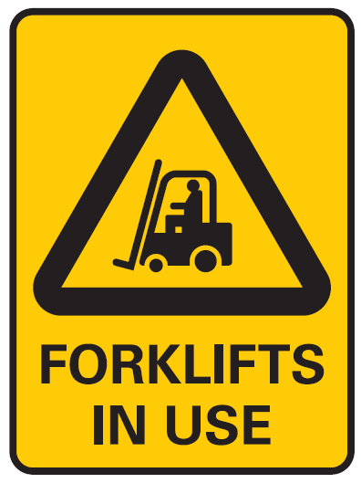The figure shows a PEDESTRIANS PROHIBITED sign.

### Lighting

Traffic routes, manoeuvring areas and yards should be well lit with particular attention given to junctions, buildings, walkways and vehicles routes. Where possible they should be designed to avoid extreme light variation, for example drivers moving from bright into dull light or vice versa.

## Personal protective equipment

Any remaining risks should be minimised with suitable personal protective equipment (PPE). For managing traffic hazards, high-visibility vests should be worn so that workers are easily visible in the workplace.

A worker must, so far as reasonably able, use or wear the PPE in accordance with any information, training or reasonable instruction and must not intentionally misuse or damage the equipment.

## Example - managing the risks of loading and unloading vehicles

An example of how control measures across the hierarchy of controls can be combined to manage the risks of loading and unloading vehicles is below (figure 7).

**Figure 7** Example of traffic control measures for truck loading and unloading

| Figure 7 shows examples of traffic control measures for truck loading and unloading including a designated pedestrian walkway protected by physical barriers; a pedestrian exclusion zone; a driver/pedestrian safety zone; a beam from a pedestrian-sensing device; barriers and bollards and warning lights activated by pedestrian sensors. | Clearly designated pedestrian walkway protected by physical barriers with staggered barriers to control approaching pedestrians.  Pedestrian exclusion zone has been established for a distance equal to the height of the load from the ground, plus an additional allowance for the type of load.  Beam from pedestrian-sensing device.  Barriers, bollards, witches hats or paint marking the pedestrian exclusion zone.  Warning light activated by pedestrian sensors.  Establish a safety zone for the driver and other pedestrians. The driver should be in full view of the forklift operator. Stop the loading and unloading activities if the driver cannot be seen or needs to enter the exclusion zone. Alternatively, if it is safe to do so, the system of work can provide for the driver to stay in the cabin during loading and unloading. Effective communication systems between the plant operator and the driver should be used such as a system of hand signals or two-way radios. |
| --- | --- |

## Review your control measures

Managing risks is an ongoing process that needs attention over time. You must regularly review control measures to ensure they are working as planned and remain effective. You should update any traffic management plan, SWMS or WHS management plan accordingly.

Where work is being carried out on or near a public road, you should review control measures if traffic conditions change on that road.

# Appendix A - Traffic hazard checklist

This checklist can help you identify potential traffic hazards at your workplace. Traffic hazards generally come from powered mobile plant and other vehicles interacting with pedestrians.

| **CONSIDER THE FOLLOWING** | **Yes** | **No** | **Comments / Action** |
| --- | --- | --- | --- |
| **Work areas where vehicles are used** |  |  |  |
| Have you asked your workers, other pedestrians and visiting drivers about traffic management problems they encounter at your workplace? |  |  |  |
| Have you reviewed your incident and injury records including near misses? |  |  |  |
| Have you checked the floor plan of your workplace? Sketching the layout of the workplace can also help. |  |  |  |
| Are there physical barriers to stop vehicles and pedestrians interacting? |  |  |  |
| Are routes wide enough to separate vehicles and pedestrians? |  |  |  |
| Are there locations with potential for collisions with other vehicles or pedestrians?  For example:   * intersections and bottleneck areas around driveways and entrances * ‘blind’ or convex corners. |  |  |  |
| Is collision with stationary objects by vehicles possible?  For example, overhead structures, stationary plant or stored or discarded items.   * Can the objects be removed? * Can the object be isolated from all traffic routes? |  |  |  |
| Do vehicles queue in a way that could create risks to pedestrians, other vehicles or things?  For example, crossing walkways or obstructing people’s view of vehicles. |  |  |  |
| Are vehicles used close to public areas?  For example, footpaths and reception areas. |  |  |  |
| Are workers and other pedestrians safe from vehicles when, for example:   * hitching and unhitching trailers * carrying out maintenance * getting on and off mobile plant * securing loads? |  |  |  |
| **Work environment** |  |  |  |
| Does the physical environment have any impact on traffic risks?  For example:   * road surfaces * poor drainage and flooding * lighting levels and visibility, and * shade and light glare at different times of day? |  |  |  |
| Are there any other hazards specific to your workplace that may have an impact on traffic risks? |  |  |  |
| **Pedestrian routes** |  |  |  |
| Can interaction between vehicles and pedestrians be eliminated or minimised?  Consider mapping how often and where interaction occurs. |  |  |  |
| Is there security footage that can be reviewed to identify areas where pedestrians and vehicles interact? |  |  |  |
| Are pedestrian routes designed so pedestrians will not take short cuts?  Is there adequate lighting? |  |  |  |
| Is the workplace safe and accessible for people with a disability?  For example, ramps for people and forklifts are separate. |  |  |  |
| What other hazards could arise along pedestrian routes?  For example, stationary objects, noise, airborne chemicals, falls from height or falling objects. |  |  |  |
| Are workers and other pedestrians aware of the hazards?  Are there procedures in place to manage risks?  For example, site induction training, signage and traffic controllers. |  |  |  |
| Are contractors and visitors to the site supervised? |  |  |  |
| **Work schedules** |  |  |  |
| Have you reviewed when traffic volumes are higher?  For example, pick-up and delivery times and vehicles arriving and leaving.  Or when people are moving around the workplace?  For example, break times and the ends of shifts. |  |  |  |
| Can work be scheduled to minimise interaction between vehicles and pedestrians?  For example, loading and unloading at night, before businesses open or when people leave the work area like during meal breaks for manufacturing process lines. |  |  |  |

# Appendix B – Traffic control measures

This checklist can help you implement effective control measures in your workplace.

| **CONSIDER THE FOLLOWING** | **Yes** | **No** | **Comments / Action** |
| --- | --- | --- | --- |
| **Isolation controls** |  |  |  |
| Are separate entries and exits provided for vehicles  and pedestrians including visitors? |  |  |  |
| Do the entries and exits protect pedestrians from  being struck by vehicles? |  |  |  |
| Does the layout of the workplace effectively separate pedestrians, vehicles and powered mobile plant? |  |  |  |
| Are systems in place to keep pedestrians and moving vehicles or plant apart like physical barriers, exclusion zones and safety zones? |  |  |  |
| **Vehicle routes** |  |  |  |
| Are the roads and pathways within the workplace suitable for the types and volumes of traffic? |  |  |  |
| Are loading zones clearly marked? |  |  |  |
| Do vehicle route designs take into account vehicle characteristics under all conditions, for example emergency braking, running out of fuel or adverse weather? |  |  |  |
| Are there enough parking places for vehicles  and are they used? |  |  |  |
| Are traffic directions clearly marked and visible? |  |  |  |
| If a one way system is provided for vehicle routes  within the workplace is it properly designed,  signposted and used? |  |  |  |
| Are vehicle routes wide enough to separate vehicles  and pedestrians and for the largest vehicle using them? |  |  |  |
| Do vehicle routes have firm and even surfaces? |  |  |  |
| Are vehicle routes kept clear from obstructions  and other hazards? |  |  |  |
| Are vehicle routes well maintained? |  |  |  |
| Do vehicle routes avoid sharp or blind corners? |  |  |  |
| **Pedestrian routes** |  |  |  |
| Are pedestrian walkways separated from vehicles? |  |  |  |
| Where necessary are there safe pedestrian  crossings on vehicle routes? |  |  |  |
| Is there a safe pedestrian route which allows  visitors to access the site office and facilities? |  |  |  |
| Are pedestrian walkways clearly marked? |  |  |  |
| Are pedestrian walkways well maintained? |  |  |  |
| **Vehicle movement** |  |  |  |
| Have drive-through, one-way systems been used  to reduce the need for reversing? |  |  |  |
| Are non-essential workers excluded from areas  where reversing occurs? |  |  |  |
| Are vehicles slowed to safe speeds, for example speed limiters on mobile plant or chicanes on vehicle routes? |  |  |  |
| Do drivers use the correct routes, drive within the  speed limit and follow site rules? |  |  |  |
| **Signs** |  |  |  |
| Are there speed limit signs? |  |  |  |
| Are there clear warnings of powered mobile  plant hazards? |  |  |  |
| Is there clear signage of pedestrian and powered  mobile plant exclusion zones? |  |  |  |
| Is there enough lighting to ensure signs are visible, particularly at night? |  |  |  |
| **Warning devices** |  |  |  |
| Are flashing lights, sensors and reversing alarms installed on powered mobile plant? |  |  |  |
| **Information, training and supervision** |  |  |  |
| Do powered mobile plant operators have relevant high risk work licences? Are they trained in operating the particular model of plant being used? |  |  |  |
| Are traffic controllers appropriately trained and qualified? |  |  |  |
| Have workers received site specific training and information on traffic hazards, speed limits, parking  and loading areas? |  |  |  |
| Is information and instruction about safe movement around the workplace provided to visitors and external delivery drivers? |  |  |  |
| Is the level of supervision sufficient to check  traffic movement and ensure safety of pedestrians  and drivers? |  |  |  |
| **Personal Protective Equipment** |  |  |  |
| Is PPE like high visibility clothing provided  and used where necessary? |  |  |  |
| **Vehicle safety** |  |  |  |
| Have vehicles and powered mobile plant been  selected which are suitable for the tasks to be done? |  |  |  |
| Do vehicles have direct visibility or devices for improving vision like external and side mirrors  and reversing sensors? |  |  |  |
| Are vehicles fitted with effective service  and parking brakes? |  |  |  |
| Do vehicles and powered mobile plant have  seatbelts where necessary? |  |  |  |
| Is there a regular maintenance program for all  vehicles and powered mobile plant? |  |  |  |
| Is there a system for reporting faults on all vehicles  and powered mobile plant? |  |  |  |
| Do drivers carry out basic safety checks before  using vehicles and powered mobile plant. E.g. daily pre-operational checks and log-books? |  |  |  |
| Are there any other control measures that should  be implemented to manage risks at your workplace? |  |  |  |