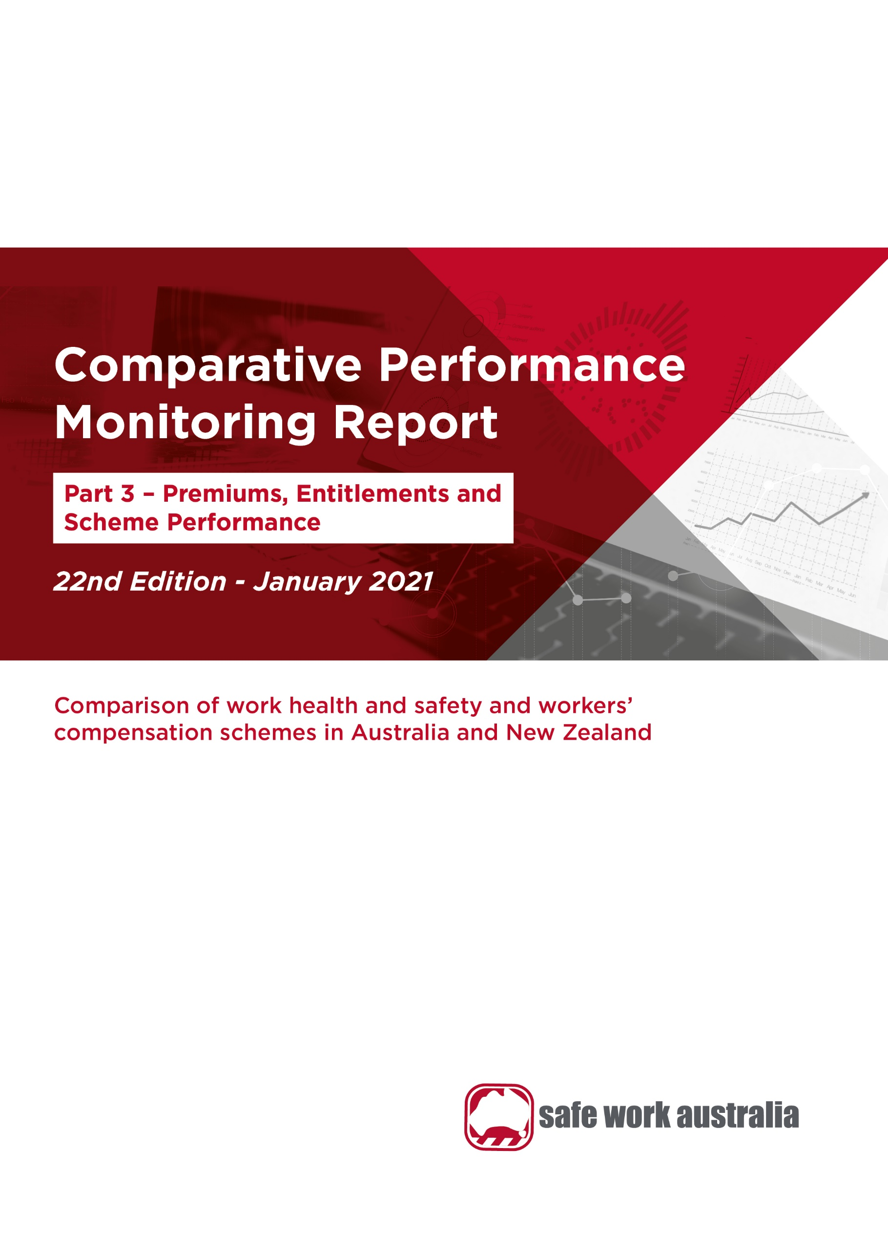4

Disclaimer

Safe Work Australia is an Australian Government statutory agency established in 2009. Safe Work Australia includes Members from the Commonwealth, and each state and territory, Members representing the interests of workers and Members representing the interests of employers.

Safe Work Australia works with the Commonwealth, state and territory governments to improve work health and safety and workers’ compensation arrangements. Safe Work Australia is a national policy body, not a regulator of work health and safety. The Commonwealth, states and territories have responsibility for regulating and enforcing work health and safety laws in their jurisdiction.

**ISSN 2209-9158**

Creative Commons

With the exception of the Safe Work Australia logo, this copyright work is licensed under a Creative Commons Attribution 4.0 International licence. To view a copy of this licence, visit creativecommons.org/licenses. In essence, you are free to copy, communicate and adapt the work, even commercially, as long as you attribute the work to Safe Work Australia and abide by the other licence terms.

Contact information

Safe Work Australia | <mailto:info@swa.gov.au> | [www.swa.gov.au](http://www.swa.gov.au)

Contents

Foreword 5

1. Workers’ compensation premiums 9

1.1 Standardised average premium rates by jurisdiction 9

1.2 Standardised average premium rates by industry 10

2. Entitlements under workers’ compensation 23

2.1 Temporary impairment 23

2.2 Permanent impairment 25

2.3 Workplace fatality 25

3. Workers’ compensation scheme performance 27

3.1 Assets to liabilities ratio 27

3.2 Scheme expenditure 29

3.3 Current return to work 32

3.4 Disputation rate 33

3.5 Dispute resolution 34

Appendix 1 — Explanatory notes 37

Premium rates and entitlements 37

Return to work data 40

Assets to liabilities ratio (funding ratio) data 41

Scheme expenditure data 42

Appendix 2 — Key features of Australian workers’ compensation schemes 43

Appendix 3 – Jurisdictional contact information 47

Indicators

Indicator 13 – Standardised average premium rates by jurisdiction ……..……………………….………10

Indicator 14 – Australian average premium rates by industry …………..…..…………….………….……11

14a Agriculture, forestry and fishing by jurisdiction……………………………………….…………...12

14b Mining by jurisdiction …………………………………………………….……………..….….……13

14c Manufacturing by jurisdiction……………………..………………………………………..…...…..13

14d Electricity, gas, water and waste services by jurisdiction…………………………….…..……....14

14e Construction by jurisdiction…………………………………………………………..……..…....…14

14f Wholesale trade by jurisdiction…………………………………………………………..…….…...15

14g Retail trade by jurisdiction…………………………………………………………………..….…...15

14h Accommodation and food services by jurisdiction………………………………………...………16

14i Transport, postal and warehousing by jurisdiction………………………………………...………16

14j Information, media and telecommunications by jurisdiction………………………………..…….17

14k Financial and insurance services by jurisdiction……………………………………………..……18

14l Rental, hiring and real estate services by jurisdiction…………………………………...…..……18

14m Professional, scientific and technical services by jurisdiction………………………………..…..19

14n Administrative and support services by jurisdiction…………………………………………..…..20

14o Public administration and safety by jurisdiction……………………………………………..….20

14p Education and training by jurisdiction…………………………………………………………....21

14q Healthcare and social assistance by jurisdiction………………………………………………..21

14r Arts and recreation services by jurisdiction…..……….…………………………………………22

14s Other services by jurisdiction……………………………………………………………………..22

Indicator 15 – Average percentage of pre-injury earnings for selected periods of incapacity, as at 1 January 2019…………………………………………………………………………………..…....24

Indicator 16 – Entitlements for permanent incapacity or fatality as at 1 January 2019……………....26

Indicator 17 – Standardised ratio of assets to net outstanding claim liabilities for centrally funded (CF) schemes …………………………………………………………………………………………………..…28

Indicator 18 – Standardised ratio of assets to net outstanding claim liabilities for privately underwritten (PU) schemes …………………………………………………………………………………………..…...28

Indicator 19 – Scheme expenditure ………………………………………………………………..……...30

Indicator 20 – Direct compensation payments by type and jurisdiction, 2018–19 …………….……..32

Indicator 21 – Current return to work rate for 2012, 2014, 2016 and 2018 ……………………………..33

Indicator 22 – Proportion of claims with dispute …………………………………………………………..34

Indicator 23 – Percentage of disputes resolved within selected time periods (cumulative) …………………………………………………………………………………………………………………36

Foreword

The Comparative Performance Monitoring (CPM) reports provide trend analyses about work health and safety (WHS) and workers’ compensation schemes operating in Australia and New Zealand. This is the 22nd annual report of the CPM project.

The CPM is complemented by the:

* [*Australian Workers’ Compensation Statistics*](https://www.safeworkaustralia.gov.au/collection/australian-workers-compensation-statistics) report, which provides more detailed analyses of national workers’ compensation data using key variables such as occupation, industry, age and gender with supporting information on the circumstances surrounding work-related injury and disease occurrences.
* [*Comparison of Workers’ Compensation Arrangements in Australia and New Zealand*](https://www.safeworkaustralia.gov.au/collection/comparison-workers-compensation-arrangements-australia-and-new-zealand), which discusses the way that each scheme deals with key aspects such as coverage, benefits, self‑insurance, common law and dispute resolution.

These publications can be found on the [Safe Work Australia](https://www.safeworkaustralia.gov.au/) website.

# Statement of purpose

The role of the CPM report is to facilitate improvement of work health and safety, workers’ compensation and related service outcomes in Australian and New Zealand schemes through an accessible report that:

1. monitors the comparative performance of jurisdictions over time, and
2. enables benchmarking across jurisdictions and the identification of best practice to support policy making.

# Data

For this report, jurisdictions supplied data for the 2018–19 financial year and provided updated data back to 2014–15.

Data in this publication may differ from jurisdictional annual reports due to the use of different definitions and the application of adjustment factors to aid in the comparability of data. Explanatory commentary on the data items is contained within each chapter with additional information included in Appendix 1 – Explanatory Notes.

The data in this report were collected from:

* workers’ compensation schemes and WHS authorities as follows:
  + New South Wales — State Insurance Regulatory Authority; SafeWork NSW; icare; NSW Workers’ Compensation Commission.
  + Victoria — WorkSafe Victoria
  + Queensland — Office of Industrial Relations
  + Western Australia — Department of Mines, Industry Regulation and Safety, WorkSafe and WorkCover WA
  + South Australia — ReturnToWorkSA and SafeWork SA
  + Tasmania — WorkSafe Tasmania and WorkCover Tasmania
  + Northern Territory — NT WorkSafe, Department of the Attorney-General and Justice
  + Australian Capital Territory — WorkSafe ACT
  + Australian Government — Comcare
  + Seacare — Seacare Authority (Seafarers Safety, Rehabilitation and Compensation Authority), and
  + New Zealand — Accident Compensation Corporation and WorkSafe New Zealand
* the National Data Set for Compensation-based Statistics and the Work-related Traumatic Injury Fatalities data set compiled by Safe Work Australia. Further information on these data sets can be found on the [Safe Work Australia](https://www.safeworkaustralia.gov.au/statistics-and-research/statistics/statistics) website
* the Return to Work Survey that replaced the Return to Work Monitor previously published by the Heads of Workers’ Compensation Authorities. The full results can be accessed at the [Safe Work Australia](https://www.safeworkaustralia.gov.au/collection/national-return-work-survey-2018) website, and
* the Australian Bureau of Statistics (ABS) which provides estimates of the number of employees and hours worked based on the Labour Force Survey, the Survey of Employment and Earnings and data provided by Comcare. Further adjustments are made using data from the Census, the Forms of Employment Survey and the Survey of Employment Arrangements, Retirement and Superannuation.

The CPM report (Part 2) does not currently include any information on compliance and enforcement activities relating to the mining industry, including the offshore petroleum industry. This is to ensure jurisdictional data are comparable, as not all jurisdictions’ WHS authorities conduct these activities. Rather they are in some cases conducted by separate specific agencies.

The CPM also does not currently include information or data from a range of other industry specific regulators that have responsibilities with respect to WHS and workers’ compensation. These include national industry based regulators with compliance and enforcement roles such as the National Heavy Vehicle Regulator, the National Rail Safety Regulator and the National Offshore Petroleum Safety and Environmental Management Authority, and other agencies with responsibility for industry‑specific compensation claims. Further information on these regulators can be found on their respective websites.

# Coordination

This report has been compiled and coordinated by Safe Work Australia with assistance from representatives of all work health and safety and workers’ compensation authorities in Australia and New Zealand. Through a partnership of governments, employers and employees, Safe Work Australia leads the development of national policy to improve WHS and workers’ compensation arrangements across Australia.

In this report the name ‘Australian Government’ is used for indicators relating to the Australian Government jurisdiction in WHS and workers’ compensation matters, while ‘Comcare’ is used for the indicators relating to premium rates and entitlements.

This image contains the first set of key findings for CPM 22 – Part 3.
The key findings include a five per cent decrease in workers' compensation premium rates between 2014-15 and 2018-19, a 4 per cent decrease in the average funding ratio for centrally funded schemes between 2014-15 and 2018-19, and a 2 per cent decrease in the average funding ratio for privately under-written schemes between 2014-15 and 2018-19.  Total payments made by Australian schemes total $8.9 billion.

This image contains the second set of key findings for CPM 22 – Part 3
The key findings include that 82 per cent of injured workers in Australia returned to work in 2018 (compared to 80 per cent in New Zealand); the disputation rate for Australian workers' compensation disputes in 2018-19 was 4.7% (a 22 per cent decrease since 2014-15) and 61 per cent of disputes in 2018-19 were resolved within three months.

1. Workers’ compensation premiums

Workers’ compensation is a compulsory form of insurance for all employers in Australia. It provides protection to employees if they suffer a work-related injury or disease. Workers’ compensation premiums are paid by employers for this insurance, with the premium generally determined based on the amount of wages paid, as well as the industry and claim history of the employer.

The premium rates in this chapter are for policies that provided coverage during the financial years 2014–15 to 2018–19. The premium rates reported are ‘earned premium’. Earned premium is defined as the amount allocated for cover in a financial year from premiums collected during the previous and current financial years, while written premium is defined as the amount of premium recorded for a policy at the time it is issued. The premiums reported are allocated for defined periods of risk, irrespective of when they were actually paid, enabling rates to be compared for each financial year. Goods and Services Tax charged on premiums is not included in the reported rates as most Australian employers recoup part or all of this tax through input tax credits.

Standardised average premium rates by jurisdiction

*About average premium rates*

The standardised average premium rates reported in this edition are different to the rates published in previous CPM reports due to:

* updates of the premium rates adjustment factors based on workers’ compensation data, and
* use of the *Australian and New Zealand Standard Industrial Classification (ANZSIC) 2006* instead of ANZSIC 1993

Premium rates published also vary to those published by the jurisdictions as adjustments are made to the data to enable jurisdictional comparisons. To increase comparability, adjustments have been applied to this indicator including:

* the exclusion of provision for coverage of journey claims
* the inclusion of self-insurers
* the inclusion of superannuation as part of remuneration, and
* the standardisation of non-compensable excesses imposed by each scheme.

The effect of each of these adjustments is shown in Appendix 1 – Table 2: Effect of adjustment factors on premium rates in 2018–19, in the Explanatory Notes.

To be consistent with Australian jurisdictions, the New Zealand premium information includes the levy on employers to fund the workers’ compensation portion of the ‘Residual Claims Account’. This account relates to workers’ compensation claims incurred prior to 1 July 1999 but excludes the liability for pre-1992 non‑work injuries for earners.

Information about jurisdictional workers’ compensation arrangements is available from the *Comparison of Workers’ Compensation Arrangements in Australia and New Zealand* publication that can be found on the [Safe Work Australia](https://www.safeworkaustralia.gov.au/collection/comparison-workers-compensation-arrangements-australia-and-new-zealand) website.

Standardised average premium rates

Indicator 13 shows that the standardised Australian average premium rate was 1.27% of payroll in 2018−19, slightly higher than the previous financial year (1% increase).

Indicator 3 – Standardised average premium rates (including insured and self-insured sectors) by jurisdiction

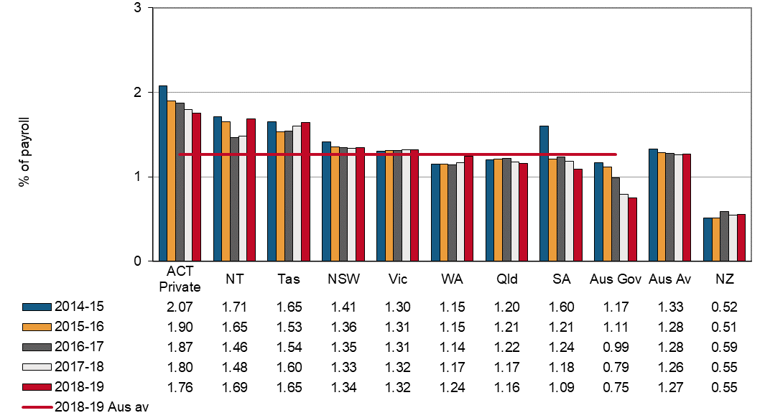

The Australian Capital Territory scheme recorded the highest premium rate in 2018–19 (1.76% of payroll). This was followed by the Northern Territory (1.69% of payroll) and Tasmania (1.65% of payroll). South Australia recorded an 8% decrease in their premium rate in 2018–19 compared with previous year, followed by Comcare who recorded a 5% decrease.

Comcare recorded the lowest premium rate among all Australian jurisdictions at 0.75% of payroll. The South Australian scheme recorded the second lowest premium rate at 1.09% of payroll in  
 2018–19, followed by Queensland at 1.16% of payroll.

The New Zealand standardised average premium rate was 0.55% of payroll in 2018–19; similar to that for the previous financial year. This rate continues to be substantially lower than the rate recorded for Australia. One reason for the lower rate in New Zealand is that the New Zealand scheme does not provide coverage for the same range of mental health conditions as the Australian schemes.

Standardised average premium rates by industry

The average premium rates by industry in Australia for the period from 2014–15 to 2018–19 are shown in Indicator 14 below. The Agriculture, forestry and fishing industry recorded the highest average premium rate at 3.52% of payroll in 2018–19. The lowest premium rate was recorded by the Financial and insurance services industry at 0.23% of payroll.

Premium rates of 14 out of the 19 industries have decreased since 2014–15. The largest percentage decrease was recorded by the Financial and insurance services industry (down 43%), followed by Rental, hiring and real estate services (down 22%) and Public administration and safety (down 18%).

Indicator 14 – Australian average premium rates by industry

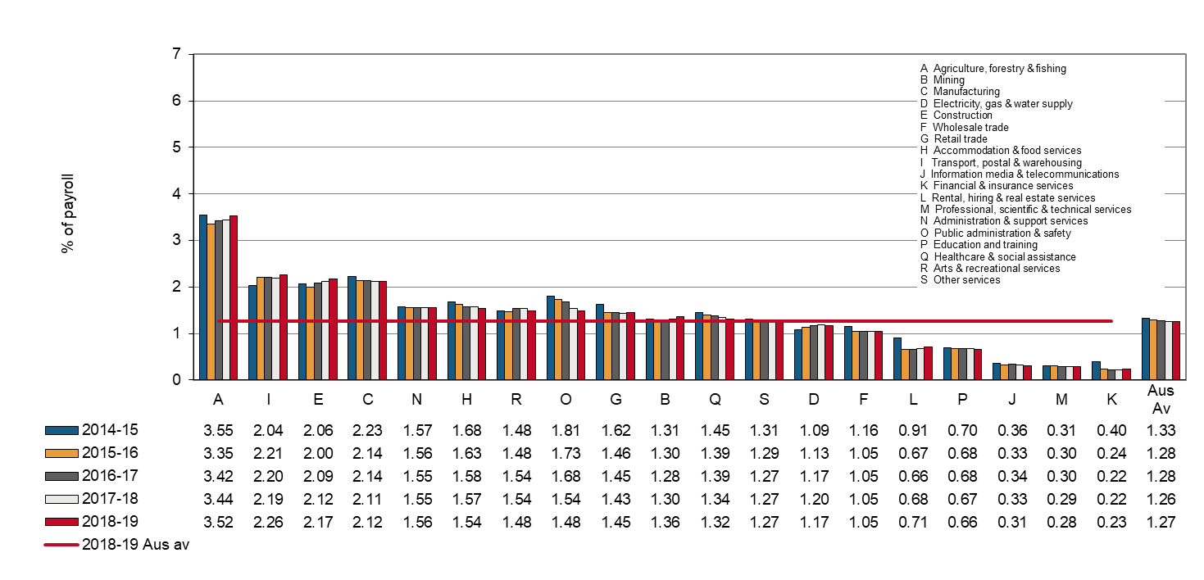

Standardised average premium rates by industry and jurisdiction

This section contains supplementary information to Indicator 14 – Australian average premium rates by industry. Presented below is a comparison of standardised average premium rates across the Australian jurisdictions for each of the 19 industry groups. Not all jurisdictions are included under each industry, as some industries will not be relevant for particular jurisdictions, particularly Comcare.

# Agriculture, forestry and fishing

In 2018–19 the standardised Australian average premium rate for Agriculture, forestry and fishing industry was 3.52% of payroll and was the highest average premium rate recorded across all industries (Indicator 14a). Three out of eight Australian jurisdictions showed a decrease in premium rates in this industry in 2018−19 compared to the previous financial year, with the largest decrease observed in the South Australian scheme (down 6%), followed by Queensland (down 5%) and Tasmania (down 4%). Queensland recorded the lowest premium rate for the industry in 2018–19 (2.64% of payroll), followed closely by Victoria (2.67%). The largest increase in the premium rate for this industry in 2018−19 compared to the previous year was recorded by Western Australia (up 20%), followed by the Northern Territory (up 17%).

The New Zealand premium rate for this industry (1.58% of payroll) was less than half the rate recorded for Australia (3.52% of payroll) in 2018–19.

Indicator 14a – Standardised premium rates for Agriculture, forestry and fishing by jurisdiction

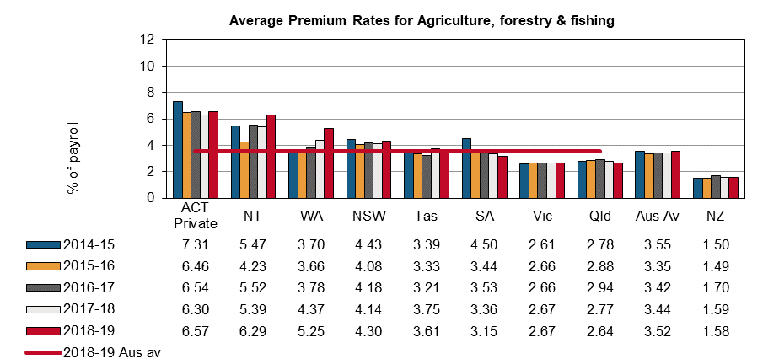

# Mining

Five out of eight Australian jurisdictions showed an increase in premium rates in this industry in 2018−19 compared to the previous financial year (Indicator 14b). The largest increase was observed in the Australian Capital Territory (up 29%), followed by Victoria (up 18%) and the Northern Territory (up 15%). The substantial increase in the Australian Capital Territory premium rate for Mining in 2018−19 has been driven up by the burner policy issued by QBE with adjustable terms, pushing the premium rate up.

Tasmania, South Australia and New South Wales were the only jurisdictions to record a decrease in their premium rates (down 21%, 13% and 2% respectively) in 2018–19 compared to the previous financial year. Western Australia had the lowest premium rate (0.83% of payroll) for this industry in 2018–19.

The New Zealand premium rate for Mining was 0.64% of payroll in 2018–19, which is substantially lower than the Australian average Mining premium rate (1.36% of payroll).

Indicator 14b – Standardised premium rates for Mining by jurisdiction

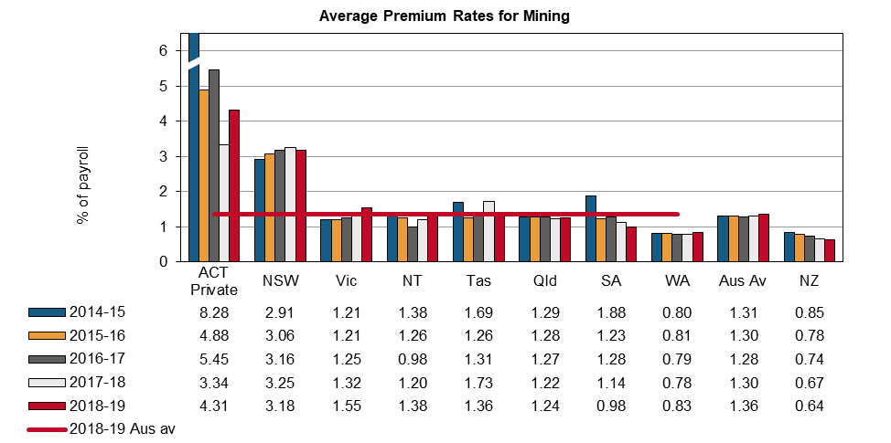

# Manufacturing

Three out of the nine Australian jurisdictions showed an increase in their premium rate for the Manufacturing industry in 2018–19 compared to the previous year (Indicator 14c). Comcare had the largest increase in its premium rate (up 10%) in 2018–19 compared to 2017–18, followed by Western Australia (up 8%). The largest decrease in premium rate was recorded by Tasmania (down 6%), followed by South Australia (down 4%). Comcare recorded the lowest premium rate (0.13% of payroll) of all Australian jurisdictions.

The New Zealand standardised average premium rate in the Manufacturing industry was 0.65% of payroll in 2018–19, a 2% increase from the previous financial year.

Indicator 14c – Standardised premium rates for Manufacturing by jurisdiction

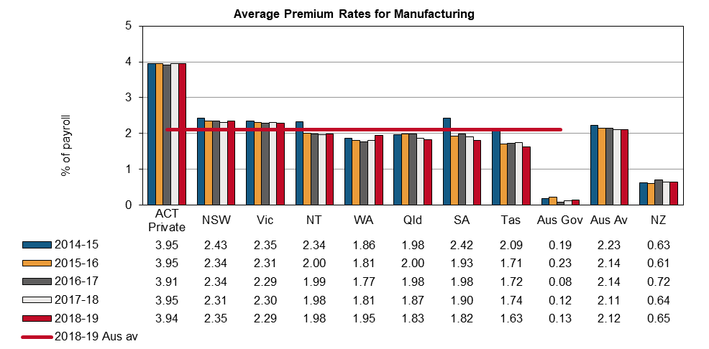

# Electricity, gas, water and waste services

Six out of nine jurisdictions recorded decreases in their average premium rates in 2018–19 compared to the previous year (Indicator 14d). The Northern Territory (down 14%) recorded the largest decrease, followed by South Australia and the Australian Capital Territory (down 10% each), New South Wales (down 7%) and Comcare (down 5%). However, Victoria recorded a 1% increase.

New Zealand had a premium rate of 0.59% of payroll in 2018–19, an increase of 4% from the previous year.

Indicator 14d – Standardised premium rates for Electricity, gas, water and waste services by jurisdiction

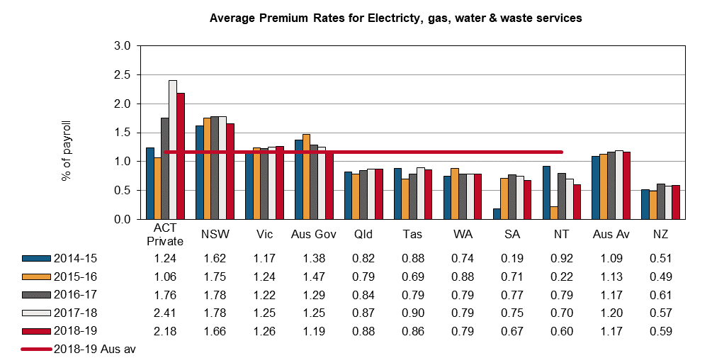

# Construction

In 2018–19 the Construction industry recorded an Australian average premium rate of 2.17% of payroll, which was a 2% increase compared to 2017–18 (Indicator 14e). Comcare recorded the largest decrease (down 29%) among Australian jurisdictions, followed by South Australia and Queensland (down 4% each). The Northern Territory recorded the highest increase (up 21%) among Australian jurisdictions, followed by Western Australia (up 17%). Comcare had the lowest premium rate (0.05% of payroll) of all Australian jurisdictions in 2018–19.

New Zealand recorded an average premium rate of 1.30% of payroll in 2018–19, slightly higher than that of the previous year (1.29% of payroll).

Indicator 14e – Standardised premium rates for Construction by jurisdiction

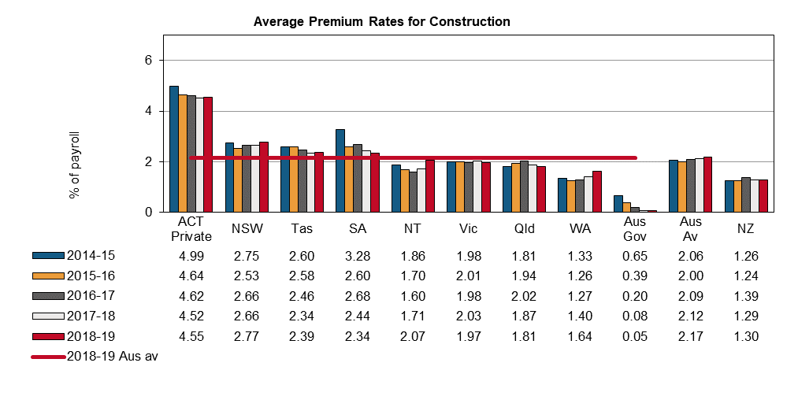

# Wholesale trade

The Australian average premium rate in the Wholesale trade industry remained stable since 2015–16 at 1.05 percent of payroll (Indicator 14f). South Australia (down 9%) and Queensland (down 2%) were the only jurisdictions who recorded a decrease in the premium rate for this industry in 2018–19 compared to the previous financial year. In 2018–19, Western Australia and the Northern Territory recorded 8% and 5% increases in their premium rates respectively compared to the previous financial year. Queensland had the lowest premium rate of all Australian jurisdictions (0.92% of payroll) in 2018–19.

The New Zealand premium rate for this industry in 2018–19 was the same as that for the previous financial year (0.4% of payroll).

Indicator 14f – Standardised premium rates for Wholesale trade by jurisdiction

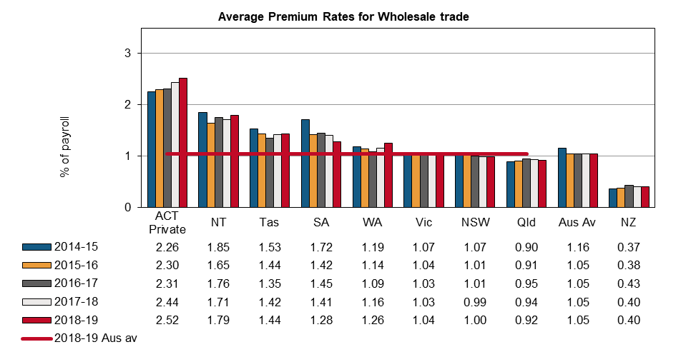

# Retail trade

The Australian average premium rate for the Retail trade industry was 1.45% of payroll in 2018–19, a 1% increase from the previous year (Indicator 14g). Five out of eight jurisdictions recorded increases in their premium rates in 2018–19 from the previous year. Tasmania (up 16%) recorded the highest increase, followed by Western Australia (up 7%), then New South Wales and Victoria (up 2% each) compared to the previous financial year. South Australia recorded a standardised premium rate of 0.96% of payroll in 2018–19, the lowest among all Australian jurisdictions.

In 2018–19, New Zealand had a premium rate of 0.46% of payroll for the Retail trade industry, the same as that for previous year.

Indicator 14g – Standardised premium rates for Retail trade by jurisdiction

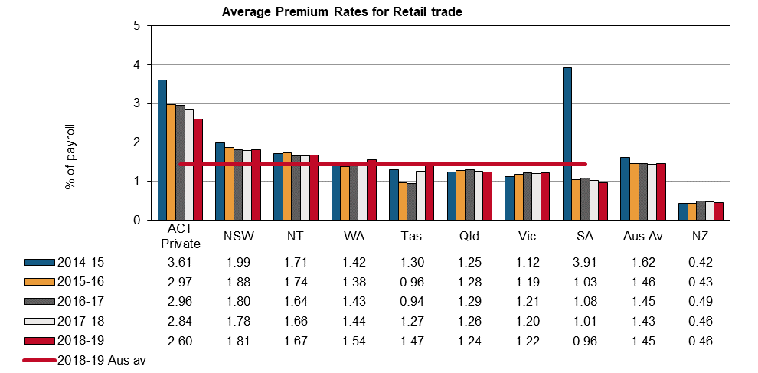

# Accommodation and food services

Indicator 14h shows that the Australian average premium rate for Accommodation and food services was 1.54% of payroll in 2018–19, a 2% reduction compared to the previous financial year.  
All jurisdictions, except Victoria (up 1%), recorded a fall in their premium rates in 2018–19 compared to 2017–18. Comcare recorded the largest reduction (down 32%), followed by South Australia (down 10%), then Western Australia and the Northern Territory (down 5% each).

The New Zealand average premium rate was 0.54% of payroll in 2018–19, down 3% compared to the previous financial year.

Indicator 14h – Standardised premium rates for Accommodation and food services by jurisdiction

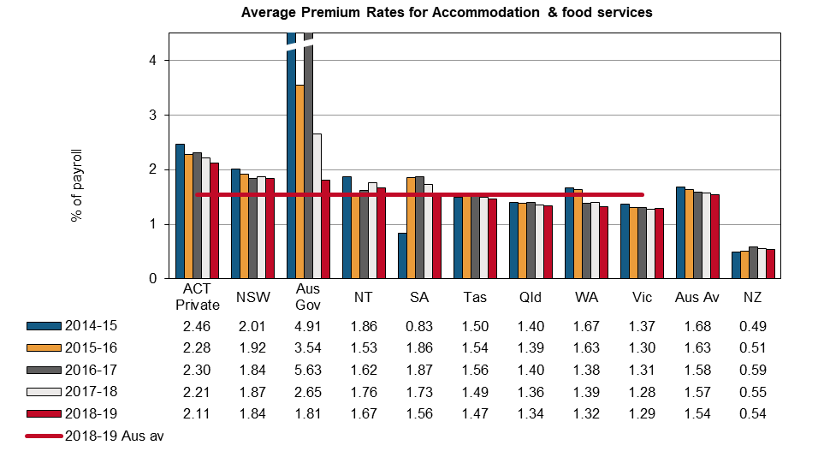

# Transport, postal and warehousing

The Australian Capital Territory had the highest premium rate (4.76% of payroll) of all Australian jurisdictions, while Comcare recorded the lowest (1.53% of payroll) in 2018–19 (Indicator 14i). Comcare showed the largest increase (up 22%) in its premium rate in 2018–19 compared to the previous year, followed by the Northern Territory and Tasmania (up 5% each). The Australian Capital Territory recorded a 3% decrease in its premium rate over the year, followed by South Australia (down 1%).

The New Zealand premium rate for Transport, postal and warehousing (1.01% of payroll) was less than half that of the Australian average for the industry (2.26% of payroll) in 2018–19.

Indicator 14i – Standardised premium rates for Transport, postal and warehousing by jurisdiction

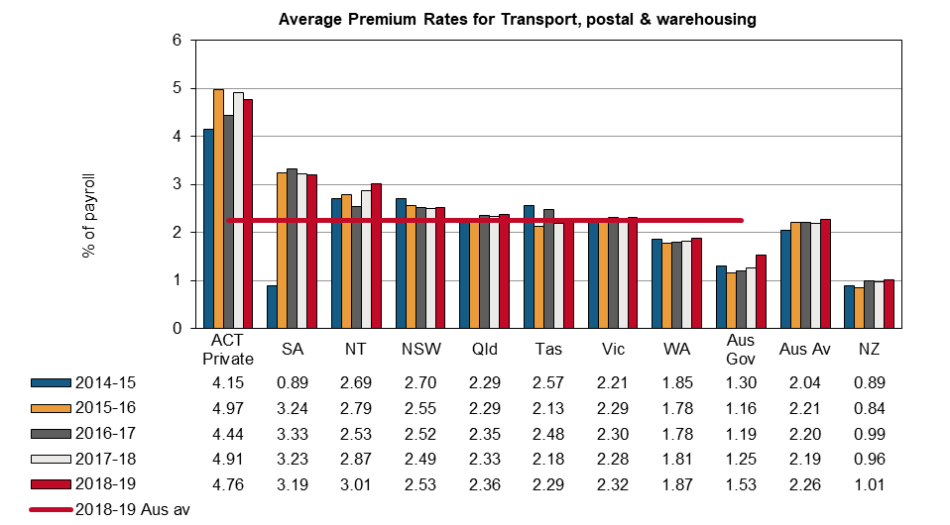

# Information, media and telecommunications

The Australian average premium rate for the Information, media and telecommunications industry was 0.31% of payroll in 2018–19, a 6% decrease from the previous financial year (Indicator 14j). South Australia recorded the largest decrease (down 12%) in the premium rate in 2018–19, followed by Comcare (down 10%), Victoria (down 8%), and New South Wales (down 6%). Western Australia recorded the largest increase compared to the previous year (up 14%), followed by the Northern Territory (up 13%), Tasmania (up 8%) and Queensland (up 6%).

New Zealand’s premium rate was 0.16% of payroll in 2018–19, decreasing by 6% since 2017–18.

Indicator 14j – Standardised premium rates for Information, media and telecommunications by jurisdiction

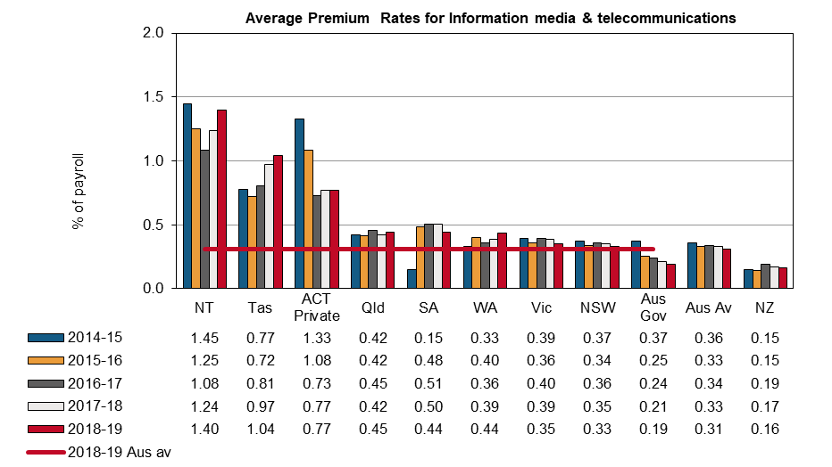

# Financial and insurance services

In 2018–19, the Financial and insurance services industry had an average premium rate of 0.23% of payroll, a 4% increase from the previous year (Indicator 14k). Five jurisdictions recorded decreases in their premium rates compared to the previous year. Tasmania recorded a 32% decrease compared to the previous year, while the Northern Territory recorded the second largest decrease (down 9%). Western Australia recorded an 8% increase in the premium rates in 2018–19, followed by New South Wales and Victoria (up 7% each), and the Australian Capital Territory (up 6%) during the same period.

New Zealand reported a premium rate of 0.11% of payroll for this industry, which is about half that of the Australian average (0.23% of payroll).

Indicator 14k – Standardised premium rates for Financial and insurance services by jurisdiction

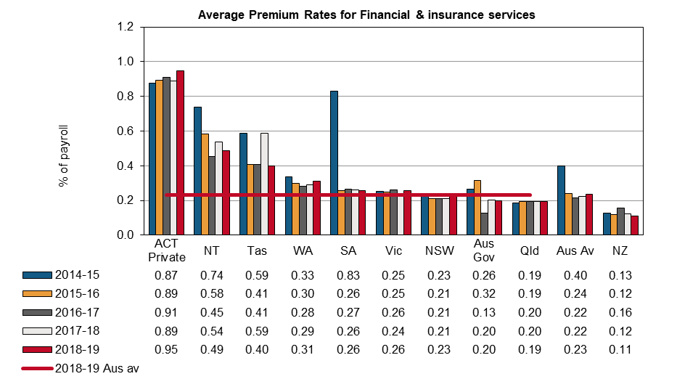

# Rental, hiring and real estate services

Three out of the nine Australian jurisdictions reported a reduction in their premium rates for the Rental, hiring and real estate services industry in 2018–19 when compared to 2017–18 (indicator 14l). Comcare showed the largest decrease over the last financial year in its premium rate (down 14%), followed by South Australia (down 9%) and Tasmania (down 8%). The Northern Territory recorded a 20% increase in their premium rate for this industry, followed by Western Australia (up 10%), the Australian Capital Territory (up 8%), and Victoria (up 6%). The Northern Territory recorded the highest premium rate (1.14% of payroll), while Queensland recorded the lowest (0.61% of payroll).

The New Zealand premium rate in 2018–19 remained at 0.41% of payroll.

Indicator 14l – Standardised premium rates for Rental, hiring and real estate services by jurisdiction

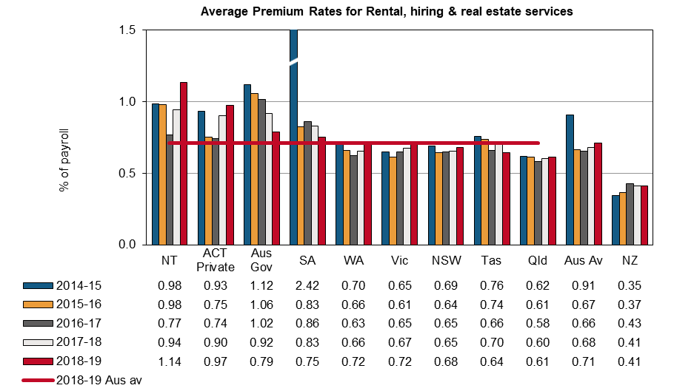

# Professional, scientific and technical services

Six out of the nine Australian jurisdictions recorded a reduction in their premium rates for the Professional, scientific and technical services industry in 2018–19 (Indicator 14m). Tasmania recorded the highest premium rate (0.63% of payroll) in 2018–19 while Queensland recorded the lowest premium rate (0.23% of payroll). Comcare recorded the largest decrease (down 15%), followed by South Australia and Tasmania (down 7% each). The Northern Territory recorded the largest increase in their premium rate in the Professional, scientific and technical service industry (up 10%), followed by Western Australia (up 4%).

The Australian average premium rate was 0.28% of payroll in 2018–19, a 2% decrease from the previous financial year.

The New Zealand average premium rate was 0.14% of payroll in 2018–19, a 4% decrease from the previous financial year.

Indicator 14m – Standardised premium rates for Professional, scientific and technical services by jurisdiction

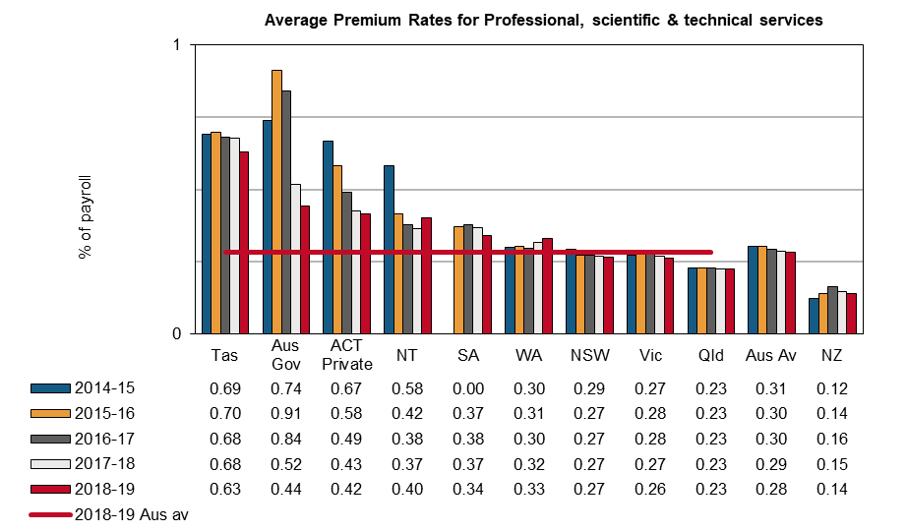

# Administrative and Support services

Four out of the nine Australian jurisdictions recorded a reduction in their premium rates for the Administrative and support services industry in 2018–19 (Indicator 14n). Tasmania recorded the highest premium rate in 2018–19 at 2.54% of payroll, while Comcare recorded the lowest premium rate (0.23% of payroll). Comcare recorded the largest decrease (down 16%), followed by South Australia and the Australian Capital Territory (down 12% each), then Western Australia (down 9%). The Northern Territory recorded the largest increase in their premium rate in the Administrative and support services industry (up 5%) followed by Queensland (up 4%).

The Australian average premium rate for this industry increased slightly in 2018–19 to 1.56 per cent of payroll.

The New Zealand average premium rate was 0.62% of payroll in 2018–19, a 3% increase from the previous financial year.

**Indicator 14n – Standardised premium rates for Administrative and support services by jurisdiction**

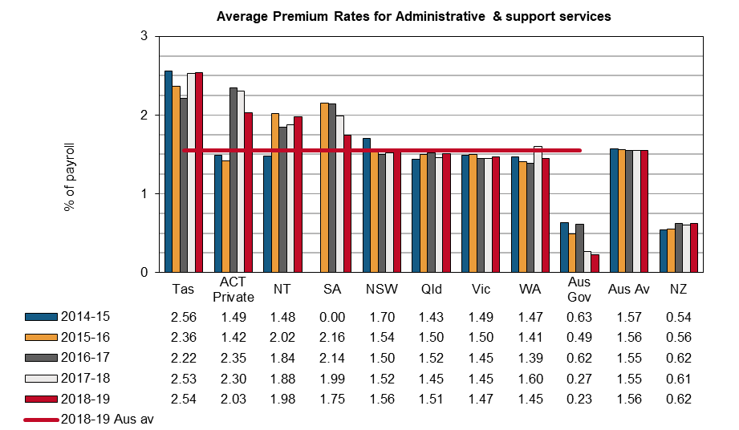

# Public administration and safety

The Australian average premium rate for the Public administration and safety industry fell by 4% in 2018–19 compared to the previous financial year (Indicator 14o). New South Wales recorded the largest decrease (down 31%), followed by Comcare (down 13%). Due to a change in the way government agencies are allocated to industry in New South Wales, this has resulted in a large number of lower risk agencies being reclassified as Public administration and safety which were previously classified elsewhere. The Northern Territory recorded the largest increase (up 28%), followed by Western Australia (up 14%), Tasmania (up 12%) and South Australia (up 10%). The premium rate for South Australia was the lowest (0.37% of payroll) among Australian jurisdictions, followed by Comcare (0.98% of payroll) and Queensland (1.18% of payroll).

The scheme covering the Australian Defence Force personnel is excluded from this industry division as they are covered by the *Military Rehabilitation and Compensation 2004 Act* administered by the Department of Veterans’ Affairs.

New Zealand showed a 6% decrease, from 0.19% of payroll in 2017–18 to 0.18% of payroll in 2018–19.

**Indicator 14o – Standardised premium rates for Public administration and safety by jurisdiction**

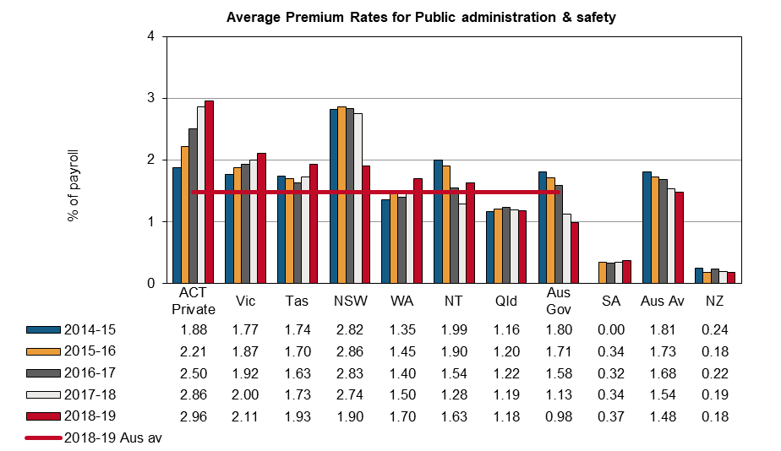

# Education and training

The Australian average premium rate for the Education and training industry fell by 2% in 2018–19 compared to the previous financial year. Comcare recorded the largest decrease (down 66%), followed by New South Wales and South Australia (down 7% each). The Australian Capital Territory and Western Australia recorded the largest increases (up 4% each), followed by Queensland (up 3%). The premium rate for Comcare was the lowest (0.18% of payroll) among Australian jurisdictions, closely followed by South Australia (0.19% of payroll).

The New Zealand premium rate remained steady at 0.26% of payroll in 2018–19.

Indicator 14p – Standardised premium rates for Education and training by jurisdiction

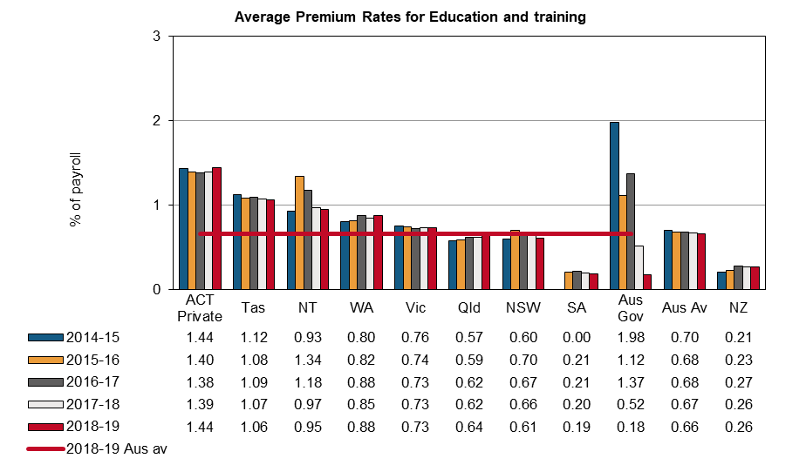

# Healthcare and social assistance

The average Australian premium rate for the Healthcare and social assistance industry has fallen from 1.34% of payroll in 2017–18 to 1.32% in 2018–19 (Indicator 14q). Four out of the nine Australian jurisdictions recorded reductions in their average premium rates in 2018–19 compared to the previous financial year. The largest reduction in premium rate was recorded by Comcare (down 43%), followed by South Australia (down 17%). Tasmania recorded the largest increase (up 12%), followed by the Northern Territory (up 11%).

New Zealand recorded a 4% increase in their 2018–19 premium rates compared to 2017–18.

Indicator 14q – Standardised premium rates for Healthcare and social assistance by jurisdiction

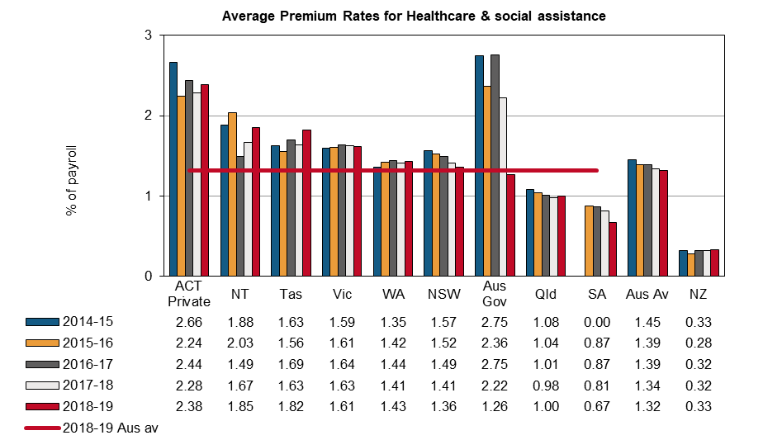

# Arts and recreation services

In 2018–19, the Australian average premium rate for the Arts and recreation services industry was 1.48% of payroll, a 4% drop from the previous financial year (Indicator 14r). Tasmania recorded the largest decrease in their premium rate for this industry in 2018–19 (down 19%), followed by Comcare (down 17%) and Victoria (down 7%). The Northern Territory recorded an increase in the premium rate for this industry (up 9%) in 2018–19.

The New Zealand premium rate remained steady at 0.74% of payroll in 2018–19.

Indicator 14r – Standardised premium rates for Arts and recreation services by jurisdiction

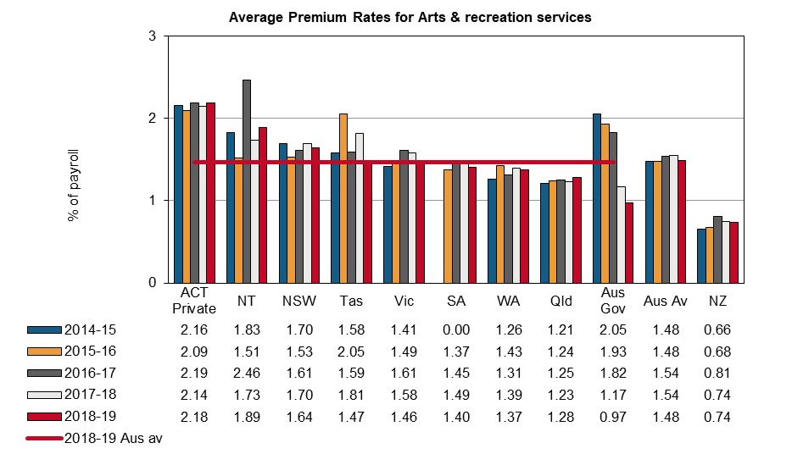

# Other services

There was no change (1.27% of payroll) in the Australian average premium rate in the Other services industry in 2018–19 compared to the previous financial year (Indicator 14s). The Australian Capital Territory recorded the largest increase in premium rate in the current financial year (up 5%), followed by Western Australia (up 4%). Comcare recorded the largest decrease (down 16%) in their premium rate in 2018–19, followed by the Northern Territory (down 9%) and South Australia (down 8%). The highest premium rate was recorded by the Northern Territory (2% of payroll) and the lowest by Queensland (0.97% of payroll).

New Zealand recorded a premium rate of 0.52% of payroll in 2018–19, 5% lower than the previous financial year.

Indicator 14s – Standardised premium rates for Other services by jurisdiction

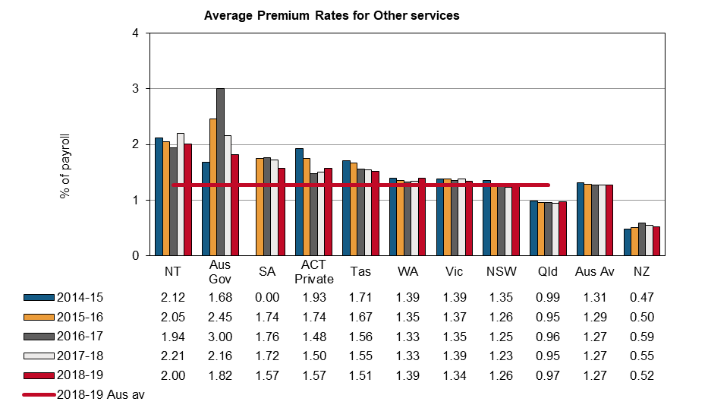

1. Entitlements under workers’ compensation

Entitlements are payable under workers’ compensation in the event an employee is injured or develops a work-related disease. Premium rates are set at a level to ensure sufficient funds are available to cover these entitlements. Different entitlement levels across the jurisdictions can explain some of the differences in premium rates.

The following examples have been included to provide indicative entitlements payable in each jurisdiction. A brief summary of how entitlements are calculated is contained in Appendix 2 – Table 2: Weekly entitlements under Australian workers’ compensation schemes for award wage earners as at 1 January 2019. These entitlements are based on legislation current at 1 January 2019. More detailed information can be found in the *Comparison of Workers’ Compensation Arrangements in Australia and New Zealand* publication on the [Safe Work Australia](https://www.safeworkaustralia.gov.au/doc/comparison-workers-compensation-arrangements-australia-and-new-zealand-2018) website.

Data provided in other chapters of this report should also be considered when comparing entitlements provided under the various workers’ compensation schemes.

Temporary impairment

Impairment is assessed as temporary when the injury or illness is not likely to continue indefinitely and the employee remains unable to work for a period of time before returning to previous duties on an ongoing basis. This example details how jurisdictions compensate low, middle and high income[1] employees during selected periods of temporary impairment. Entitlements for an injured employee are shown in the following table using pre-injury earnings of $1,150 gross per week, $1,800 gross per week and $2,400 gross per week. These profiles have been chosen to highlight the statutory maximum entitlements payable, as well as jurisdictional differences in entitlements to workers employed on different income levels.

*Scenario: The employee remains unable to work for a period of time before returning to their previous duties on a full-time basis. The employee has a dependant spouse and two children aged seven and eight. The employee injured their back and has lower back strain as a result.*

Indicator 15 shows that for low income earners, Western Australia provided full coverage (100%) of pre‑injury earnings for 130 weeks of impairment. After the 13th week of compensation, the Western Australian scheme does not compensate low income workers for overtime and bonuses and a 15% reduction in weekly payments applies for non-award workers.

The Queensland scheme provided the second highest percentage (94%) of pre‑injury earnings in compensation at 130 weeks of incapacity for low income earners, followed by the Northern Territory (92%), then Tasmania and South Australia (both 88%). The Australian Capital Territory provided the lowest percentage of pre-injury earnings for 130 weeks of impairment (72%) due in part to the step-down[2] in benefits to 65% of pre-injury earnings after 26 weeks of compensation (see Appendix 2 – Table 2 for more details).

For middle income earners with 130 weeks of impairment, Tasmania and South Australia provided the highest percentage of pre-injury earnings (both 88%), followed by Western Australia (87%). The Australian Capital Territory provided the lowest percentage of pre-injury earnings for the full period of impairment (72%).

In contrast to the low income scenario, where seven of the nine Australian jurisdictions provided full income protection for the first 26 weeks, only five jurisdictions provided full income protection for middle and high income earners for this period of incapacity.

Indicator 15 – Average percentage of pre-injury earnings for selected periods of incapacity, as at 1 January 2019

| Level of pre-injury income | NSW | Vic | Qld | WA | SA | Tas | NT | ACT | Comcare | NZ |
| --- | --- | --- | --- | --- | --- | --- | --- | --- | --- | --- |
| 13 weeks of incapacity |  |  |  |  |  |  |  |  |  |  |
| Low income | 95 | 95 | 100 | 100 | 100 | 100 | 100 | 100 | 100 | 80 |
| Middle income | 95 | 95 | 85 | 100 | 100 | 100 | 100 | 100 | 100 | 80 |
| High income | (a)89 | 95 | 78 | 100 | 100 | 100 | 100 | 100 | 100 | 80 |
| 26 weeks of incapacity |  |  |  |  |  |  |  |  |  |  |
| Low income | 88 | 88 | 100 | 100 | 100 | 100 | 100 | 100 | 100 | 80 |
| Middle income | 88 | 88 | 85 | 93 | 100 | 100 | 100 | 100 | 100 | 80 |
| High income | (a)85 | 88 | 78 | 93 | 100 | 100 | 100 | 100 | 100 | 80 |
| 52 weeks of incapacity |  |  |  |  |  |  |  |  |  |  |
| Low income | 84 | 84 | 96 | 100 | 100 | 95 | 95 | 83 | 97 | 80 |
| Middle income | 84 | 84 | 80 | 89 | 100 | 95 | 88 | 83 | 97 | 80 |
| High income | (a)82 | 84 | 73 | 89 | 100 | 95 | 88 | 83 | 97 | 80 |
| 130 weeks of incapacity |  |  |  |  |  |  |  |  |  |  |
| Low income | 82 | 82 | 94 | 100 | 88 | 88 | 92 | 72 | 84 | 80 |
| Middle income | 82 | 82 | 77 | (c) 87 | 88 | 88 | 81 | 72 | 84 | 80 |
| High income | (a)81 | 82 | (b)71 | (c) 87 | 88 | 88 | 80 | (d)72 | 84 | 80 |

In New South Wales maximum weekly payments are capped at $2,145.30 as at 1 January 2019. The level of pre-injury income for a high income earner will vary depending on the proportion of their pre-injury average weekly earnings to the maximum weekly payment.

In Queensland workers are paid a proportion of their normal weekly earnings (NWE) or a percentage of the original series amount of Queensland full time adult persons ordinary time earnings (QOTE) (i.e. 0 to 26 weeks – 85% NWE or Award; 26 to 130 weeks – 75% NWE or 70% QOTE). The percentages are calculated on the higher amounts of the two possible payments. The statutory maximum amount for weekly payments as at 1 January 2019 was $330,240.

In Western Australia there is a cap on weekly earnings set at twice the annual Average Weekly Earnings (WA) as published by the ABS each year. The weekly cap as at 1 January 2019 was $2,665.70 and applied to all income levels. The prescribed amount for weekly payments is $228,307. In addition, for a middle income earner (e.g. $1800 per week) and high income earner (e.g. $2400 per week) the prescribed total amount for weekly benefit would be exhausted before 130 weeks of compensation.

(d) In the Australian Capital Territory, 65% of average pre-incapacity weekly earnings or the Statutory floor applies (whichever is greater) after 26 weeks of total incapacity. Statutory floor means the national minimum wage set by Fair Work Australia under the *Fair Work Act 2009 (Cwlth).* National minimum wage as at 1 January 2019 is $718.60 per week ($18.90 per hour). In this example the statutory floor applies.

Permanent impairment

Impairment is assessed as permanent when it has reached maximal medical improvement. Maximal medical improvement generally refers to where the impairment has become stable and is unlikely to change, with or without medical treatment. Over time, there may be some change; however, further recovery or deterioration is not anticipated.

This scenario shows the entitlements payable for a degree of permanent impairment caused by a workplace injury. Appendix 2 – Table 3 lists entitlements under workers’ compensation schemes for each jurisdiction. The following scenario is indicative only for these types of payments.

*Scenario: As a result of a workplace incident the employee was diagnosed with complete tetraplegia below the 6th cervical neurological segment. This resulted in paralysis of his hands, impaired upper body movement and paralysis of his trunk and lower limbs. He lost all lower body function and was wheelchair-bound. Impairment was total and permanent and there was no real prospect of returning to work.*

*The employee’s pre-injury earnings were $1,800 gross per week. The employee is 35 years of age and has a dependant spouse and two children aged seven and eight. The younger child entered the workforce at 16 and the older child remained in full-time education until age 25. The employee contributed to a superannuation fund. There was no contributory negligence on his part; however there was negligence on the part of the employer.*

Indicator 16 details the entitlements payable to the injured employee. Entitlements may be paid as two components; a statutory component that may include both weekly payments and/or a lump sum, and a common law component paid as a lump sum.

The statutory component includes the weekly benefits payable for the remainder of the employee’s working life. Weekly payments in the New South Wales workers’ compensation scheme may be paid up to one year after retirement age (30 years in this instance assuming retirement age is 65).

The common law component is an estimate of the additional payment available under a common law settlement, where applicable. All figures exclude medical and like services such as attendant care. If a common law component is paid, previous statutory components are deducted from the lump sum. Appendix 2 – Table 1: Key features of Australian workers’ compensation schemes as at 1 January 2019, identifies the jurisdictions that have access to common law.

In Western Australia, New South Wales, Queensland, Tasmania and the Australian Capital Territory there is no upper limit on damages that could be expected from a common law claim under this scenario. The Australian Capital Territory did not provide a figure for this scenario. Western Australia provided a figure of $5,897,723 which is based on the average of the five highest common law payments for claims finalised between 2014–15 and 2018–19. Queensland provided a figure of $1,528,490, which is based on an example similar to this scenario.

The entitlements provided by the New Zealand scheme in this scenario are comparable to those provided by Australian jurisdictions. However, there is no access to common law under the New Zealand scheme.

Workplace fatality

This example examines the entitlements payable to dependants of an employee who died as a result of a work‑related injury. Entitlements to dependants are paid by way of a lump sum and/or weekly benefits, depending on the employee’s circumstances and scheme design.

Pecuniary entitlements may be affected by common law payments in jurisdictions where there is access to common law redress. South Australia and the Northern Territory have no access to common law, while the Comcare scheme has limited access to common law. In Victoria there may be access to an additional lump sum under the Wrongs Act 1958 (Wrongs Act)*,* which is the main legislation in Victoria that applies to common law claims for damages for personal injury in cases other than workplace injuries or transport accidents.

*Scenario: The employee and family circumstances in this scenario are the same as the previous example, but in this case the workplace incident resulted in death on 1 January 2019. The spouse did not re-enter the workforce or re-marry for 10 years.*

Indicator 16 shows that total entitlements payable to dependants in the case of a fatality varied across jurisdictions. New South Wales provided the highest entitlement payable to dependants in Australia following a workplace incident resulting in a fatality at the amount of $961,578, followed by Victoria at $884,010 and Queensland at $876,028. The lowest entitlements for a fatality were provided in Tasmania ($687,281) and Western Australia ($725,208). Appendix 2 – Table 3 provides more detail on how these entitlements are calculated.

Indicator 16 – Entitlements for permanent incapacity or fatality as at 1 January 2019

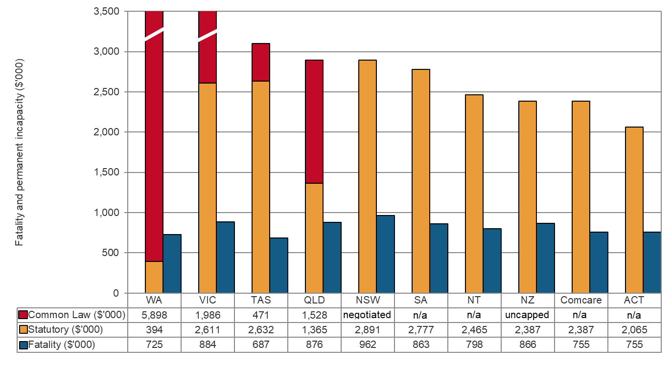

Notes:

New South Wales workers’ compensation arrangements allow workers with 15% or more whole person impairment (WPI) to sue for modified common law damages only - these are known as work injury damages. Workers are limited to recovering past and future economic loss only. There is no upper limit on compensation that can be paid for a work injury damages claim. The figure provided by New South Wales is based on the following assumptions: legislation as at 1 January 2019; the worker does not have access to other heads of damages (e.g. motor vehicle accident or civil liability claim); the worker has no residual earning capacity; assume a settlement date of 1 January 2019. When a worker successfully recovers damages, the worker is liable to repay out of those damages the amount of weekly compensation that a person has already been paid in respect of the injury.

In Queensland there is no upper limit on compensation that could be paid for a common law claim. The amount provided is based on an example. The common law additional amount excludes all statutory payments made and the estimated proportion of the lump sum payment attributed to medical and carer services (only one payment is made to the worker).

In the Australian Capital Territory, common law is uncapped so an amount is unable to be determined.

In Western Australia, a cap on common law benefits applies for injuries with more than 15% to less than 25% WPI. The cap amount is $472,337. However, in this example no common law cap would apply as the impairment would likely exceed the 25% or more WPI threshold. The figure provided ($5,897,723 excluding medical and carer costs) is based on the average of the five highest common law payments for claims finalised between 2014–15 and 2018–19. It should be noted that weekly benefits and common law payments are not mutually exclusive. Common law payments are inclusive of weekly benefits, therefore, any statutory entitlements received would be deducted from the amount ordered at the common law claim. In Victoria the pain and suffering maximum is $598,360, less any sum received as a statutory lump sum. For economic damages or losses that can be measured in money (pecuniary loss) the maximum amount is $1,374,370 less any amount received in weekly benefits prior to settlement plus tax paid on the weekly benefits received. These total to the Common Law maximum amount of $1,972,730.

1. Workers’ compensation scheme performance

There are significant differences in funding arrangements for the various schemes around Australia. The schemes that are fully centrally funded (New South Wales, Victoria, Queensland, South Australia, the Australian Government and New Zealand) have both WHS and workers’ compensation functions, and staffing and operational budgets funded by premiums. For those jurisdictions with privately underwritten schemes, funding for non-workers’ compensation functions comes directly from government appropriation. This difference in funding arrangements may have an impact on the data shown in this section.

Assets to liabilities ratio

This section reports the standardised ratio of assets to net outstanding claim liabilities (funding ratio) for each jurisdiction over the past five years. This indicator is a measure of the adequacy of the scheme to meet future claim payments. Ratios above 100% indicate that the scheme has more than sufficient assets to meet its predicted future liabilities. Conversely, low ratios could be an indication of the need for a scheme to increase its premium rates to ensure that assets are available for future claim payments. Funding ratio trends should therefore be considered in conjunction with the premium rates reported elsewhere in this report.

Self-insurers are employers who are allowed by jurisdictions to self-insure for workers’ compensation where they manage and pay for their employees’ claims for work-related injuries and disease, rather than paying premiums to insurers to take on these responsibilities. Self‑insurers are excluded from the funding ratio measures as the workers’ compensation assets and liabilities are not quarantined from the rest of the self-insurer’s business. Self‑insurers are regulated in each jurisdiction and are required to lodge financial guarantees with the regulatory authority to provide security for workers’ compensation entitlements. The level of guarantee varies between jurisdictions. A summary of the current requirements can be found in the *Comparison of Workers’ Compensation Arrangements in Australia and New Zealand* on the [Safe Work Australia](https://www.safeworkaustralia.gov.au/collection/comparison-workers-compensation-arrangements-australia-and-new-zealand) website.

The data shown in this indicator may differ from jurisdictions’ annual reports due to the use of standard definitions of assets and liabilities. While a standard definition of the funding ratio of net outstanding claim liabilities has been adopted to improve comparability across jurisdictions, fundamental differences remain between centrally funded and privately underwritten schemes.

Insurers in privately underwritten schemes are governed by the Australian Prudential Regulatory Authority’s prudential regulatory requirements to make sure that enough funds are available to cover all liabilities. Including the measure for privately underwritten schemes alongside centrally funded schemes can be misleading because the funding ratio measure for privately underwritten schemes does not capture the true extent of the private schemes’ abilities to meet future claim payments. Therefore, the funding ratios of privately underwritten schemes are shown on a separate graph to those for the centrally funded schemes.

Indicator 17 shows that the average funding ratio for centrally funded schemes was 132% in   
2018–19, a 5% decrease from the previous financial year. Except for the Australian Government, all centrally funded schemes recorded a decrease in funding ratios compared to the previous year. All centrally funded schemes have funding ratios above 100%, indicating that assets are sufficient to meet future liabilities in these jurisdictions. The Australian Government funding ratio for 2018–19 increased by 13% compared to the previous year. However, South Australia and Victoria each recorded a 7% decrease, followed by New South Wales (down 5%) and Queensland (down 4%) in 2018–19 compared to the previous financial year.

In New Zealand, the funding ratio in 2018–19 (140%) decreased by 9% when compared to the previous financial year.

Indicator 17 – Standardised ratio of assets to net outstanding claim liabilities for centrally funded (CF) schemes

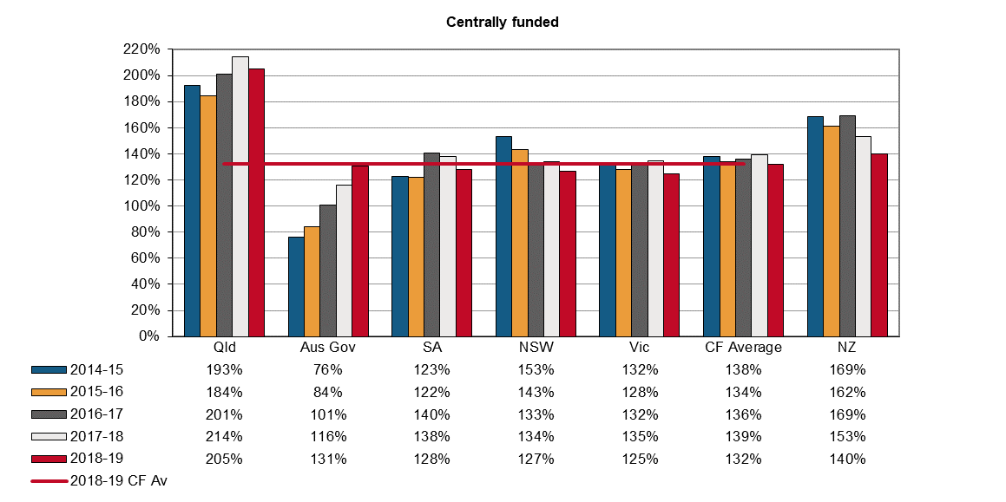

Indicator 18 shows that in 2018–19 the average funding ratio for privately underwritten schemes was 110%, a 5% increase from the previous year. Tasmania (up 7%) and the Northern Territory (up 4%) recorded increases in funding ratio, while Western Australia recorded a 2% decrease in 2018–19 compared to the previous financial year.

Seacare and the Australian Capital Territory schemes are privately underwritten, but no data is currently available for this Indicator.

Indicator 18 – Standardised ratio of assets to net outstanding claim liabilities for privately underwritten (PU) schemes

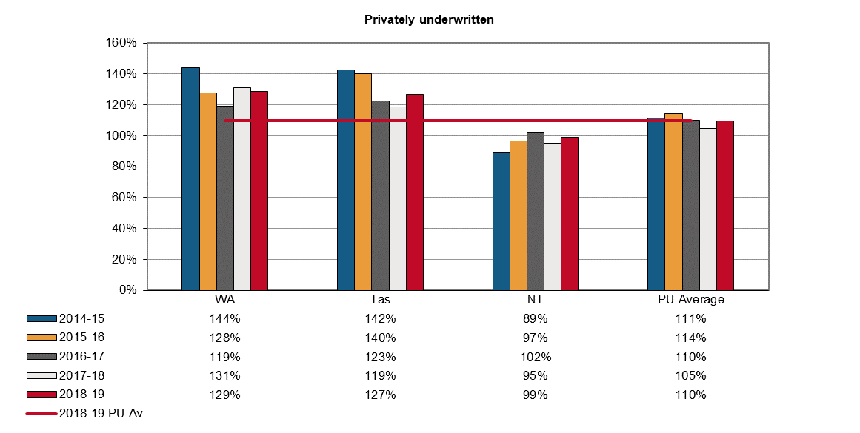

Scheme expenditure

Indicator 19 shows the amount and proportion of total scheme expenditure paid out to injured workers, plus administrative costs, for the periods 2014–15 and 2018–19. Since centrally funded and privately underwritten schemes have different financial structures, for this indicator the jurisdictions are shown in their respective funding arrangement group.

Total scheme expenditure across Australia slightly increased (up 5%) over the period from 2014–15 to 2018–19. Five out of the nine jurisdictions recorded increases in their total scheme expenditure during this period. The largest percentage increase was recorded by the Northern Territory (up 52%), followed by New South Wales (up 23%), Victoria (up 6%), and Queensland (up 5%), during this period. South Australia recorded the largest decrease in their total scheme expenditure (down 32%), followed by the Australian Government (down 22%) and Seacare (down 18%).

Payments direct to workers increased by 2% over the five years and accounted for 51% of total expenditure in 2018–19. Direct compensation is paid to injured employees either as weekly benefits, redemptions, common law settlements (excluding legal costs), and non-economic loss benefits. Three jurisdictions recorded increases in expenditure on payments direct to workers ranging from 55% in the Northern Territory to 6% in Victoria. The rest of the jurisdictions recorded decreases in payments direct to workers between 2014−15 and 2018−19, ranging from 36% in South Australia to 3% in Tasmania. Payments direct to workers in Queensland remained steady between 2014−15 and 2018−19.

Expenses paid to workers as services to claimants recorded the second largest percentage increase in expenditure of all cost items (up 15%) between 2014–15 and 2018–19. It accounted for 26% of total expenses in 2018–19. Seven out of nine jurisdictions recorded increases in the total expenses for services to claimants with the highest increase in the Northern Territory (up 35%), followed by New South Wales (up 32%) and Queensland (up 25%). South Australia recorded the largest decrease (down 24%) in expenditure as services to claimants over the five year period, followed by Comcare (down 21%). Costs associated with services to claimants include expenditures for medical and legal services plus expenditures for other services like funeral, interpreting and transport services.

Four out of the nine jurisdictions recorded increases in dispute resolution expenses. The Northern Territory’s increase of 236% for dispute resolution expenses between 2014–15 and 2018–19 was substantially larger than increases in other jurisdictions. However, their costs for dispute resolution remain below that of other jurisdictions. Overall South Australia recorded the largest percentage decrease in dispute resolution expenses (down 18%), followed by Queensland and Tasmania (down 9% each), and New South Wales (down 6%).

Expenditures spent on ‘Other administration’ recorded the highest percentage increase among all cost items (up 103%); mainly due to the substantial increases recorded by New South Wales (up 863%), the Northern Territory (up 339%) and Tasmania (up 135%). Other administration costs are generally expenditures for corporate administration purposes.

Costs associated with expenses for insurance operations recorded decreases in six jurisdictions, ranging from 40% in South Australia to 2% in Tasmania. The Northern Territory recorded a 31% increase in total expenses for insurance operations, followed by Western Australia (up 2%).

New Zealand proportions have a different pattern to the Australian schemes with a lower proportion of expenditure going direct to the claimant and a higher proportion going to services for the claimant. This is due to the nature of the New Zealand scheme, where a greater proportion of workers’ medical costs are identified as work-related.

Indicator 19 – Scheme expenditure

|  |  |  |  |  |  |  |  |  |  |  |  |
| --- | --- | --- | --- | --- | --- | --- | --- | --- | --- | --- | --- |
| **Expenditure ($M)** | **Centrally funded** | | | | | **Privately underwritten** | | | | **Total** | |
| **Scheme costs** | **NSW** | **Vic** | **Qld** | **SA** | **Aus Gov** | **WA** | **Tas** | **NT** | **Seacare** | **Australia** | **NZ** |
| **2014–15** |  |  |  |  |  |  |  |  |  |  |  |
| Direct to claimant | 1 072.6 | 1,219.4 | 896.0 | 312.7 | 181.8 | 633.2 | 74.4 | 58.0 | 13.6 | **4,461.8** | 243.3 |
| Services to claimant | 697.0 | 466.5 | 286.5 | 161.8 | 96.5 | 242.2 | 29.7 | 25.2 | 2.7 | **2,008.1** | 170.7 |
| Insurance operations | 451.3 | 470.4 | 125.7 | 156.9 | 25.9 | 281.0 | 36.5 | 9.4 | 2.1 | **1,559.3** | 49.9 |
| Regulation | 35.6 | 37.1 | 10.3 | 6.5 | 2.2 | 4.3 | 2.1 | 0.0 | 0.0 | **98.1** | 20.3 |
| Dispute resolution | 77.3 | 35.6 | 12.7 | 7.8 | 3.2 | 4.5 | 1.3 | 0.2 | 0.8 | **143.5** | 0.0 |
| Other administration | 18.2 | 49.0 | 38.7 | 36.3 | 24.3 | 9.0 | 0.5 | 1.5 | 1.0 | **178.6** | 38.3 |
| **Total** | 2 352.1 | 2,278.1 | 1,370.0 | 682.1 | 333.8 | 1,174.1 | 144.5 | 94.3 | 20.3 | **8,449.4** | 522.5 |
| **2018–19** |  |  |  |  |  |  |  |  |  |  |  |
| Direct to claimant | 1,261.0 | 1,288.8 | 894.9 | 201.6 | 132.1 | 596.0 | 72.4 | 89.8 | 11.4 | **4,548.0** | 378.1 |
| Services to claimant | 918.4 | 522.7 | 359.4 | 122.9 | 76.7 | 244.1 | 35.0 | 34.1 | 3.1 | **2,316.3** | 250.2 |
| Insurance operations | 423.3 | 470.5 | 102.4 | 94.5 | 24.4 | 285.7 | 35.8 | 12.3 | 1.5 | **1,450.3** | 62.5 |
| Regulation | 30.9 | 38.0 | 11.5 | 5.8 | 1.4 | 4.1 | 1.1 | 0.0 | 0.0 | **92.8** | 24.4 |
| Dispute resolution | 72.3 | 37.4 | 11.5 | 6.4 | 3.5 | 4.5 | 1.1 | 0.8 | 0.0 | **137.6** | 0.0 |
| Other administration | 175.6 | 56.3 | 58.6 | 33.7 | 22.3 | 7.9 | 1.2 | 6.8 | 0.8 | **363.3** | 46.7 |
| **Total** | 2,881.5 | 2,413.7 | 1,438.4 | 464.9 | 260.4 | 1,142.3 | 146.6 | 143.8 | 16.7 | **8,908.4** | 761.9 |

*Note: Figures are rounded to the nearest one decimal place and therefore the rows and columns may not add to the respective totals.*

Indicator 19 – Scheme expenditure (continued)

| **Percentage of total expenditure (%)** | **Centrally funded** | | | | | **Privately underwritten** | | | | **Total** | |
| --- | --- | --- | --- | --- | --- | --- | --- | --- | --- | --- | --- |
| **Scheme costs** | **NSW** | **Vic** | **Qld** | **SA** | **Aus Gov** | **WA** | **Tas** | **NT** | **Seacare** | **Australia** | **NZ** |
| **2014–15** |  |  |  |  |  |  |  |  |  |  |  |
| Direct to claimant | 45.6 | 53.5 | 65.4 | 45.8 | 54.5 | 53.9 | 51.5 | 61.5 | 67.2 | **52.8** | 46.6 |
| Services to claimant | 29.6 | 20.5 | 20.9 | 23.7 | 28.9 | 20.6 | 20.6 | 26.7 | 13.3 | **23.8** | 32.7 |
| Insurance operations | 19.2 | 20.6 | 9.2 | 23.0 | 7.7 | 23.9 | 25.3 | 9.9 | 10.3 | **18.5** | 9.6 |
| Regulation | 1.5 | 1.6 | 0.8 | 1.0 | 0.7 | 0.4 | 1.5 | 0.0 | 0.1 | **1.2** | 3.9 |
| Dispute resolution | 3.3 | 1.6 | 0.9 | 1.1 | 1.0 | 0.4 | 0.9 | 0.2 | 4.1 | **1.7** | 0.0 |
| Other administration | 0.8 | 2.2 | 2.8 | 5.3 | 7.3 | 0.8 | 0.4 | 1.6 | 5.0 | **2.1** | 7.3 |
| **Total** | **100.0** | **100.0** | **100.0** | **100.0** | **100.0** | **100.0** | **100.0** | **100.0** | **100.0** | **100.0** | **100.0** |
| **2018–19** |  |  |  |  |  |  |  |  |  |  |  |
| Direct to claimant | 43.8 | 53.4 | 62.2 | 43.4 | 50.7 | 52.2 | 49.3 | 62.5 | 67.8 | **51.1** | 49.6 |
| Services to claimant | 31.9 | 21.7 | 25.0 | 26.4 | 29.5 | 21.4 | 23.9 | 23.7 | 18.4 | **26.0** | 32.8 |
| Insurance operations | 14.7 | 19.5 | 7.1 | 20.3 | 9.4 | 25.0 | 24.4 | 8.6 | 8.9 | **16.3** | 8.2 |
| Regulation | 1.1 | 1.6 | 0.8 | 1.2 | 0.6 | 0.4 | 0.8 | 0.0 | 0.0 | **1.0** | 3.2 |
| Dispute resolution | 2.5 | 1.5 | 0.8 | 1.4 | 1.3 | 0.4 | 0.8 | 0.5 | 0.0 | **1.5** | 0.0 |
| Other administration | 6.1 | 2.3 | 4.1 | 7.2 | 8.6 | 0.7 | 0.8 | 4.7 | 4.9 | **4.1** | 6.1 |
| **Total** | **100.0** | **100.0** | **100.0** | **100.0** | **100.0** | **100.0** | **100.0** | **100.0** | **100.0** | **100.0** | **100.0** |

Administrative costs are affected by the type of scheme in operation. Indicator 20 shows the distribution of direct payments into weekly benefits and lump sums. The payment of long-term weekly benefits results in higher administration costs. This indicator shows that in 2018–19, all but three Australian schemes paid out more as weekly benefits than lump sum benefits. Queensland, Tasmania and the Northern Territory are the only jurisdictions which paid out more in lump sum payments than in weekly benefits. The New Zealand scheme has little provision for lump sum payments.

Indicator 20 – Direct compensation payments by type and jurisdiction, 2018–19

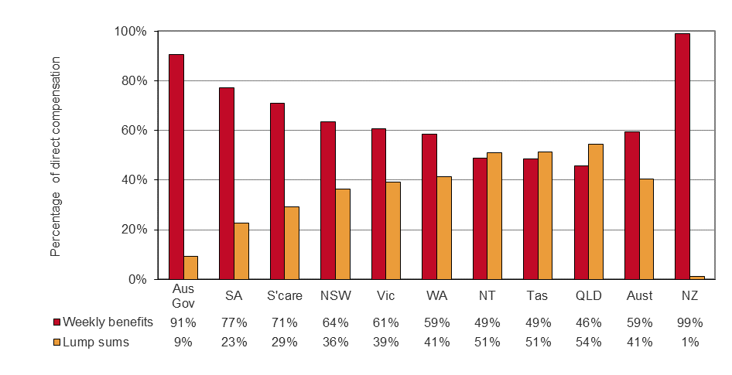

Current return to work

The Return to Work Survey is conducted biennially and draws sample from the population of injured workers who:

* had at least one day away from work
* submitted a claim in the two years prior to the interview period
* had or did not have payment-related activity within six months prior to the sample being drawn
* worked in either premium paying (including own businesses) or self-insured organisations.

The last survey was conducted in 2018. All Australian workers compensation authorities, except for South Australia, took part in the survey in 2018.

The current return to work rate is based on Question RTW2 ‘Are you currently working in a paid job?’ and Question RTW1 ‘Have you returned to work at any time since your work-related injury or illness?’ of the survey, with the rate referring to the proportion of injured workers who state ‘yes’ to both questions.

Current return to work rates reported here are for premium payers and self-insurers together, and are estimates based on a sample of the eligible population. Differences between and within jurisdictions over time should be interpreted with caution. More information on this aspect and the survey design can be found in Appendix 1.

Indicator 21 shows the current return to work rates by jurisdiction for the four surveys conducted in 2012, 2014, 2016 and 2018. In 2018, 82% of Australian and 80% of New Zealand injured workers from premium paying and self-insured organisations had returned to work and were working in a paid job at the time of the interview.

Indicator 21 – Current return to work rate for 2012, 2014, 2016 and 2018

Indicator 21 – Current return to work rate for 2012, 2014, 2016 and 2018 

This bar graphs shows the current return to work rates for 2012, 2014, 2016 and 2018 by jurisdiction, and the Australian average return to work rate.

n/a – Data is not applicable

The current return to work rate in 2018 for the Australian Capital Territory (86%), Comcare (85%) and Queensland (83%) was higher than the national rate. By contrast Victoria and New South Wales (81% each), Tasmania (79%), the Northern Territory (73%) and Seacare (68%), all recorded lower rates than the national average. The current return to work rate for Seacare is affected by legislation which requires a person to be certified medically fit to perform the normal on-board work tasks and duties of a seafarer.

The current return to work rate increased for all jurisdictions who participated in the four biennial return to work surveys between 2012 and 2018. The rate fell in New Zealand during the same period.

Each jurisdiction faces varying challenges in their endeavors to improve return to work rates. Some drivers of return to work are defined by legislation and can only be influenced by the nature of the scheme design (whether it is short or long term in nature). For example, the benefit structure can influence return to work, as can the associated step down provisions and legislative differences regarding early claims reporting, employer obligations and common law arrangements.

Disputation rate

*About disputation rates*

A dispute is an appeal to a formal mechanism, such as a review officer, conciliation or mediation service, against an insurer’s decision or decisions relating to compensation. Disputes exclude common law and redemptions and commutations unless they are processed as disputes through the jurisdiction’s dispute resolution system.

Indicator 22 shows the number of new disputes as a proportion of ‘active’ claims in the reference financial year. An active claim is described as any claim on which a payment of any type was made during the reference financial year (including claims with medical treatment costs only) regardless of when that claim was lodged.

The measure includes all disputes lodged for the year against any active claim that had any type of payment in the reference financial year. However, there could be a small number of disputes lodged against claims that are not active, such as liability disputes. The comparison of disputation rates between jurisdictions must be treated with caution due to jurisdictional differences in scheme design, types of decisions that can be appealed, dispute resolution models and the cost of appeals.

*Disputation rate*

The Australian disputation rate (4.7% of active claims) in 2018–19 has decreased by 22% since 2014–15. The majority of Australian jurisdictions recorded decreases in disputation rates during the five-year period. Comcare, the Northern Territory, Western Australia and Tasmania, however, recorded increases (up 39%, 32%,12% and 2% respectively) in their disputation rate since 2014–15.

New South Wales reported the lowest disputation rate of all the Australian jurisdictions at 2.5% of active claims in 2018–19, followed by Queensland (2.7%), Western Australia (4.4%) and Comcare (6.3%). The disputation rate of Seacare in 2018–19 was the highest of all jurisdictions at 17.3% of active claims.

The New Zealand disputation rate is very low (0.7%) because of the universal nature of its accident compensation scheme. Since people are covered whether the incident occurs at work, home, on the road, playing sport and whether they are employed, self-employed or a non-earner (child, pensioner, student, unemployed) there are very few disputes relating to cover.

Indicator 22 – Proportion of claims with dispute

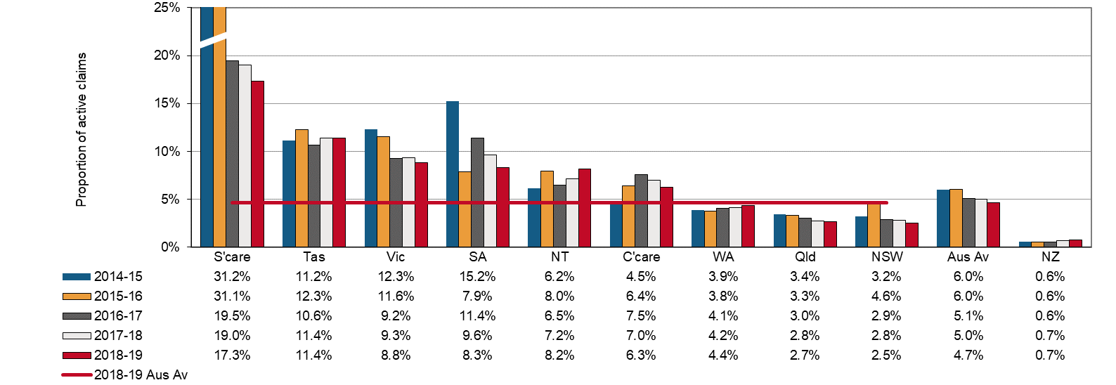

Dispute resolution

The speed with which disputes are resolved depends on the systems and processes that are in place for each jurisdiction. Generally, the simpler the process, the faster the dispute is resolved. Where there is a lag in collection, exchange and lodgment of information by one or more parties, disputes are likely to be more adversarial and therefore more costly. A high percentage of disputes resolved in a longer time frame may also indicate that there are a high number of more complex disputes being dealt with within a jurisdiction, or that there are some mandatory medical or legal processes in place that inherently delay resolution.

In the past five years in Australia there has been a substantial decrease (down 20%) in the proportion of disputes resolved within one month. By contrast, the percentage of disputes resolved within three months increased by 3%, while the percentage of disputes resolved within six and nine months remained steady during this period.

In 2018–19, more than half the disputes (61%) were resolved within three months of the date of lodgment on average in Australia. Queensland resolved the highest proportion of disputes within three months (89%), followed by Western Australia and Tasmania (74% each), and Victoria and New South Wales (60% each).

Comcare disputes generally took more time to resolve than disputes in other jurisdictions. As Comcare disputes are referred to an external and independent body (Administrative Appeals Tribunal), it has minimal control over the associated time frames for dispute resolution. Disputes tend to be complex and require a long time to resolve. In line with this, Comcare recorded the lowest proportion of disputes resolved for each of the four time periods in 2018–19.

Seacare recorded substantial increases in the proportions of disputes resolved within one (up 296%) and three months (up 6%). However, Seacare recorded substantial decreases in disputes resolved within six (down 16%) and nine months (down 18%) between 2014–15 and 2018–19.

The time it takes to resolve applications in the seafarers’ jurisdiction is influenced by many factors, particularly the time needed by parties to obtain further evidence such as expert medical evidence as well as any delays associated with ensuring all related claims are before the Administrative Appeals Tribunal. The nature and complexity of the decisions under review will affect the time within which any agreed resolution can be reached or the applications can be progressed to hearing and determination. The number of applications made to the Administrative Appeals Tribunal is relatively small. Small changes in the number of cases finalised at particular times can result in relatively large percentage changes in the resolution rates within the specified time frames.

In the New South Wales scheme, while only 6% of disputes were resolved within one month in  
2018–19, there were substantial increases in the resolution rates for all the time periods. As a result of the New South Wales legislative amendments in 2012, the Workers’ Compensation Commission (WCC) experienced a significant increase in the number of dispute applications it received during 2012–13, 2013–14 and 2014–15. This led to a temporary decline in the timeliness of resolving disputes while the additional dispute lodgments were resolved. The WCC has since returned to its normal resolution of disputes. Timeliness figures for the WCC are affected by activities such as medical specialist assessments in permanent impairment disputes and internal appeal processes for decisions by Arbitrators and assessments by Approved Medical Specialists.

The resolution times for Victoria are affected by the compulsory conciliation process, which may or may not involve medical panel referral, and the fact that court litigation can only occur at the conclusion of the compulsory conciliation process. In 2018–19, Victoria recorded decreases in dispute resolution rates for one (down 38%), three (down 9%) and six months (down 1%), while a 1% increase was recorded in the dispute resolution rate for the nine month time period.

The proportion of disputes resolved in New Zealand in 2018–19 was higher than the Australian average for the one, six and nine month time periods, but lower than the Australian average for the three month time period.

Indicator 23 – Percentage of disputes resolved within selected time periods (cumulative)

| **Jurisdiction\*** | **Within 1 month** | **Within 3 months** | **Within 6 months** | **Within 9 months** |
| --- | --- | --- | --- | --- |
| **2014–15** |  |  |  |  |
| New South Wales | 2.8 | 22.8 | 59.9 | 73.8 |
| Victoria | 15.4 | 66.6 | 81.9 | 90.8 |
| Queensland | 11.9 | 88.4 | 94.3 | 96.1 |
| Western Australia | 34.7 | 79.8 | 88.5 | 95.1 |
| Tasmania | 58.0 | 68.7 | 81.2 | 88.6 |
| Comcare | 4.7 | 14.5 | 29.8 | 49.3 |
| Seacare | 3.4 | 14.6 | 37.1 | 51.7 |
| **Australia** | **17.5** | **59.4** | **79.0** | **87.6** |
| New Zealand | 13.4 | 56.0 | 90.2 | 96.6 |
| **2018–19** |  |  |  |  |
| New South Wales | 5.7 | 59.7 | 88.2 | 95.9 |
| Victoria | 9.5 | 60.3 | 81.0 | 91.4 |
| Queensland | 11.5 | 89.3 | 93.6 | 95.0 |
| Western Australia | 36.7 | 74.4 | 83.9 | 92.6 |
| Tasmania | 63.3 | 74.4 | 87.5 | 94.8 |
| Comcare | 2.8 | 8.8 | 19.2 | 30.7 |
| Seacare | 13.3 | 15.6 | 31.1 | 42.2 |
| **Australia** | **13.9** | **61.2** | **79.3** | **87.6** |
| New Zealand | 17.2 | 57.3 | 88.5 | 95.4 |

* South Australia and the Northern Territory cannot supply data on the time required to resolve disputes.

Appendix 1 — Explanatory notes

Premium rates and entitlements

Issues affecting the comparability of premium rates across the schemes include:

* differences in benefits and coverage for certain types of injuries, in particular the coverage of the journey to and from work
* differences in claims management arrangements
* variations in the funding arrangements for delivery of work health and safety services, with some jurisdictions providing degrees of cross-subsidisation
* differences in the definitions of wages for premium setting purposes, including whether superannuation contribution is part of wages
* different scheme excess deductibles (note that wage under-declaration has not been accounted for as it is considered to have a similar prevalence in each jurisdiction)
* different levels of self-insurance
* different industry mixes
* differences in premium calculation methodology, and
* different actuarial assumptions used in the calculation of premium rates.

## Premiums in the self-insured sector

Most jurisdictions allow large employers to self-insure their workers’ compensation if they prove that they can manage the associated financial and other risks. Jurisdictions with a large proportion of employees under self-insurance arrangements include New South Wales, South Australia, Tasmania and Comcare. Significantly fewer self-insurers operate in Victoria, Queensland, Western Australia and the Australian Capital Territory Private Scheme. A number of methodologies are employed in this report to obtain an estimate of the amount of premium that self-insurers would pay.

## Employer excess factors

Some schemes have non-compensable excesses where the employer pays the first five or 10 days compensation and/or meets medical expenses to a maximum amount. To improve comparability of premium rates a common deductible for the first five days of compensation with no medical costs has been applied. The factors applied to the insured sector data in each jurisdiction are shown in Appendix 1 – Table 1. Adjustment factors have also been applied to the self-insured sector to make the data consistent with the common deductible of the first five days compensation with no medical costs.

## Journey factors

All jurisdictions except Victoria, Western Australia, Tasmania, Comcare and New Zealand provide some level of coverage for journey claims. Hence, an estimated amount equal to the cost of providing this coverage has been removed from the premium rates of the jurisdictions that provide this type of coverage. The factors applied are shown in Appendix 1 – Table 1. In New Zealand, journey claims are covered by a different scheme.

Appendix 1 – Table 1: Premium rate adjustment factors (%)

| **Jurisdiction** | **Employer excess factors** | | | **Journey** |
| --- | --- | --- | --- | --- |
| **Insured sector** | | **Self-insured** |
| **Time lost excess** | **Medical expenses** | **Time lost excess** |
| New South Wales | -2.1 | n/a | -3.5 | n/a |
| Victoria | 2.0 | 0.8 | -2.5 | n/a |
| Queensland | n/a | n/a | n/a | -6.7 |
| Western Australia | -3.2 | n/a | n/a | n/a |
| South Australia | -2.5 | n/a | -3.7 | n/a |
| Tasmania | -2.8 | 0.2 | -2.5 | n/a |
| Northern Territory | -1.8 | n/a | n/a | -3.0 |
| Australian Capital Territory Private | -1.8 | n/a | n/a | -6.7 |
| Comcare | -2.0 | n/a | -4.5 | n/a |
| Seacare | Excess adjustment factors reviewed annually | | | -6.0 |
| New Zealand | n/a | n/a | n/a | -6.7 |

## Seacare scheme

Seacare scheme policies often include large excesses, ranging from $5,000 to $100,000, representing approximately three weeks to more than 12 months compensation, with the majority of policies containing excesses in the $5,000 to $25,000 range. An adjustment factor has been developed to take into account the large and variable deductible.

## Effect of adjustment factors on premium rates

Appendix 1 – Table 2 presents average premium rates with various adjustments to assist comparability. Each column in this table represents progressively adjusted premium rates as follows:

Column 1 – These data are average premium rates for insured employers only, calculated using the definition of remuneration as used by that jurisdiction, i.e. superannuation included where applicable. GST was excluded in all cases. Rates are applicable to the employer and medical excesses that apply in each jurisdiction and should not be compared.

Column 2 – These rates are average premium rates for the insured sector adjusted to include superannuation in the definition of remuneration. Estimates of superannuation were applied to Western Australia, Tasmania and the Northern Territory. All other jurisdictions were able to provide appropriate data. Data for New Zealand were also adjusted to include superannuation.

Column 3 – These rates are the average premium rates for each jurisdiction including both the insured and self-insured sectors before any adjustment factors are applied.

Column 4 – These rates adjust the rates in column 3 to account for the different employer excesses that apply in each jurisdiction. The adjustment made to the data from the self-insured sector may be different to the adjustment applied to the premium paying sector due to the assumption that a nil employer excess applies to the self-insured sector.

Column 5 – These rates further adjust the rates in column 4 to remove a component comparable to the cost of providing workers’ compensation coverage for journeys to and from work. These adjustments apply to all jurisdictions except Victoria, Western Australia, Tasmania and New Zealand where the coverage for these types of claims is outside the workers’ compensation system.

Appendix 1 – Table 2: Effect of adjustment factors on premium rates in 2018–19

| **Jurisdiction** | **Average premium rates for premium paying sector (%)** | | **Total(a) average premium rate**  **(%)** | **Total(a) average premium rate adjusted for employer excess (%)** | **Total(a) average premium rate adjusted for employer excess and journey claims**  **(%)** |
| --- | --- | --- | --- | --- | --- |
|  | **Unadjusted** | **Adjusted to include superannuation** |
|  | **1** | **2** | **3** | **4** | **5** |
| NSW(b) | 1.25 | 1.25 | 1.38 | 1.34 | 1.34 |
| Vic | 1.33 | 1.33 | 1.28 | 1.31 | 1.31 |
| Qld(c) | 1.19 | 1.19 | 1.24 | 1.24 | 1.16 |
| WA | 1.41 | 1.28 | 1.29 | 1.24 | 1.24 |
| SA | 1.73 | 1.73 | 1.12 | 1.09 | 1.09 |
| Tas | 1.86 | 1.69 | 1.69 | 1.65 | 1.65 |
| NT | 1.92 | 1.75 | 1.72 | 1.69 | 1.69 |
| ACT Private | 1.91 | 1.91 | 1.92 | 1.88 | 1.76 |
| Comcare | 0.91 | 0.91 | 0.77 | 0.75 | 0.75 |
| Seacare(d) | unavailable | unavailable | unavailable | unavailable | unavailable |
| **Australia** | **1.29** | **1.29** | **1.29** | **1.28** | **1.26** |
| NZ | 0.76 | 0.69 | 0.59 | 0.59 | 0.55 |

(a) Total of adjusted premium for insured sector plus calculated premium for self-insured sector. (b) The NSW average premium rates also include the dust diseases levy which is not part of the New South Wales scheme but is payable by employers in that State. (c) Queensland includes stamp duty levied at a rate of 5% of the premium including GST. (d) Note that there are no self-insurers in the Seacare scheme.

## Legislative changes to the NSW workers’ compensation system

The Workers Compensation System legislative amendments in 2012 not only introduced a new benefit structure but created a major cultural shift with the introduction of determining the ‘work capacity’ of the injured worker to return to work in suitable employment.

Changes to benefits and how they were calculated were introduced so those who had capacity to work were encouraged to return to work with benefits decreasing in percentages over the life of the claim (from 95% of Pre-injury Average Weekly Earnings (PIAWE) initially to 80% of PIAWE for a maximum of five years. For workers with a permanent impairment (PI) greater than 20%, the five year cap on weekly payments does not apply. Medical expenses were limited to a 12-month period from when the worker ceased to be entitled to weekly benefits or from the date the claim was made (if the worker had not received any weekly benefits). For workers with a PI greater than 30%, the entitlement to medical cover continues for life. There were also restrictions introduced for journey claims, heart attack/stroke claims, nervous shock and disease claims to better connect employment as a contributing factor to the injury.

Changes were also made to permanent impairment benefits, introducing a single ‘once-and-for-all’ assessment of PI, whereas previously top up payments were made as required if subsequent PI assessments deemed it necessary. Benefits for pain and suffering were removed from the scheme.

Further legislative amendments in 2015 extended medical expenses entitlements to:

* for workers assessed with 0–10% PI, 2 years from when the worker ceased to be entitled to weekly benefits or from the date the claim was made (if the worker had not received any weekly benefits)
* for workers assessed with an 11–20% PI, 5 years from when the worker ceased to be entitled to weekly benefits or from the date the claim was made (if the worker had not received any weekly benefits)
* for workers with a PI greater than 20%, the entitlement to medical cover continues for life. In addition, the legislative amendments in 2015 provided that for those workers with highest needs (being those with PI over 30%), weekly benefits were improved to better support those injured workers. The legislative amendments in 2015 also enabled injured workers to continue on weekly payments until the disputed work capacity assessment and/or decision had been resolved.

Return to work data

Data for the 2018 Return to Work (RTW) indicator are drawn from the RTW – Full Summary Report. This measure is based on Question RTW2 ‘Are you currently working in a paid job?’ and Question RTW1 ‘Have you returned to work at any time since your work-related injury or illness?’. It reports the proportion of injured workers who state ‘yes’ to both questions. The 2018 sample consisted of 4,602 injured workers who had made a workers’ compensation claim (Appendix 1 – Table 3). The Australian average for each year is calculated using the jurisdictions that participated in the survey for that year.

All Australia jurisdictions participated in the 2018 National Return to Work Survey except South Australia. New Zealand undertook a separate, but comparable, survey in 2018.

For Australian jurisdictions, the sample was selected in two cohorts: Historic Return to Work (Historic) and Balance. The Historic cohort refers to injured workers of premium paying organisations who had 10 or more days compensated, with claims ranging from 7 to 8 months of age in large jurisdictions and 7 to 9 months of age in smaller jurisdictions. Large jurisdictions were Queensland, New South Wales, Victoria, and Western Australia. Small jurisdictions were Comcare, Seacare, Tasmania, the Australian Capital Territory and the Northern Territory.

The Balance cohort refers to injured workers of premium payers or self-insured organisations from a 2 year period (1 March 2016 to 31 January 2018) with at least one day compensated.

The full RTW Summary Reports since 2012 are available at the [Safe Work Australia](https://www.safeworkaustralia.gov.au/collection/national-return-work-survey-2018) website.

Appendix 1 – Table 3: Return to Work Survey: Interviews by jurisdiction, 2018

| **Jurisdiction** | **Historic Cohort** | **Balance cohort** | | | **Total** |
| --- | --- | --- | --- | --- | --- |
| **(Premium payers only)** | **Premium payer** | **Self-insurer** | **Sub-total** |
| New South Wales | 419 | 255 | 191 | 446 | 865 |
| Victoria | 399 | 369 | 37 | 406 | 805 |
| Queensland | 439 | 339 | 31 | 370 | 809 |
| Australian Capital Territory | 39 | 96 | 15 | 111 | 150 |
| Western Australia | 373 | 125 | 15 | 140 | 513 |
| Tasmania | 123 | 332 | 27 | 359 | 482 |
| Comcare | 51 | 326 | 393 | 719 | 770 |
| Seacare | 7 | 51 | 0 | 51 | 58 |
| Northern Territory | 39 | 96 | 15 | 111 | 150 |
| **Total of Australian Jurisdictions** | **1,889** | **1,989** | **724** | **2,713** | **4,602** |
| New Zealand (work-related injury only) | 360 | n/a | n/a | 212 | 572 |

## Interpretation of Seacare return to work results

Injured workers within the Seacare scheme face unique problems in attempting to return to work that need to be considered when interpreting Seacare data. To facilitate graduated return to work for an injured seafarer a supernumerary position on a ship needs to be found, but there are few supernumerary positions available. Also it can be difficult to include shore-based duties as part of a graduated return to work as many seafarers live in different locations to their employers’ offices.

Injured seafarers have to be passed as medically fit under fitness-for-duties regulations to resume full pre‑injury duties. The injury time for seafarers may also be extended by the fact that ships are away from port for four to six weeks, meaning that injured workers may not be able to resume work immediately after they are deemed fit to do so. These factors can result in injured workers waiting additional time to return to work.

Assets to liabilities ratio (funding ratio) data

Different measures of assets to liabilities can arise from different economic and actuarial assumptions in valuing liabilities as well as differences in the definitions of:

* assets and net assets, and
* liabilities, such as allowance in some schemes for prudential margins, and allowance for different levels of claim handling expenses.

Different definitions of net assets have been addressed in this publication by applying a consistent definition. For centrally funded schemes, net assets are equal to the total current and non-current assets of the scheme minus the outstanding claim recoveries as at the end of the reference financial year. For privately underwritten schemes, assets are considered to be the insurers’ overall balance sheet claims provisions.

A consistent definition of net outstanding claim liabilities has also been adopted, but there are still some differences between jurisdictions in the measurement of net outstanding claim liabilities. These relate to the different assumptions for claim handling expenses by jurisdictions for which adjustments have not been applied.

Net outstanding claim liabilities for centrally funded schemes are equal to the total current and non-current liabilities of the scheme minus outstanding claim recoveries as at the end of the reference financial year. For privately underwritten schemes, liabilities are taken as the central estimate of outstanding claims for the scheme (excluding the self-insured sector) as at the end of the reference financial year.

For jurisdictions with a separate fund dedicated to workers’ compensation (centrally funded schemes), the assets set aside for future liabilities can be easily identified from their annual reports. Centrally funded schemes operate in Victoria, Queensland, South Australia, the Australian Government and New Zealand.

For jurisdictions where workers’ compensation is underwritten by insurance companies (privately underwritten schemes), assets are set aside to meet all insurance liabilities but the insurance companies do not identify reserves specifically for workers’ compensation liabilities. For these schemes net assets are considered to be the balance sheet provisions made by the insurers at the end of each financial year. Privately underwritten schemes operate in Western Australia, Tasmania, the Northern Territory, the Australian Capital Territory and Seacare.

The New South Wales scheme is a managed fund, combining some of the features of centrally funded schemes and privately underwritten schemes.

## Prudential margins

Many jurisdictions add prudential margins to their estimates of outstanding claims liabilities to increase the probability of maintaining sufficient assets to meet the liabilities estimate. This is done in recognition that there are inherent uncertainties in the actuarial assumptions underlying the value of outstanding liabilities. The addition of a prudential margin will lower the assets to liabilities ratio for that jurisdiction. As some jurisdictions do not have prudential margins, these margins have been removed from the estimates to enhance comparability. For jurisdictions that use prudential margins in determining their liabilities there will be a greater discrepancy between the ratios shown in this report and those shown in their annual reports. The margins that have been removed are:

* New South Wales — a risk margin of 12% from 2014–15, 11.9% for 2015–16 and 2016–17, and 11.5% for 2017–18 and 2018–19 at 75% probability of adequacy.
* Victoria — a risk margin of 8.0% for 2014–15, 2015–16, 2016–17, 2017–18 and 2018–19. The risk margin for the Insurers’ Guarantee Fund and the Uninsured Employers and Indemnity Funds is 40% for the period 2014–15 to 2018–19.
* Queensland — a prudential margin 9.7% for 2014–15, 9.8% from 2015–16 and 2016–17 and 9.6% from 2017–18 and 9.0% from 2018–19.
* South Australia — a prudential margin of 6.3% from 2014–15, 6.8 from 2015–16, 12.9% from 2016–17 and 13.3% from 2017–18 and 2018–19.
* Northern Territory — a prudential margin of 15% for all years.

Scheme expenditure data

The data items for this measure are:

* **Direct to worker costs** are compensation paid to injured employees either as weekly benefits, redemptions, lump sums, common law settlements (excluding legal costs) and non-economic loss benefits.
* **Services to worker costs** include medical treatment, rehabilitation, legal costs, return to work assistance, transportation, employee advisory services and interpreter costs that are used to assist employees to recover from their injury and return to work.
* **Insurance operations costs** encompass claims management, premiums/levy management, fees paid to agents, medical reports, licensed-insurer expenses, registration of employers, collection of premiums and other costs associated with the claims management and premium collection functions of the scheme.
* **Dispute resolution costs** include all activities associated with the finalising of disputes other than the direct costs associated with a claim, such as legal representation costs, which are included as claim payments. Dispute resolution costs also include costs associated with departments of justice/courts, conciliation, medical panels and workers’ compensation tribunals/courts.
* **Other administration costs** include expenditure associated with corporate administration, but exclude corporate administration costs allocated to WHS. Costs encompass executive management, board/management committee, corporate planning and reporting, finance, human resources and personnel, administration, audit costs, corporate legal costs, bank charges and IT costs (including depreciation).
* **Regulation costs** include license and performance management, compliance activity, fraud investigations, litigation and prosecution, return to work and compensation, advertising, IT costs, injury management and return to work research, actuarial services and administration and overseeing of self-insurers and exempt employers.

Appendix 2 — Key features of Australian workers’ compensation schemes

Appendix 2 — Table 1: Key features of Australian workers’ compensation schemes as at 1 January 2019

| **Jurisdiction** | **NSW** | **Vic** | **Qld** | **WA** | **SA** | **Tas** | **NT** | **ACT** | **Comcare** |
| --- | --- | --- | --- | --- | --- | --- | --- | --- | --- |
| **Fund type** | Managed fund | Central fund | Central fund | Private insurers | Central fund | Private insurers | Private insurers | Private insurers | Central fund |
| Cover for journey claims | Yes(a) | No(b) | Yes | No | Limited(c) | No | No unless a police officer(d) | Yes | No(e) |
| Common law available | Yes(f) | Yes – limited | Yes | Yes | Yes – limited(f) | Yes | No | Yes | Yes –limited |
| Redemptions/settlements available | Yes(g) | Yes – limited | Yes | Yes | Yes – limited | Yes | Yes | Yes | Yes – limited |
| Number of employees (h) | 3,744,030 | 3,107,320 | 2,299,920 | 1,263,570 | 787,690 | 226,360 | 136,170 | 141,940 | 416,560 |
| Number of self-insurers | 59(i) | 42 | 28 | 25 | 72 plus crown | 11(j) | 5 | 8 | 38(k) |

1. Limited coverage continues for police officers, firefighters, paramedics, bushfire fighters, emergency services volunteers, and workers injured while working in or around coal mines. For all other workers injured on or after 19 June 2012 there must be a real and substantial connection between employments and the accident or incident out of which the personal injury arose.
2. Journey claims as a result of a transport accident are covered by the TAC in Victoria for injuries sustained to/from work. Journey injuries sustained in the course of work are compensable under the *Workplace Injury Rehabilitation and Compensation Act 2013*.
3. Journey claims are only covered in South Australia in limited circumstances – the journey must have been undertaken while carrying out work duties. Commutes between home and work are only compensable where there is a ‘real and substantial connection’ with employment.
4. Journey claims are not covered if the incident involves a motor vehicle. These are covered by the *Motor Accidents (Compensation) Amendment Act 2007*.
5. As of 13 April 2007, the *Safety, Rehabilitation and Compensation Act 1988* (SRC Act) was amended to remove coverage for non-work related journeys and recess breaks; however on 7 December 2011 section 6 of the SRC Act was amended to reinstate ordinary recess claims.
6. To access common law, workers must reach a threshold of 15% permanent impairment in NSW and 30% or more in SA.
7. Commutations are subject to pre-conditions as per section 87EA of the *Workers Compensation Act 1987.*
8. Number of employees is supplied by the ABS using Labour Force Survey data as a base, with a number of adjustments applied to account for differences in coverage for some jurisdictions (rounded to the nearest 10).
9. New South Wales licences 59 employers as self-insurers. New South Wales also licences 6 general insurers to provide insurance within specialised industries and an additional 202 government agencies deemed self-insurers covered by the Treasury Managed Fund which is centrally administered by the New South Wales Self-Insurance Corporation.
10. Not including the Tasmanian State Service.
11. As at 30 June 2019.

Appendix 2 – Table 2: Weekly entitlements under Australian workers’ compensation schemes for award wage earners as at 1 January 2019(a)

| **Jurisdiction** | **NSW** | **Vic** | **Qld** | **WA** | **SA** | **Tas** | **NT** | **ACT** | **Comcare** |
| --- | --- | --- | --- | --- | --- | --- | --- | --- | --- |
| **Entitlements expressed as a percentage of pre-injury earnings for award wage earners** | | | | | | | | | |
| **0–13 weeks (total incapacity)** | 95%(b) | 95% | 85% of NWE(c) (or 100% under industrial agreement) (greater of) | 100% | 100% | 100% | 100% | 100% | 100% |
| **14–26 weeks (total incapacity)** | 80% | 80% | 85% of NWE(c) (or 100% under industrial agreement) (greater of) | 100% | 100% | 100% | 100% | 100% | 100% |
| **27–52 weeks (total incapacity)** | 80% | 80% | 75% NWE or 70% QOTE(c)  (greater of) | 100% | 100% | 90% or 95%(d) | 75–90% | 65% or Stat Floor | 27–45 wks 100%  46–52 wks 75%(e) |
| **53–130 weeks (total incapacity)** | 80% (excl O/T(f) and shift allowance) | 80% (excl O/T and shift allowance) | 75% NWE or 70% QOTE(c) | 100% | 80% | 53–78 weeks 90% or 95%(d), 79–130 weeks 80% or 85%(d) | 75–90% | 65% or Stat Floor | 75%(e) |
| **130+ weeks (total incapacity)** | 80% - (excl O/T; cease at five years unless >20% permanent impairment | 80% (excl O/T and shift allowance, subject to work capacity test after 130 weeks) | 75% NWE if >15% impairment, otherwise an amount equal to the single pension rate(c). | 100% | 80% (ongoing entitlement if worker is taken to be seriously injured on account of an assessment of whole person impairment arising from their work injury of 30% or more) | 80% or 85%(d)(g) | 75–90% but limited to 260 weeks unless more than 15% PI | 65% or Stat Floor | 75%(e) |

1. Entitlement benefits in Victoria, Western Australia, Tasmania, Northern Territory, Australian Capital Territory and New Zealand do not include superannuation contributions. Compensation in the form of a superannuation contribution is payable in Victoria after 52 weeks of weekly payments.
2. Maximum weekly payment is capped at $2,145.30.
3. NWE – normal weekly earnings, QOTE – Original series amount of Queensland full-time adult persons Ordinary Time Earnings.
4. If there is medical evidence that the worker is unable to perform the worker’s usual duties with the employer; and there is medical evidence that the worker is able to return to perform suitable alternative duties with the employer and the employer does not enable the worker to undertake suitable alternative duties as part of the worker’s employment by the employer.
5. If the incapacitated employee is retired and receives an employer funded superannuation benefit, the SRC Scheme will pay a maximum of 70% of NWE per week taking into account the weekly superannuation benefit or weekly equivalent of any lump sum amount received and the compensation amount.
6. O/T – ‘overtime’
7. But not exceeding: 9 years from the date of the initial incapacity, if the worker’s permanent impairment (if any), at a percentage of the whole person, is (i) less than 15% or is not assessed; or (ii) 12 years from the date of the initial incapacity, if the worker’s permanent impairment, assessed at a percentage of the whole person, is 15% or more but less than 20%; or (iii) 20 years from the date of the initial incapacity, if the worker’s permanent impairment, assessed at a percentage of the whole person, is between 20% and 30%; or (iv) the period extending from the date of the initial incapacity to the day on which the entitlement of the worker ceases in accordance with Section 87 of the *Workers Rehabilitation and Compensation Act 1988*, if the worker’s permanent impairment, assessed at a percentage of the whole person, is 30% or more.

Appendix 2 – Table 3: Other entitlements under Australian workers’ compensation schemes for award wage earners as at 1 January 2019

| **Jurisdiction** | **NSW** | **Vic** | **Qld** | **WA** | **SA** | **Tas** | **NT** | **ACT** | **Comcare** |
| --- | --- | --- | --- | --- | --- | --- | --- | --- | --- |
| **Lump sums– maximum** | >75% permanent impairment: $610,930 (plus additional 5% for back impairment) (a) | $611,240 is the stat maximum for 2018–19 | Max $330,240 permanent impairment + up to $330,240 additional lump sum if 30% or more degree of permanent impairment (DPI) + up to $374,100 for gratuitous care if 15% or more DPI and a moderate to total level of dependency on day to day care for the fundamental activities of daily living. | $228,307 + $171,231 in special circumstances (b) | $511,600– lump sum for non-economic loss/ $361,476 for economic loss | $367,038 permanent impairment >70% | $347,048 permanent impairment | $149,137 Maximum permanent impairment benefit for a single injury - $223,705 Maximum permanent impairment benefit for multiple injuries | Up to $189,310.19 permanent impairment + up to $70,991.36 non-economic loss |
| **Limits– medical and hospital** | 2 years from cessation of weekly payments (or date claim made if no weekly payments made)(c)  $50,000 or greater amount fixed by the Authority and published in the Gazette or directed by Workers’ Compensation Commission | 52 weeks from cessation of weekly payments (d) | Medical - no limit.  Hospital - 4 days (>4 days if reasonable) | $68,492 + $50,000 in special circumstances | Not limited in time for workers taken to be seriously injured. Non-seriously injured workers' entitlement ceases after 12 months. | No limits but entitlements cease one year following the cessation of weekly benefits, or if not entitled to weekly benefits, one year following the date the claim is made. | No limit | No limit | No limit |
| **Death benefits (all jurisdictions pay funeral expenses to differing amounts)** | $798,100 + $142.90pw for each dependant child | $611,240 (shared) + pre-injury earnings-related pensions to a maximum of $2,310 pw for dependant partner/s and children | $618,565 for total dependency + dependents under 16 or students (under 21, receiving full time education) $152.80 per week paid quarterly. If totally dependent spouse the following additional sums - $16,540 for spouse + if dependents under 16 or students an additional $33,060 for each member other than spouse + while dependents under 6, to the spouse $122.25 per week paid quarterly. If there are no dependents (spouse, issue, next of kin) to the estate $61,860. If death of worker under 21, to the parent/s $37,180. | $570,768 + $135 pw for each dependant child + reasonable expenses for workers' medical treatment. | $511,600.00 + 50% of deceased worker's Notional Weekly Earnings ("NWE") to totally dependent spouse + 25% of worker's NWEs to totally dependent orphaned child + 12.5% of worker's NWEs to totally dependent non-orphaned child. | $367,038 + 100% weekly payment 0-26 weeks, 90% weekly payment 27-78 weeks, 80% weekly payment 79-130 weeks + $132.66 pw for each dependant child. | $607,334 plus $166.85 pw for each dependant child to a maximum of 10 children. | $550,321 + $151.34 pw for each dependant child (CPI indexed as of 1st Jan, 2019. Funeral Benefits $12,053.62) | $550,321.42 lump sum + up to $12,053.62 funeral + up to $151.34pw for each dependant child |
|  |

1. PI amounts increased as part of the legislative amendments in 2015 reforms. For injuries on or after 5 August 2015, the maximum amount payable (for PI 75% and above) is $610,930. The amounts are subject to indexation - this is the amount applicable from 1 January 2019. Workers exempt from the June 2012 legislative changes to the NSW workers’ compensation system may also be entitled to pain and suffering lump sum compensation (max $50,000).
2. Lump sum shared under statutory formulae between spouse and children. Pension payable to partner for 3 years and to children until age of 16 (or 21 in full-time study).
3. For workers with a PI between 11% and 20%, the period extends up to five years, and for workers with a PI >20% entitlement to medical treatment and services for life. Some entitlements continue for life, including provision of crutches, artificial members, eyes or teeth and other artificial aids or spectacles, including hearing aids and hearing aid batteries, home or vehicle modifications for life. Secondary surgery is also available for eligible workers.
4. Except for workers who receive pecuniary loss damages, receive a statutory voluntary settlement or meet statutory requirements for ongoing entitlement.

Appendix 3 – Jurisdictional contact information

| Jurisdiction | Organisation | Contact details |
| --- | --- | --- |
| New South Wales | State Insurance Regulatory Authority  SafeWork NSW  NSW Workers Compensation Commission  icare NSW | 13 10 50  [contact@sira.nsw.gov.au](mailto:contact@sira.nsw.gov.au)  [www.sira.nsw.gov.au](http://www.sira.nsw.gov.au/)  contact@safework.nsw.gov.au  [www.safework.nsw.gov.au](http://www.safework.nsw.gov.au/)  1300 368 040  [registry@wcc.nsw.gov.au](mailto:registry@wcc.nsw.gov.au)  [www.wcc.nsw.gov.au](http://www.wcc.nsw.gov.au)  [www.icare.nsw.gov.au](http://www.icare.nsw.gov.au) |
| Victoria | WorkSafe Victoria | Advisory Service 1800 136 089  [info@worksafe.vic.gov.au](mailto:info@worksafe.vic.gov.au)  [www.worksafe.vic.gov.au](http://www.worksafe.vic.gov.au/) |
| Queensland | Office of Industrial Relations | Infoline 1300 362 128  [www.worksafe.qld.gov.au](https://www.worksafe.qld.gov.au/) |
| Western Australia | WorkCover WA  Department of Mines, Industry Regulation and Safety – WorkSafe | (08) 9388 5555  [www.workcover.wa.gov.au](http://www.workcover.wa.gov.au/)  1300 307 877  [www.dmirs.wa.gov.au](http://www.dmirs.wa.gov.au/) |
| South Australia | ReturnToWorkSA  SafeWork SA | 13 18 55  [www.rtwsa.com](http://www.rtwsa.com/)  1300 365 255  [www.safework.sa.gov.au](http://www.safework.sa.gov.au/) |
| Tasmania | WorkSafe Tasmania | 1300 366 322 (inside Tas)  (03) 6166 4600 (outside Tas)  [wstinfo@justice.tas.gov.au](mailto:wstinfo@justice.tas.gov.au)  [www.worksafe.tas.gov.au](http://www.worksafe.tas.gov.au/) |
| Northern Territory | NT WorkSafe | 1800 019 115  [ntworksafe@nt.gov.au](mailto:ntworksafe@nt.gov.au)  [www.worksafe.nt.gov.au](http://www.worksafe.nt.gov.au/Pages/default.aspx) |
| Australian Capital Territory | WorkSafe ACT | (02) 6207 3000  [www.worksafe.act.gov.au](https://www.worksafe.act.gov.au/) |
| Seacare | Seacare Authority | (02) 6275 0070  [seacare@comcare.gov.au](mailto:seacare@comcare.gov.au)  [www.seacare.gov.au](http://www.seacare.gov.au/) |
| Australian Government | Comcare | 1300 366 979  [www.comcare.gov.au](http://www.comcare.gov.au/) |
| New Zealand | Accident Compensation Corporation  WorKSafe New Zealand | 64 7 848 7400  [www.acc.co.nz](http://www.acc.co.nz/)  0800 030 040  [www.worksafe.govt.nz](http://www.worksafe.govt.nz) |

1. Low ($1,150 pw), medium ($1,800 pw) and high ($2,400 pw) incomes are indicative amounts selected to show differences in entitlements for injured employees between jurisdictions based on income during selected periods of temporary impairment.
2. Step-down denotes the proportionate reduction in the entitlements paid to an injured worker to the increase in time lost (in weeks) from work.