A Guide to Work Health and Safety for Volunteer Organisations

Guidance material

# Contents

Contents 2

Introduction 3

1. Who has duties under the WHS laws? 4

1.1. Organisations and their duties 4

1.2. Organisations with state divisions or local groups and their duties 5

1.3. Volunteers 6

2. What activities are covered by the model WHS laws? 7

3. What does the organisation need to do? 8

3.1. Managing health and safety risks 8

3.2. What are some of the risks to volunteers engaging in work? 9

3.3. Providing information, training and instruction to volunteers 9

3.4. Talking about health and safety 9

3.5. Finding the right consultative arrangements 10

3.6. Notifying serious incidents 11

3.7. Resolving issues 12

4. Volunteers working from their or other person’s home 13

4.1. Private homes as a workplace 13

4.2. Volunteering in other people’s homes 13

5. What do the volunteers need to do? 15

5.1. Volunteers and prosecution 15

6. Officer duties 16

6.1. Who is an officer 16

6.2. Duties of officers 16

6.3. Prosecution of volunteer officers 17

7. Emergency Service Volunteer Organisations 18

7.1. Duties of emergency service organisations 18

7.2. Emergency service volunteers and ‘officers’ 18

7.3. Is an ‘incident controller’ an officer? 18

7.4. Attending the same incident as other emergency service organisations 19

7.5. Risk assessments 19

8. Bullying, harassment and discrimination 20

9. Other laws 21

10. Checklist 22

# Introduction

Everyone has the right to be safe at work, including volunteers. Volunteers play a vital role in communities across Australia and make significant contributions by carrying out unpaid work for a variety of organisations every day.

This guide provides information on how the model work health and safety (WHS) laws apply to organisations that engage volunteers. It outlines the primary duty that organisations employing workers and engaging volunteers have under the model WHS Act and explains how to meet this duty. This guide also refers to other useful resources which organisations can use to help them understand and meet their WHS duties.

The model WHS laws have been implemented in all jurisdictions except Victoria and Western Australia. For information on the laws in the relevant jurisdiction see [Safe Work Australia’s website.](https://www.safeworkaustralia.gov.au/law-and-regulation)

# Who has duties under the WHS laws?

## Organisations and their duties

A volunteer organisation will have WHS duties as a person conducting a business or undertaking (PCBU) under the model WHS laws where one or more persons are employed to carry out work for the organisation. A person may be employed by either:

* the organisation itself, or
* the organisation’s members, whether alone or jointly with any other members.

The organisation will owe a duty to both the paid worker and any volunteers it (or its members) engage.

The model WHS laws do not apply if the organisation is a ‘volunteer association’ (whether incorporated or unincorporated). A volunteer association is a group of volunteers working together for one or more community purposes and none of the volunteers, either separately or jointly, or the association itself employ a person to carry out any work for the association.

Use the flow chart below to find out if the organisation owes health and safety duties.

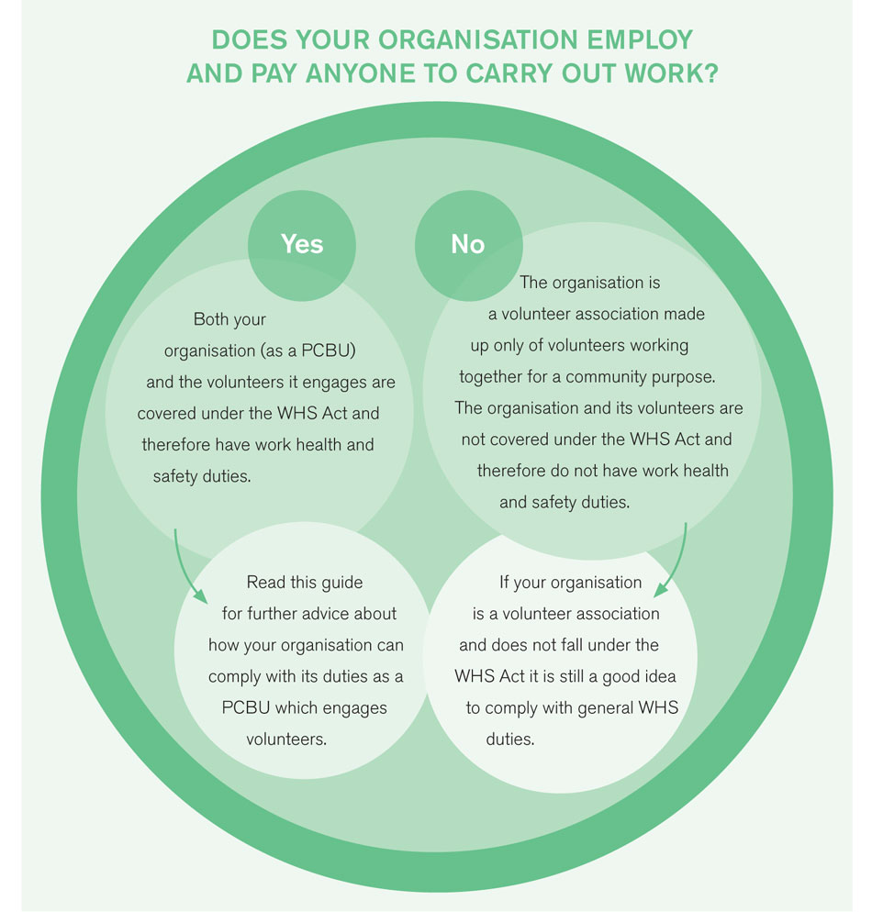

General and common law duties of organisations who engage volunteers are well established. Australian courts have long recognised that volunteers are owed a general duty of care by the people and the organisations they support. So even if the organisation is a volunteer association and does not fall under the model WHS Act it is a good idea to comply with general WHS duties.

## Organisations with state divisions or local groups and their duties

An organisation can consist of a national body with state divisions and local groups. The national body will be a PCBU if they engage paid workers. The national body as a PCBU will owe duties to all workers, including the volunteers of the state divisions or local groups that are volunteer associations. This is because the work of those volunteers is directed or influenced by the national body.

If a state division or local group of the organisation is:

* a separate entity from the national body and
* engages paid workers to perform work for the organisation (as an incorporated association or through its members as an unincorporated association),

it will owe WHS duties to their volunteers and the volunteers of the local groups to the extent that they direct or influence the work that is carried out.

If the state division or local group (or its members) does not employ workers and is made up entirely of volunteers working for the same community purpose, it is a volunteer association and will not have any duties as PCBUs.

The diagram below illustrates how these duties work.

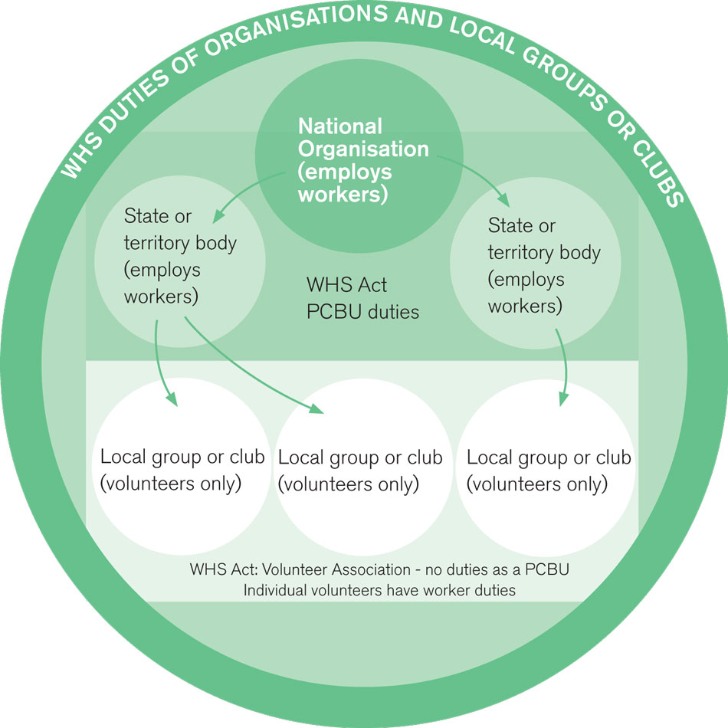

The duty the national body or state division owes to the local volunteers is qualified by what is [reasonably practicable](https://www.safeworkaustralia.gov.au/doc/how-determine-what-reasonably-practicable-meet-health-and-safety-duty) for them to do or what is reasonably able to be done. What is reasonably practicable will vary depending on the:

* specific structure and circumstances of each organisation and
* the extent to which each organisation can control or influence a particular thing or the actions of another person.

To meet their duty to workers including local volunteers, the national body or state division could for example:

* ensure the distribution of WHS policies and procedures on a range of topics to each division or group and
* set up processes to ensure consultation can occur between the national body and state and local groups or divisions.

The model WHS Act requires that where more than one PCBU has a duty for the same issue, each person retains responsibility for the matter and must discharge the duty to the extent they can influence and control the issue. In these situations, each person with a duty must, so far as is reasonably practicable, consult, co-operate and co-ordinate activities with all other persons with a duty in relation to the same matter

PCBUs that share the same duty may enter into an arrangement that only one PCBU takes the required action. However, in order to fulfil their duties, the other PCBUs must make sure and check that the other PCBU is carrying out the required action. For example, a PCBU may not need to provide first aid equipment or facilities if these are already provided by another PCBU at the workplace but must check that the equipment and facilities are adequate and accessible for workers.

PCBUs that talk to, co-operate and co-ordinate activities with others who are involved in the work will make controlling risks more likely and help each duty holder comply with their duty. It can also improve the efficiency of health and safety measures.

## Volunteers

Under the model WHS laws a volunteer is a person who works for an organisation without payment or financial reward (but they may receive out of pocket expenses). The law also recognises volunteers as workers. This means that the PCBU must provide the same protections to its volunteers as it does to its paid workers.

As a worker, a volunteer has duties under the model WHS Act. A volunteer may also be an officer of a business or undertaking with due diligence duties under the model WHS Act (see Officer Duties).

# What activities are covered by the model WHS laws?

Only work activities are covered by the model WHS laws. Activities that are purely domestic, social, recreational or private in nature are not included. Whether an activity is considered work may depend on specific circumstances. The following criteria may help determine if an activity is work under the model WHS Act:

* the activity involves physical or mental effort or the application of particular skills for the benefit of someone else or for themselves (if self employed), whether or not for profit or payment
* activities where someone would ordinarily be paid may be considered work
* activities that are part of an ongoing process or project may be work if some of the activities are paid
* an activity may be more likely to be work if someone is managed or controlled by another person when they undertake that activity
* formal, structured or complex arrangements may be considered to be work than ad hoc or unorganised activities.

The activity may be work even though one or more of the criteria are absent or minor.

Examples of activities that may be considered work include:

* maintenance of the things needed to enable an organisation to carry out its work. For example maintenance work on a hall where a volunteer group meets
* activities that people are ordinarily paid to do but are carried out for the organisation by a volunteer, for instance, driving clients to appointments
* activities that the organisation has a great degree of direction or influence over, or
* activities carried out in accordance with formal or structured arrangements.

For more information on what is and is not ‘work’ under the model WHS Act, please refer to Safe Work Australia’s [*Interpretive Guideline: The meaning of ‘person conducting a business or undertaking’*.](https://www.safeworkaustralia.gov.au/doc/interpretive-guideline-model-work-health-and-safety-act-meaning-person-conducting-business-or)

# What does the organisation need to do?

If a volunteer organisation is a PCBU under the model WHS laws it must ensure, so far as is reasonably practicable, the health and safety of all of its workers, including volunteers. This means that the organisation must provide the same protections to its volunteers as it does to its paid workers. The protection covers the physical safety and mental health of all workers, including volunteers.

The primary duty of a PCBU is qualified by ‘so far as is reasonably practicable’. This means the organisation does not have to guarantee that no harm will occur but must do what is reasonably able to be done to ensure health and safety. If the organisation is run by volunteers, this is a factor that will be taken into account in determining what is reasonably practicable for the organisation to do in any given circumstance.

Other factors that will be taken into account in determining what the organisation is required to do to protect its workers, including volunteers, are:

* the type of business or undertaking it is
* the type of work that the organisation carries out
* the nature of the risks associated with that work and the likelihood of injury or illness occurring
* what can be done to eliminate or minimise those risks, and
* the location or environment where the work is carried out.

The primary duty of an organisation includes ensuring, so far as is reasonably practicable:

* the provision and maintenance of a work environment without risks to health and safety
* the provision and maintenance of safe plant and structures and safe systems of work
* the safe use, handling and storage of plant, structures and substances
* the provision of accessible and adequate facilities for the welfare at work of workers, including volunteers, for example toliets, first aid facilities, and
* the provision of information, training and instruction or supervision that is necessary to protect all persons from risks to their health and safety arising from their work.

## Managing health and safety risks

A safe and healthy workplace does not happen by chance or guesswork. Organisations will have to think about what could go wrong at the workplace and what the consequences could be. Then it must do whatever it can—whatever is reasonably practicable—to eliminate or minimise the health and safety risks arising from the work the organisation undertakes.

The process of eliminating or minimising health and safety risks is called risk management and involves four steps:

1. *identifying hazards* – find out what could cause harm
2. *assess the risks if necessary* – understand the nature of the harm that could be caused by the hazard, how serious the harm could be and the likelihood of it happening
3. *control risks* – implement the most effective control measure that is reasonably practicable in the circumstances, and
4. *review control measures* – to ensure they are working as planned.

For further information refer to the [model Code of Practice: *How to Manage Work Health and Safety Risks*](https://www.safeworkaustralia.gov.au/node/974).

## What are some of the risks to volunteers engaging in work?

Volunteers, like other workers, face a wide range of possible risks and injuries from carrying out work. Such injuries may be physical or psychological and can result from common activities carried out by volunteers undertaking community services. The level of care that is required will depend on individual circumstances, such as the age of the volunteer, where the work is carried out and the relationship between the organisation and volunteer.

Psychological injuries and illness can be caused by challenging behaviour that the volunteer is confronted with or poor management of organisational change.

Physical injury or illness can be caused by work equipment for example by electrocution or electric shock, exposure to hazardous chemicals or contact with moving machinery parts. Injury or illness can also be caused by working in unsafe or unhealthy work environments caused by unsafe or unstable structures or extreme temperatures particularly when working outdoors.

## Providing information, training and instruction to volunteers

Volunteers must be provided with information, training, instruction or supervision so they can carry out their work safely. Training and information should be tailored to the type of work the volunteers do and where they work.

## Talking about health and safety

The model WHS Act requires PCBUs to consult with workers, including volunteers, so far as reasonably practicable, about WHS matters that affect them. PCBUs must also talk to workers when it proposes changes that may affect the workers’ health or safety.

The aim of the consultation is to ensure that volunteers are given an opportunity to contribute to the identification of hazards and the assessment and control of any risks they face when they carry out their work. The organisation must take volunteer’s ideas into consideration when making decisions about safety in the workplace.

## Finding the right consultative arrangements

Some workplaces may need a mix of consultation arrangements to suit the different types of workers and work situations within the organisation. There is no ‘one right way’ to talk about WHS. How the organisation does it will depend on factors like:

* the nature and size of the organisation
* the type of work that is carried out, and
* the current engagement arrangements of workers, including volunteers.

For example, if there are a number of full-time workers in an organisation, structured arrangements involving a health and safety committee may be suitable. Whereas an organisation that engages contractors, on-hire workers or volunteers to carry out specific tasks may find ‘toolbox talks’ (short discussions on specific health and safety topics relevant to the task) are the most practical way to consult.

Organisations must consult with workers when making decisions on the process and arrangements for consultation. Both the organisation and workers should agree to and be happy with the arrangements in place for consultation. Some of the ways the organisation might consult with its volunteers include:

* sending out regular newsletters via mail, email or relevant app which feature WHS news, information and updates
* regularly updating the volunteer section of its notice board website or app with information, including its latest safe work policies and procedures
* having a ‘suggestions’ email box for workers, including volunteers to send suggestions to about ways to work safely and other matters
* holding regular meetings to talk to volunteers about the work they do and how to do it in the safest way. Meetings can be via teleconference or online if required
* holding short ‘toolbox talks’ where specific health and safety topics relevant to the task at hand are discussed, and
* through Health and Safety Representatives (HSRs), if requested by workers.

**Health and Safety Representatives (HSRs)**

A Health and Safety Representative (HSR) is one way for workers to be represented in relation to WHS matters. If workers are represented by an HSR you must include them in the consultation process.

The appointment of HSRs is not mandatory, and an HSR is not obliged to undertake training. An untrained HSR can exercise most powers except for directing that unsafe work cease or issuing provisional improvement notices (PIN).

The organisation must facilitate the election of an HSR if one or more of the workers, whether paid or volunteer, ask for an HSR to be elected to represent their health and safety matters. To ensure the best representation of workers, HSRs are elected to represent specific work groups. Work groups must be determined before an HSR can be elected. There is also the option for the WHS regulator to become involved if an agreement can’t be reached. The regulator can determine if it is not appropriate for there to be an HSR.

**Health and Safety Committees (HSCs)**

Health and Safety Committees (HSCs) are another way for larger organisations to facilitate consultation. HSCs are not mandatory but must be established within two months of a request to do so from an HSR or five or more workers, who may be volunteers. An organisation can also establish an HSC without a request from workers.

HSCs can assist in developing health and safety policies and procedures for the organisation.

The organisation should also let the volunteers know what to do and who to contact if something happens when they are volunteering. If volunteers notice a health and safety matter that needs fixing they should know who to raise it with.

For more information about consultation refer to the model Code of Practice: Work Health and Safety; Consultation, Cooperation and Coordination or Worker Representation and Participation Guide.

## Notifying serious incidents

PCBUs are required to let the relevant state and territory WHS regulator know if any ‘notifiable incidents’ occur as a result of the work of the organisation as soon as it is reasonably able.

A notifiable incident is a serious incident that relates the work organisation caries out and involves:

* the death of a person
* the serious injury or illness of a person, or
* a dangerous incident.

To help determine what type of incident must be notified, ‘serious injury or illness’ and ‘dangerous incident’ are defined in the model WHS Act.

*A serious injury or illness* is one that requires a person to have:

* medical treatment within 48 hours of exposure to a substance
* immediate treatment as an in-patient in a hospital, or
* immediate treatment for a serious injury or illness such as a serious head injury, a serious burn or a spinal injury and a number of other injuries listed in the model WHS Act.

Importantly, it does not matter whether a person actually received the treatment referred to in this definition, just that the injury or illness could reasonably be considered to need the treatment.

A *dangerous incident* (also known as a near miss) is an incident in a workplace that exposes a worker or any other person to a serious risk to their health or safety emanating from an immediate or imminent exposure to a number of risks. These risks include an uncontrolled escape, spillage or leakage of a substance, an electric shock, a fall from a height or the collapse of a structure.

If a notifiable incident occurs it is the responsibility of the person with management or control of a workplace to ensure, so far as is reasonably practicable, that the site is not disturbed until an inspector arrives or otherwise directs.

To ensure the organisation satisfies this duty, volunteers could be required to inform the organisation immediately of any incidents that occur. While only incidents that cause serious injury or illness will be considered notifiable, being informed of all incidents may help the organisation to comply with its duties under the model WHS Act. The organisation may even create and implement a policy or procedure for reporting of incidents. Organisations that talk with volunteers about the less serious incidents that might arise from the work of the organisation may also help to prevent more serious incidents from happening in the future.

## Resolving issues

The model WHS Act outlines a process for the resolution of issues about WHS arising out of:

* work carried out at the workplace, or
* from the conduct of the organisation.

The issue resolution process applies after a WHS matter is raised but not resolved to the satisfaction of any party after discussing the matter. All parties involved in the issue must make reasonable efforts to come to an effective, timely and final solution of the matter.

If a WHS matter cannot be resolved by talking with all involved parties then the organisation needs to follow the process it and workers have agreed to in writing, or if there is no agreed process, the default issue resolution process set up in the WHS Regulations.

For more information on issue resolution and the model WHS laws contact the relevant state or territory [WHS regulator](https://www.safeworkaustralia.gov.au/node/228).

# Volunteers working from their or other person’s home

The organisation may engage volunteers who carry out work for the organisation in their own home. If this is the case, the organisation still needs to talk to its volunteers about doing work safely.

Volunteers that are engaged by the organisation to do work from their own home still need to take reasonable care of their own health and safety and ensure what they do for the organisation does not affect others. They also need to follow any reasonable instructions given to them by the organisation and cooperate with reasonable policies and procedures of the organisation that relate to WHS.

## Private homes as a workplace

Because the organisation obviously does not own, control or manage the places that these volunteers work from (their homes) it means the organisation has a limited ability to ensure a volunteer’s health and safety when at work. The organisation must still comply with its duty to ensure the health and safety of its volunteers but what is reasonably practicable for the organisation will be different than if the volunteers worked in a workplace that the organisation has control over.

For example to meet this duty the organisation might:

* give its volunteers who work from their own home information or advice about how to set up a comfortable workstation, or safely carry out the work they have been assigned
* give volunteers information on why they should not be sedentary for long periods of time and how to avoid this
* ensure volunteers have all the equipment they need to do the work they are given
* require volunteers to familiarise themselves and comply with good ergonomic practices and safe lifting techniques, consistent with any of the organiation’s policies and procedures,
* establish good communication between the organisation and volunteer including a contact person who volunteers can talk to about any concerns when working in their home.

Similar to when a volunteer works in another person’s private home, the organisation might ask its volunteers who work from their own home questions about their homes to gather enough information so that the instructions the organisation provide are appropriate and practical to address the relevant risks to volunteer’s health and safety when carrying out the work.

## Volunteering in other people’s homes

The organisation might engage volunteers who carry out work in other people’s homes. If this is the case, the organisation should provide these volunteers with information about the home they will be visiting before they go there. The organisation might tell its volunteers about specific hazards to be aware of in the home, for example:

* the presence of domestic animals in the yard
* instructions and/or training on how to use unfamiliar machinery or equipment
* the presence of other people in the home
* the layout of the property including any structures that may pose a risk such as stairs, that are particularly steep.

If volunteers visit a number of homes it may not be reasonably practicable for the organisation to provide information about specific hazards in each home. However, the organisation should provide its volunteers with information about the types of hazards they might encounter.

The organisation should also consider asking volunteers questions relating to the work environment to determine if there are any specific risks you should address before the volunteer visits other people’s homes. For example:

* is the volunteer comfortable around domestic pets
* does the volunteer has any mobility issues that may impede their ability to access the home (e.g uses a walking stick or frame and the house has stairs)
* does the volunteer have an allergy,
* does the volunteer hold a first aid certificate.

The organisation should always provide the volunteers with any other information that they need to carry out their volunteer work safely. The organisation should also consider the risk of volunteers being exposed to violence when performing volunteering work in a person’s home. Violence can harm both the person it is directed at, and anyone witnessing it, both physically and psychologically.

The best way to reduce the likelihood of violence is to eliminate the risk of exposure to it. If that’s not possible, the organisation will need to minimise the risk as far as reasonably practicable. While it is not a requirement that two volunteers attend a home to carry out work for an organisation at any time, the organisation may ask the volunteers to do so as a way of reducing the risk of violence. Other control measures may include providing volunteers with a reliable means of communicating with the organisation to request and obtain assistance when needed.

For more information about work related violence refer to Safe Work Australia’s page on [work related violence](https://www.safeworkaustralia.gov.au/work-related-violence)

# What do the volunteers need to do?

Volunteers also have health and safety duties to:

* take reasonable care for their own health and safety
* take reasonable care to ensure they don’t affect the health and safety of other people, for example, other volunteers, members of the public or clients they may be assisting
* comply, so far as they are reasonably able, with any reasonable instruction that is given to them by the organisation, and
* co-operate with any reasonable policy or procedure that the organisation has provided to them.

Essentially what is reasonable care and what is expected of workers is what a reasonable person would do in the circumstances having regards to things like:

* their knowledge
* their role
* their skills and the resources available to them
* their qualifications
* the information that they have, and
* the consequences to health and safety of a failure to act in the circumstances.

## Volunteers and prosecution

If the volunteers do the things listed in the previous section when carrying out work for the organisation, they cannot be fined or prosecuted under the model WHS Act.

Prosecutions against workers including volunteers have been rare and only in relation to serious incidents where there was a high degree of recklessness or negligence.

# Officer duties

## Who is an officer

Under the model WHS Act an officer of an organisation is not necessarily a volunteer or other worker who has ‘officer’ in their job title, for example, first aid officer, health and safety officer or administrative officer.

An officer is a person who makes, or participates in making, decisions that affect the whole, or a substantial part, of the organisation's activities. Volunteers may sit on the board of the organisation or be in another role where they make or participate in making such decisions. Their decisions may also have the capacity to significantly affect the organisation’s financial standing. Only if a person makes, or participates in making, these kinds of decisions are they are an ‘officer’ under the model WHS Act.

## Duties of officers

Any officer of an organisation, volunteer or paid, must exercise due diligence to ensure that the organisation complies with its health and safety duties. This means they must ensure that the organisation has appropriate systems of work in place and they must actively monitor and evaluate health and safety management within the organisation.

Exercising due diligence as an officer means that officers must take reasonable steps to:

* continuously learn about and keep up to date with WHS matters
* have an understanding of the nature of the work the organisation does and stay aware of the hazards and risks workers and volunteers may face when working for the organisation
* ensure and verify that the organisation has available for use, and uses, appropriate resources and processes to eliminate or minimise risks to health and safety
* ensure and verify the organisation has processes in place for communicating and considering information regarding WHS and responding to that information, and
* ensure and verify the organisation has, and implements, processes for complying with any duties and requirements under the model WHS laws.

More information on a volunteer officer’s duties are explained in the [*Guide to Work Health and Safety for Volunteers*](https://www.safeworkaustralia.gov.au/node/1287).

There are things that the organisation can do to help volunteer officers fulfil their due diligence duty and at the same time ensure that their organisation is complying with its health and safety duties. For example the organisation may:

* make WHS a standing agenda item on board meeting agendas
* implement a process for evaluation and review of safe work policies and procedures
* provide officers with an avenue or contact person to ask questions about WHS in the organisation, for example the WHS manager or the human resource manager,
* provide training or information to its officers about the model WHS laws and the work of the organisation which is carried out by its workers, including volunteers.

## Prosecution of volunteer officers

A volunteer officer cannot be prosecuted for failing to comply with their officer duties under the model WHS Act. This immunity for volunteer officers is designed to ensure that voluntary participation at the officer level is not discouraged. A volunteer officer can however be prosecuted in their capacity as a worker if they do not take reasonable care as a worker (see What do the volunteers need to do?).

Officers who are not volunteers can be prosecuted for failing to comply with due diligence duties under the model WHS Act.

# Emergency Service Volunteer Organisations

Emergency service organisations have always owed duties to take care of the health and safety of their workers and others at their place of work. The model WHS Act makes it clear that the duties of organisations are owed to all workers, including volunteers. Volunteers are entitled to the same protections as paid workers.

The model WHS laws do not affect the ability of emergency service organisations to respond to incidents as long as they continue to ensure, so far as is reasonably practicable, the health and safety of their workers, including volunteers, and other people. This does not mean the emergency service organisation must guarantee the health and safety of its workers, it simply needs to ensure it does all that can be reasonably done to keep its workers, including volunteers, safe.

## Duties of emergency service organisations

The WHS laws treat emergency service organisations in exactly the same way as any other organisation or volunteer association. The primary duty on an organisation is to ensure, so far as is reasonably practicable, the health and safety of its workers, including volunteers of local groups or clubs, and others. Organisations, including emergency services, also have duties for the management and control of workplaces and the management or control of fixtures, fittings or plant at the workplace.

## Emergency service volunteers and ‘officers’

Under the model WHS Act an officer of an organisation does not mean someone with the word ‘officer’ in their job title, for example first aid officer, health and safety officer or administrative officer.

An officer is a person who makes, or participates in making, decisions that affect the whole, or a substantial part, of the organisation's activities. Some workers, including volunteers may sit on the board of an organisation or be in another role where they make, or participate in making, such decisions. The decisions they make may also have the capacity to significantly affect the organisation’s financial standing. Only if a volunteer makes, or participates in making, these kinds of decisions are they are an officer under the model WHS Act.

Officers under the model WHS Act have duties to exercise due diligence to ensure that the emergency service organisation has appropriate and robust WHS measures in place for all its staff and volunteers (see Officer duties).

## Is an ‘incident controller’ an officer?

Under the model WHS Act an incident controller is unlikely to be an officer. Although incident controllers may direct particular response operations, they do not generally make, or participate in making, key decisions which affect the whole or a substantial part of an organisation or on how the organisation operates.

An officer under the model WHS Act is determined by the individual’s level of involvement in decision making for the whole or substantial part of the organisation. It is not determined by a role taken in response to a specific emergency (see Officer duties).

## Attending the same incident as other emergency service organisations

Sometimes more than one emergency service organisation will attend the same incident. For example, a car accident might be attended by the volunteer fire brigade, the State Emergency Service and the ambulance service. As they may all be PCBUs they all have duties and obligations under WHS law. Each organisation at the scene has a duty to ensure, so far as is reasonably practicable, the health and safety of their workers, including volunteers. They also must ensure, so far as is reasonably practicable, that their activities do not expose others to unnecessary risk.

To help each organisation meet their duty under the model WHS Act each organisation must also, so far as is reasonably practicable, consult, co-operate and co-ordinate activities with each other.

## Risk assessments

There is no need for emergency service organisations to stop and complete paper work before responding to the emergency situation at hand.

An emergency service organisation may consider that there is a real risk during the emergency for people to overlook or simply forget agreed safety processes and procedures. To help to minimise this risk the emergency service organisation may want to develop a checklist to remind incident commanders of things to look out for and steps to follow in an emergency. Whether or not a checklist is required to meet the organisation’s WHS duties, and what would be most effective given the urgent nature of the required emergency response, is something the organisation needs to consider by talking with its workers, including volunteers.

# Bullying, harassment and discrimination

The organisation has a WHS responsibility to ensure not only the physical health of the volunteers but also their mental health. This includes doing what you can to ensure they are not exposed to workplace bullying, harassment and discrimination.

Bullying in the workplace is repeated and unreasonable behaviour directed towards a worker or group of workers that creates a risk to health and safety. Some examples of workplace bullying include abusive or offensive language or comments, aggressive and intimidating behaviour, belittling or humiliating comments, practical jokes or initiation and unjustified criticism or complaints.

The responsibility to prevent workplace bullying, harassment and discrimination is covered in the model WHS Act by the duty to provide a healthy and safe working environment and safe systems of work.

Volunteers also have a duty under the model WHS Act to ensure that their actions do not constitute a risk to their own health and safety or that of other people in the workplace. See our website for more information on [bullying.](https://www.safeworkaustralia.gov.au/bullying)

Volunteers may also be covered by the national workplace bullying laws. See the [Fair Work Commission’s website](https://www.fwc.gov.au/disputes-at-work/anti-bullying) for further information.

The organisation needs to send a clear message that bullying will not be tolerated and provide information to volunteers about who they can contact if they are bullied in the workplace.

The model WHS Act also expressly prohibits the discrimination or unfair treatment of workers, including volunteers, because they have raised a WHS concern. A person found to be engaging in this type of discrimination may be liable to criminal penalties. See our [guide on discriminatory coercive or misleading conduct](https://www.safeworkaustralia.gov.au/doc/interpretive-guideline-model-work-health-and-safety-act-discriminatory-coercive-or-misleading)

# Other laws

WHS laws are not the only laws that the organisation should be aware of. Below is an outline of some of the laws that the organisation should know about when engaging volunteers. The organisation should seek further information on these laws and other laws from the relevant government body. Organisations can also seek further information on volunteers from the [volunteer peak body](https://www.safeworkaustralia.gov.au/volunteer-peak-bodies) in the relevant state or territory.

**Workplace relations laws** – The [Fair Work Ombudsman website](https://www.fairwork.gov.au/how-we-will-help/templates-and-guides/fact-sheets/unpaid-work/unpaid-work) has information on when an arrangement between a person and an organisation is a volunteer arrangement as oppose to an employment relationship.

**Anti-discrimination laws** - state, territory and Commonwealth anti-discrimination laws prohibit discrimination of a person because of that person’s attributes. The [Australian Human Rights Commission](http://www.hreoc.gov.au/index.htm) provides information about Commonwealth anti-discrimination laws and links to the websites of [State and Territory anti-discrimination bodies](http://www.hreoc.gov.au/about/links/index.html#ad).

**Workers compensation, insurance and civil liability-** Organisations should have appropriate insurance that adequately covers its workers including volunteers and the activities they carry out when volunteering. Organisations will be liable to pay any compensation for personal injury, property damage or financial loss caused by the volunteer. With some exceptions, volunteers are protected by law from incurring personal civil liability. The [Volunteering Australia website](http://www.volunteeringaustralia.org/policy-and-best-practise/insurance/) provides information about the most common types of insurance that covers volunteers.

It is also important the organisation has insurance as volunteers are generally not covered by workers’ compensation laws. Contact the relevant jurisdictional [workers’ compensation authority](https://www.safeworkaustralia.gov.au/covid-19-information-workplaces/industry-information/taxi-and-ride-share/workers-compensation) for more information.

# Checklist

If the organisation is covered by the model WHS laws, this checklist may be used as a guide to assist in complying with WHS duties. It is not a comprehensive list and there may be other actions needed to comply.

| **Question ​ ​** | | **​Yes ​​** | **No ​​** |
| --- | --- | --- | --- |
| ​Duties of organisations  **If you answer ‘No’ to questions 1-7 or are unsure, the organisation will need to take corrective action to meet WHS duties.** | | | |
| **1​** | Does the organisation have and keep up to date safe work policies, instructions and procedures? | ​ | ​ |
| **2​** | Does the organisation tailor and distribute its safe work policies, instructions and procedures?​ | ​ | ​ |
| **3​** | Does the organisation make sure all its volunteers are provided with training, information, instruction and supervision so that they can do their work safely?​ | ​ | ​ |
| **4​** | Does the organisation provide the same protections to its volunteers as its paid workers?​ | ​ | ​ |
| **5​** | Does the organisation consult its volunteers about WHS matters that affect them?​ | ​ | ​ |
| **6​** | Does the organisation provide its volunteers a way to raise WHS matters and make suggestions for WHS practices?​ | ​ | ​ |
| **7​** | Does the organisation tell its volunteers about what to do and who to tell if something goes wrong while they are volunteering?​ | ​ | ​ |
| Officer Duties  **If you answer ‘No’ to any relevant questions at 8-15, you need to take corrective action to ensure the organisation meets its WHS duties. ​** | | | |
| **​8** | Has the organisation identified who are its officers, paid or volunteer?​ | ​ | ​ |
| **9​** | Do all officers in the organisation know what their duties are under the model WHS Act? | ​ | ​ |
| **10​** | Do the members of the organisation’s board talk about WHS matters, policies, procedures and safe work practices at its meetings? | ​ | ​ |
| Volunteers working from their own or other people’s homes | | | |
| **11​** | Does the organisation provide its volunteers who work from their home instructions, information and procedures relating to working from home? | ​ | ​ |
| **12​** | Does the organisation provide its volunteers who volunteer in other people’s homes information about the hazards they may encounter when visiting another person’s home including work based violence? | ​ | ​ |
| ​Emergency Service Volunteer Organisations | | | |
| **13​** | Does the emergency service organisation consult, cooperate and coordinate with other emergency service organisations that attend the same incident at the same time as the organisation? | ​ | ​ |
| **14​** | Does the emergency service organisation have safe practices, policies and procedures it activates when responding to an incident? | ​ | ​ |
| **15​** | Does the emergency service organisation know who its ‘officers’ under the model WHS laws are? |  |  |